**ONLINE FORM PROCESSING SYSTEM**

Project Report submitted in partial fulfillment for award of the Degree of Bachelor of Science in Computer Science

submitted by

**A.MAHADEVAN** (reg.no.**2017CSC021**)

**J.MUTHUKARUPPAN** (reg.no**.2017CSC024**)

under the guidance of

**PROF. P. SRIDEVI, M.Sc., M.Phil.,**

(Dept.of Computer Science The Madura College(autonomous)



DEPARTMENT OF COMPUTER SCIENCE THE MADURA COLLEGE (AUTONOMOUS)

(Re-accredited with ‘A’ by NAAC) MADURAI-625011

APRIL-2020

**DECLARATION**



**DECLARATION**

We hereby declare that this project work entitled **“ONLINE FORM PROCESSING SYSTEM”** submitted by Department of Computer Science. The Madura College is a record of original work done by us for the partial fulfillment of the requirements of the Degree of Bachelor of Computer Science.

The project report is originally prepared by us and carried out under the guidance of our Asst Prof**. P. SRIDEVI, M.Sc., M.Phil**., Madura College, Madurai for the award of bachelor degree of Science in Computer and this has not been submitted elsewhere for any other degree.

Date: **A. Mahadevan**

Place: Madurai (2017CSC021)

**J. Muthukaruppan**

(2017CSC024)



THE MADURA COLLEGE (Autonomous) MADURAI-625003

DEPARTMENT OF COMPUTER SCIENCE

**CERTIFICATE**

This is to certify that the project work entitled “**ONLINE FORM PROCESSING SYSTEM”** is a bonafide record of the project work done by **A.MAHADEVAN(2017CSC021)** and **J.MUTHUKARUPPAN(2017CSC024)** and submitted to the Department of Computer Science, The Madura College, Madurai, in partial fulfillment of the requirements for the award of the Degree of Bachelor of Science in Computer. The VIVA-VOCE examination held in the department of computer science, The Madura College, Madurai on

**Project guide Head of the department**

**Internal Examiner External Examiner**

**ACKNOWLEDGEMENT**

**ACKNOWLEDGEMENT**

We first thank the almighty for giving strength to us to do this project work. Through this acknowledgement, we express our sincere gratitude to all those people who have been associated with this assignment and have helped us with it and make it a worthwhile experience.

We would like to express our wholehearted respects and thanks to the our principal **Dr.J.Suresh, M.Sc.,M.Phil., B.Ed., PBDCA., Ph.D.,** who gave us the golden opportunity to do this project on the topic “**ONLINE FORM PROCESSING SYSTEM**” ,Which also helpful us in doing a lot of Research and we came to know about so many new things.

We would like to thank to our vice principal **Dr.k.Muthuvel M.A., (Tamil), M.A. (Pub ad.,) M.Phil., D.G.T.P.G.D.JMC., Ph.D.,** for having offered the facilities required to complete this project.

We would like to thank our Head of the Department **Er.J.Rajendran B.E.,M.Phil**, for his moral support, whose guidance and constant receiving provide us with a total inside into effective programming techniques and helped to bring out the best in us.

We own our respect and sense of the gratitude to our guide **Asst Prof. P. SRIDEVI, M.Sc., M.Phil.,** of computer science department for her help and sincere advice that helped us to complete this project work successfully.

We thank all our staff member for giving us timeliness help and moral support to complete our project.

Finally we would also like to thank our parents and friends who helped us a lot in finishing this project within the limited time.

**SYNOPSIS**

**SYNOPSIS**

**Online Form Processing System** is mainly developed for users who want to apply for joining a college by giving application form details online and also for college authority members to analyze and process the data.

The user uses the browser to access the web application which is a php file from the server. After giving all details using the forms in the web application, it stores the details in the Oracle database.

The college members can analyze and process the form details using another java application which is distributed using RMI(Remote Method Invocation).

The members can only access the client part of the java application which has only GUI coding & function calls. The server part of the java application has the function body statements for connecting the database and processing.

It is successfully implemented using a web application which was created using HTML, CSS, JAVASCRIPT & PHP and a desktop application which uses JAVA. Both of the above application uses ORACLE as backend.

**CONTENTS**

|  |  |  |
| --- | --- | --- |
| **S.NO.** | **DESCRIPTION** | **PAGE NO.** |
| 1. | Introduction | 1 |
| 2. | Problem Definition & Description | 3 |
| 3. | System Environment   * 1. Hardware Requirement   2. Software Requirement | 8 |
| 4. | System Analysis   * 1. Existing System   2. Proposed System | 10 |
| 5. | System Design   * 1. Data Flow Diagram   2. Database Design   3. Input Design   4. Output Design | 13 |
| 6. | Sample coding | 23 |
| 7. | System Testing | 204 |
| 8. | Screen Shots | 206 |
| 9. | Conclusion | 216 |
| 10. | Future Enhancement | 217 |
| 11 | Bibliography | 218 |

**INTRODUCTION**

**INTRODUCTION**

**“ONLINE FORM PROCESSING SYSTEM”** deals with computerization of works performed on a college for student admission. Previously it has been processed manually. Due to this many problem arises. All information has to be recorded manually in big registers. Computerization will eliminate the above problems providing a very efficient way of running passages up to date information about all required details.

**“ONLINE FORM PROCESSING SYSTEM”** operations include applying form, viewing selected list, course details - through web application; analyzing student forms using pie chart, viewing and selecting toppers, querying student forms and sending messages - through desktop application.

**PROBLEM DEFINITION AND**

**DESCRIPTION**

**PROBLEM DEFINITION AND DESCRIPTION**

**ONLINE FORM PROCESSING SYSTEM** plays a major role in college student admission which is a process that requires huge effort of human resources and record maintenance.

Computerized will support for student admission to do in efficient manner and reduce the utilization of manpower and paper work. This will save college resources and manpower.

The Management is able to organize all activities under a single computer. They are able to get all the required details such as number of students applied for each department, toppers in each department, number of students who are outside of Madurai etc., by simply sitting before the computer.

**MODULE DEFINITION**

**AND**

**MODULE DESCRIPTION**

**MODULE DEFINITION AND DESCRIPTION**

Nowadays the requirement to record every purchase and sales hence managing them has become tedious. This project is objected to make the above stated transactions in an easy way. This project uses Microsoft visual studio as front-end and Microsoft access as back-end.

The ‘**ONLINE FORM PROCESSING SYSTEM’** is implemented in various modules as follows,

**DESKTOP APPLICATION**

* Analysis module
* View Toppers module
* Query Builder module
* Messenger module

**ANALYSIS MODULE**

Analysis module is used to view the pie chart of number of forms submitted according to the category such as stream, major, etc.,

**VIEW TOPPERS MODULE**

This module is designed to view and select toppers according to categories such as stream, major, community, etc., and also we can verify their mark sheet by view their mark sheet photos.

**QUERY BUILDER MODULE**

It is used for performing query operation to get the details we want to know about the forms submitted. We can perform any query on the database using the GUI and SQL knowledge is not needed.

**MESSENGER MODULE**

Analysis module is used to view the pie chart of number of forms submitted according to the category such as stream, major, etc.,

**WEB APPLICATION**

* Apply Form module
* View Selected List module
* Course Details module

**APPLY FORM MODULE**

This module is used to get the student details through a form and uploading it on the database.

**VIEW SELECTED LIST MODULE**

This module is used viewing the list of selected students on each department.

**COURSE DETAILS MODULE**

This module is designed for getting the information about the available courses.

**SYSTEM ENVIRONMENT**

**SYSTEM REQUIREMENT**

**HARDWARE REQUIREMENT:**

Processor : Intel Pentium processor

Speed : 65 MHz - 250 MHz

RAM : 2GB

Hard Disk : 512 GB

Monitor : LCD monitor

Keyboard : 104 Keys multimedia keyboard Mouse : Logitech Scroll

**SOFTWARE REQUIRMENT:**

Plat Form : Window 7 or Higher

**DESKTOP APPLICATION**

Front End : JAVA

Back End : ORACLE

**WEB APPLICATION**

Front End : HTML, CSS, JAVASCRIPT.

Back End : PHP AND ORACLE

**SYSTEM ANALYSIS**

**SYSTEM ANALYSIS**

System analysis and design refers to process of programming a business situation with the intent of improving it through better methods and procedures. System design is the process of planning a new business system to replace the old, but before this programming can done; we must thoroughly understand the told system determine how the computer can be best to makes its operation more effective.

System analysis then, the process of totally understanding the current system by gathering an interpreting fact, diagnosing problem and using the facts to improve the system.

Having determined the requirement what the system is intended to do? The system designer designs the new system keeping in mind, the objectives set during the system analysis.

Analysis comprises information gathering, fact-finding and review of written documents, onsite observations, interview and questionnaires. The traditional approach is to organize and to convert data through flowchart, which support future development the system and simplify communication with user.

**SYSTEM STUDY**

The system study begins with the study of existing system so as to determine the requirements of the proposed system. This is accomplished by conducting interviews and structured meetings with the end users and interacting with them throughout the whole process as to what is the requirement and what kind of a report they expected at the end. This can be done with having open talks with the end users and finding out the actual requirements.

**FEASIBILITY STUDY**

The feasibility study is to determine whether the proposed system is financial and technically feasible. In this the analysis of the problem and the collection of data which would be input to the system the processing required to be carried out on these data required to be produced.

**EXISTING SYSTEM**

In the existing system all processing are done manually. Voluminous registers are maintained in which all information is stored. It suffers from the serious raw backs including the laborious tasks involved every time during the sales process, inaccuracy arising out of manual work and retrieving information requires lot of register reference and provide ambiguity. Important drawback of existing system is time factor. It will not help the management to solve the problem in time

**PROPOSED SYSTEM**

With the continued growth of the work force as with the growth textiles, the existing system is found to be insufficient to meet the user requirements. The main objective of the development system is to be keep in pace with continue of growth of the work force for the textiles, to automated the whole process and to upgrade the technology to keep abreast with the technical elevation of other modules and system.

**SYSTEM DESIGN**

**SYSTEM DESIGN**

System design is a solution to how to approach to the creation of new system. This is important phase is composed of several steps. It provides understanding the procedural details necessary for the implementing the systems. Emphasis must be laid on translating the performance requirement in the design specifications.

System design is a multiple of in which the representation of the procedural approach. Data dealing and interface characteristics are synthesis from the information requirements. The total system design tags is classified in to below components.

* + Data flow diagram
  + Database design
  + Input Design
  + Output Design

**DATA FLOW DIAGRAM**

- Process

* Dataflow
* Checking
* Database
* Datasource

LOGIN

VERIFY

VERIFY

VERIFY

VERIFY

VIEW, SELECT

S

VIEW

VIEW

CREATE

MESSENGER

QUERY BUILDER

VIEW TOPPERS

ANALYSIS

QUERY BUILDER

VIEW TOPPERS

MESSENGER

ANALYSIS

ADD

APPLY FORM

COURSE DETAILS

VIEW

SELECTED LIST

VIEW

**DATABASE DESIGN**

**UGPHOTOS TABLE**

|  |  |  |
| --- | --- | --- |
| **FIELD NAME** | **DATA TYPE** | **DESCRIPTION** |
| studid | Varchar2 | Id of the student |
| url | Varchar2 | Path of the image |

**PGPHOTOS TABLE**

|  |  |  |
| --- | --- | --- |
| **FIELD NAME** | **DATA TYPE** | **DESCRIPTION** |
| studid | Varchar2 | Id of the student |
| url | Varchar2 | Path of the image |

**UGMAJORS TABLE**

|  |  |  |
| --- | --- | --- |
| **FIELD NAME** | **DATA TYPE** | **DESCRIPTION** |
| ugid | Varchar2 | Id of the ug majors |
| majors | Varchar2 | Name of the ug majors |

**PGMAJORS TABLE**

|  |  |  |
| --- | --- | --- |
| **FIELD NAME** | **DATA TYPE** | **DESCRIPTION** |
| pgid | Varchar2 | Id of the ug majors |
| majors | Varchar2 | Name of the ug majors |

**TWELVETHGROUPS TABLE**

|  |  |  |
| --- | --- | --- |
| **FIELD NAME** | **DATA TYPE** | **DESCRIPTION** |
| groupid | Varchar2 | Id of the group |
| groups | Varchar2 | 12th groups |

**UGMARKDETAIL TABLE**

|  |  |  |
| --- | --- | --- |
| **FIELD NAME** | **DATA TYPE** | **DESCRIPTION** |
| studid | Varchar2 | Id of the student |
| ugid | Varchar2 | Id of the ug majors |
| pgid | Varchar2 | Id of the pg majors |
| incol | Varchar2 | Name of the previous college |
| univ | Varchar2 | Name of the previous university |
| yp | Varchar2 | Ug passed year |
| percentage | Number | Percentage scored in their ug |
| stream | Number | Type of admission. Eg.1 for Regular, 2 for Self-finance. |

**TMARKDETAIL TABLE**

|  |  |  |
| --- | --- | --- |
| **FIELD NAME** | **DATA TYPE** | **DESCRIPTION** |
| studid | Varchar2 | Id of the student |
| groupid | Varchar2 | Id of the twelveth group |
| sub1 | Number | Marks |
| sub2 | Number | Marks |
| sub3 | Number | Marks |
| sub4 | Number | Marks |
| sub5 | Number | Marks |
| sub6 | Number | Marks |
| total | Number | Total Marks |
| ugid | Varchar2 | Id of the ug major |
| mony | Varchar2 | Month ,year passed in 12th std |
| stream | Number | Type of admission. Eg.1 for Regular, 2 for Self-finance. |

**STUDENTDETAIL TABLE**

|  |  |  |
| --- | --- | --- |
| **FIELD NAME** | **DATA TYPE** | **DESCRIPTION** |
| studid | Varchar2 | Id of the student |
| name | Varchar2 | Name of the student |
| dob | Varchar2 | Date of birth |
| fname | Varchar2 | Father name |
| foccup | Varchar2 | Father occupation |
| mname | Varchar2 | Mother name |
| moccup | Varchar2 | Mother occupation |
| street | Varchar2 | Street name |
| area | Varchar2 | Area name |
| pincode | Varchar2 | Pincode |
| mobno | Varchar2 | Mobile number |
| email | Varchar2 | Email address |
| nationality | Number | Nationality |
| mtongue | Number | Mother tongue |
| religion | Number | Religion |
| community | Number | Community |
| gender | Number | Gender |
| caste | Varchar2 | Caste |
| ndid | Varchar2 | Native district |

**INPUT DESIGN**

Here the input design deals with information that has been given to the system as master data. In this system the input design is designed in such a way that the valid data enter the system which is later taken into process. To communicate with the computer in an efficient manner, the data we are entering into the system must be valid and reliable. The output we get through the system is only based on the kind of input we give into the system. Thus input design plays a vital important role in any project.

The input design is considered mainly to attain the following objectives.

* + - Valid input to the system.
    - Making input uncomplicated.
    - Assuring input meets the intended purpose.
    - Assuring accurate completion.
    - Creating forms that are consistent.

All these objectives are achieved in this system. The input designs are designed in such a way that the user could understand the form easier. Apart from that validations are effectively done which avoid illegal data entering in to system. Alert about the input data are provided which ensure user friendly environment to the user. Navigation between the controls is done properly which makes the user to understand the flow easily while entering data.

**OUTPUT DESIGN**

Output design thus mainly concentrated on the display of processed data based on the requirement. The system will be considered as a complete one, only when it provides the right output. Apart from the right output provided by the system after processing, the output has to be displayed in such a way that it satisfies the user by fulfilling the requirement. Thus output design plays a vital role in the fulfilling of the system.

The outputs are mostly provided in the form of reports. The report produced should be providing all the values that takes the user easily understand the data. Proper format should be followed for displaying the output.

For creating an effective output design the following aspects has to be followed they are.

* Clear Titles
* Contain needed information
* Effective alignment and balanced structure
* Easy to use

In our system, titles have been set to every from describing about the form. Only the necessary details are displayed to the user. Through the data are enormous, only précised consistent data displayed under various categories. The output design structure is created neatly.

**SAMPLE CODING**

**SAMPLE CODING**

**JAVA APPLICATION**

**//Go.java**

**import javax.swing.*;**

**import java.awt.*;**

**import java.awt.event.*;**

**import java.util.*;**

**import java.io.*;**

**import java.rmi.*;**

**import java.sql.*;**

**import oracle.jdbc.driver.*;**

**import oracle.sql.*;**

**import javax.swing.border.*;**

**import javax.swing.table.*;**

**public class Go extends JWindow {**

**Image splashScreen;**

**ImageIcon imageIcon;**

**public Go() {**

**splashScreen = Toolkit.getDefaultToolkit().getImage("clglogo.png");**

**// Create ImageIcon from Image**

**imageIcon = new ImageIcon(splashScreen);**

**// Set JWindow size from image size**

**setSize(imageIcon.getIconWidth(),imageIcon.getIconHeight());**

**// Get current screen size**

**Dimension screenSize = Toolkit.getDefaultToolkit().getScreenSize();**

**// Get x coordinate on screen for make JWindow locate at center**

**int x = (screenSize.width-getSize().width)/2;**

**// Get y coordinate on screen for make JWindow locate at center**

**int y = (screenSize.height-getSize().height)/2;**

**// Set new location for JWindow**

**setLocation(x,y);**

**// Make JWindow visible**

**setVisible(true);**

**}**

**// Paint image onto JWindow**

**public void paint(Graphics g) {**

**super.paint(g);**

**g.drawImage(splashScreen, 0, 0, this);**

**}**

**public static void main(String[]args) {**

**Go splash = new Go();**

**try {**

**// Make JWindow appear for 10 seconds before disappear**

**Thread.sleep(5000);**

**splash.dispose();**

**} catch(Exception e) {**

**e.printStackTrace();**

**}**

**javax.swing.SwingUtilities.invokeLater(new Runnable() {**

**public void run() {**

**StartLogin fp= new StartLogin();**

**}**

**});**

**}**

**}**

**class StartLogin implements ActionListener**

**{**

**JFrame f;**

**JLabel l1,l2,l3,l4,l5;**

**JButton b1,b2;**

**JTextField t1,t3;**

**JPasswordField t2;**

**String s;**

**char c1[]=new char[]{};**

**char c2[]=new char[]{'m','i','r','d','a','d'};**

**GridBagLayout gb;**

**GridBagConstraints gc;**

**MyRemote service;**

**public StartLogin()**

**{**

**f=new JFrame("StartLogin");**

**Container c= f.getContentPane();**

**gb = new GridBagLayout();**

**c.setLayout(gb);**

**gc = new GridBagConstraints();**

**gc.weighty = 0.1;**

**gc.weightx = 0.1;**

**gc.gridwidth = 2;**

**gc.anchor = GridBagConstraints.PAGE_START;**

**l2=new JLabel("THE MADURA COLLEGE");**

**l2.setFont(new Font("Helvetica",Font.BOLD,34));**

**l2.setForeground(new Color(155,21,2));**

**gc.gridx = 1;**

**gc.gridy = 1;**

**gb.setConstraints(l2,gc);**

**c.add(l2);**

**l3=new JLabel("ENTER ADMIN NAME",JLabel.LEFT);**

**l3.setFont(new Font("Helvetica",Font.BOLD,25));**

**l3.setForeground(new Color(155,21,2));**

**gc.gridx = 0;**

**gc.gridy = 3;**

**gb.setConstraints(l3,gc);**

**c.add(l3);**

**l4=new JLabel("ENTER THE PASSWORD",JLabel.RIGHT);**

**l4.setFont(new Font("Helvetica",Font.BOLD,25));**

**l4.setForeground(new Color(155,21,2));**

**gc.gridx = 0;**

**gc.gridy = 5;**

**gb.setConstraints(l4,gc);**

**c.add(l4);**

**l5=new JLabel("ENTER THE SERVER IP ADDRESS",JLabel.RIGHT);**

**l5.setFont(new Font("Helvetica",Font.BOLD,25));**

**l5.setForeground(new Color(155,21,2));**

**gc.gridx = 0;**

**gc.gridy = 7;**

**gb.setConstraints(l5,gc);**

**c.add(l5);**

**t1=new JTextField(10);**

**t1.setFont(new Font("Helvetica",Font.BOLD,25));**

**t1.setForeground(new Color(252,220,177));**

**t1.setBackground(new Color(155,21,2));**

**gc.gridx = 2;**

**gc.gridy = 3;**

**gb.setConstraints(t1,gc);**

**c.add(t1);**

**t3=new JTextField(10);**

**t3.setFont(new Font("Helvetica",Font.BOLD,25));**

**t3.setForeground(new Color(252,220,177));**

**t3.setBackground(new Color(155,21,2));**

**gc.gridx = 2;**

**gc.gridy = 7;**

**gb.setConstraints(t3,gc);**

**c.add(t3);**

**t2=new JPasswordField(10);**

**t2.setFont(new Font("Helvetica",Font.BOLD,25));**

**t2.setEchoChar('*');**

**t2.setForeground(new Color(252,220,177));**

**t2.setBackground(new Color(155,21,2));**

**gc.gridx = 2;**

**gc.gridy = 5;**

**gb.setConstraints(t2,gc);**

**c.add(t2);**

**b1=new JButton("EXIT");**

**b1.addActionListener(this);**

**b1.setMnemonic('E');**

**b1.setForeground(new Color(252,220,177));**

**b1.setBackground(new Color(155,21,2));**

**b1.setFont(new Font("Helvetica",Font.BOLD,25));**

**gc.gridx = 1;**

**gc.gridy = 8;**

**gb.setConstraints(b1,gc);**

**c.add(b1);**

**b2=new JButton("LOGIN");**

**b2.addActionListener(this);**

**b2.setMnemonic('L');**

**b2.setBackground(new Color(155,21,2));**

**b2.setForeground(new Color(252,220,177));**

**b2.setFont(new Font("Helvetica",Font.BOLD,25));**

**gc.gridx = 2;**

**gc.gridy = 8;**

**gb.setConstraints(b2,gc);**

**c.add(b2);**

**c.setBackground(new Color(252,220,177));**

**f.setVisible(true);**

**f.setSize(1150,600);**

**f.setDefaultCloseOperation(JFrame.EXIT_ON_CLOSE);**

**}**

**public void actionPerformed(ActionEvent ae)**

**{**

**if(ae.getSource()==b2)**

**{**

**boolean set=true;**

**if(t1.getText().isEmpty())**

**{**

**set=false;**

**JOptionPane.showMessageDialog(null, "Enter the Admin name","Error",JOptionPane.ERROR_MESSAGE);**

**}**

**if(t2.getText().isEmpty())**

**{**

**set=false;**

**JOptionPane.showMessageDialog(null, "Enter the password","Error",JOptionPane.ERROR_MESSAGE);**

**}**

**if(t3.getText().isEmpty())**

**{**

**set=false;**

**JOptionPane.showMessageDialog(null, "Enter the server IP address","Error",JOptionPane.ERROR_MESSAGE);**

**}**

**if(set)**

**{**

**s=t1.getText();**

**c1=t2.getPassword();**

**if(Arrays.equals(c1,c2) && s.equals("bookof"))**

**{**

**JOptionPane.showMessageDialog(null,"LoginSuccessfull","Password",1);**

**String IP=t3.getText();**

**try{**

**service = (MyRemote)Naming.lookup("rmi://"+IP+"/done");**

**}catch(Exception exx){exx.printStackTrace();}**

**Homef hf = new Homef();**

**hf.setTitle("DATA PROCESSOR");**

**hf.setVisible(true);**

**hf.setSize(1150,600);**

**f.dispose();**

**}**

**else**

**{**

**JOptionPane.showMessageDialog(null,"LoginFailed","Password",1);**

**}**

**}**

**}**

**else if (ae.getSource()==b1)**

**{**

**System.exit(0);**

**}**

**}**

**//class Homef**

**public class Homef extends JFrame implements ActionListener**

**{**

**JLabel l1;**

**JButton b1,b2,b3,b4,b5;**

**GridBagLayout gb;**

**GridBagConstraints gc;**

**Homef()**

**{**

**Container c = this.getContentPane();**

**gb = new GridBagLayout();**

**c.setLayout(gb);**

**gc = new GridBagConstraints();**

**l1=new JLabel("DATA PROCESSOR");**

**l1.setFont(new Font("Helvetica",Font.BOLD,34));**

**l1.setForeground(new Color(155,21,2));**

**gc.gridx = 3;**

**gc.gridy = 0;**

**gc.anchor = GridBagConstraints.PAGE_START;**

**gc.gridwidth = 1;**

**gc.weighty = 0.7;**

**gc.weightx = 0.7;**

**gb.setConstraints(l1,gc);**

**c.add(l1);**

**b5=new JButton("<<");**

**b5.addActionListener(this);**

**b5.setMnemonic('B');**

**b5.setBackground(new Color(155,21,2));**

**b5.setForeground(new Color(252,220,177));**

**b5.setFont(new Font("Helvetica",Font.BOLD,25));**

**gc.gridx = 0;**

**gc.gridy = 0;**

**gc.anchor = GridBagConstraints.FIRST_LINE_START;**

**gc.insets = new Insets(0,0,20,20);**

**gb.setConstraints(b5,gc);**

**c.add(b5);**

**ImageIcon bi= new ImageIcon("anal.png");**

**b1=new JButton("ANALYSIS",bi);**

**b1.addActionListener(this);**

**b1.setMnemonic('A');**

**b1.setBackground(new Color(155,21,2));**

**b1.setForeground(new Color(252,220,177));**

**b1.setFont(new Font("Helvetica",Font.BOLD,20));**

**b1.setToolTipText("Get the chart and count of applied students");**

**gc.gridx = 0;**

**gc.gridy = 1;**

**gc.fill = GridBagConstraints.BOTH;**

**gc.insets = new Insets(0,100,100,0);**

**gc.gridwidth = 2;**

**gc.gridheight = 2;**

**gb.setConstraints(b1,gc);**

**c.add(b1);**

**ImageIcon bv= new ImageIcon("view.png");**

**b2=new JButton("VIEW TOPPERS",bv);**

**b2.addActionListener(this);**

**b2.setMnemonic('V');**

**b2.setBackground(new Color(155,21,2));**

**b2.setForeground(new Color(252,220,177));**

**b2.setFont(new Font("Helvetica",Font.BOLD,20));**

**b2.setToolTipText("Get the list of students with maximum marks");**

**gc.gridx = 4;**

**gc.gridy = 1;**

**gc.insets = new Insets(0,0,100,100);**

**gb.setConstraints(b2,gc);**

**c.add(b2);**

**ImageIcon bq= new ImageIcon("query.png");**

**b3=new JButton("QUERY BUILDER",bq);**

**b3.addActionListener(this);**

**b3.setMnemonic('Q');**

**b3.setBackground(new Color(155,21,2));**

**b3.setForeground(new Color(252,220,177));**

**b3.setFont(new Font("Helvetica",Font.BOLD,20));**

**b3.setToolTipText("Get the user-required details from database");**

**gc.gridx = 0;**

**gc.gridy = 4;**

**gc.insets = new Insets(0,100,100,0);**

**gb.setConstraints(b3,gc);**

**c.add(b3);**

**ImageIcon bm= new ImageIcon("mess.png");**

**b4=new JButton("MESSENGER",bm);**

**b4.addActionListener(this);**

**b4.setMnemonic('M');**

**b4.setBackground(new Color(155,21,2));**

**b4.setForeground(new Color(252,220,177));**

**b4.setFont(new Font("Helvetica",Font.BOLD,20));**

**b4.setToolTipText("Convey information to the applying students");**

**gc.gridx = 4;**

**gc.gridy = 4;**

**gc.insets = new Insets(0,0,100,100);**

**gb.setConstraints(b4,gc);**

**c.add(b4);**

**this.setDefaultCloseOperation(JFrame.EXIT_ON_CLOSE);**

**c.setBackground(new Color(252,220,177));**

**}**

**public void actionPerformed(ActionEvent ae)**

**{if (ae.getSource()==b5)**

**{**

**StartLogin fp= new StartLogin();**

**this.dispose();**

**}**

**else if (ae.getSource()==b1)**

**{**

**Analys as = new Analys();**

**as.setTitle("ANALYSIS");**

**as.setVisible(true);**

**as.setSize(1150,600);**

**this.dispose();**

**}**

**else if (ae.getSource()==b2)**

**{**

**Vtop vt = new Vtop();**

**vt.setTitle("VIEW TOPPERS");**

**vt.setVisible(true);**

**vt.setSize(1150,600);**

**this.dispose();**

**}**

**else if (ae.getSource()==b4)**

**{**

**Sms1 sm = new Sms1();**

**sm.setTitle("SEND MESSEGE");**

**sm.setVisible(true);**

**sm.setSize(1150,600);**

**this.dispose();**

**}**

**else if (ae.getSource()==b3)**

**{**

**Qb1 q1 = new Qb1();**

**q1.setTitle("QUERY BUILDER");**

**q1.setVisible(true);**

**q1.setSize(1150,600);**

**this.dispose();**

**}**

**}**

**public class Analys extends JFrame implements ActionListener**

**{**

**JLabel l1,l2,l3,l4;**

**JButton b1,b2,bh;**

**JComboBox bx1,bx2,bx3,bx4;**

**GridBagLayout gb;**

**GridBagConstraints gc;**

**String s1[] = new String[10];**

**String s2[] = new String[10];**

**String s3[] = new String[10];**

**String a[] = new String[8];**

**Container c= this.getContentPane();**

**String x;int a1;**

**String text="<html>"+**

**"Using this window you can select the details"+"<br>"+**

**"to view the chart form of the details selected"+"<br>"+**

**"by choosing the options in the combo boxes."+"<br>"+**

**"Eg. you can view the details of students who "+"<br>"+**

**"applied for UG B.Sc.ComputerScience Regular "+"<br>"+**

**"distinguished by their groups(12th group for UG,"+"<br>"+**

**"UG MAJORS for PG category) or by their Gender."+"<br>"+**

**"</html>";**

**Analys()**

**{**

**s1[0] = "B.Sc.ComputerScience";**

**s1[1] = "B.Sc.Mathematics";**

**s1[2] = "B.Sc.Physics";**

**s1[3] = "B.Sc.Chemistry";**

**s1[4] = "B.Sc.Botany";**

**s1[5] = "B.Sc.Zoology";**

**s1[6] = "B.A.Tamil";**

**s1[7] = "B.A.English";**

**s1[8] = "B.Com.CA";**

**s1[9] = "B.Com.CS";**

**s2[0] ="M.Sc.ComputerScience";**

**s2[1] ="M.Sc.Mathematics";**

**s2[2] ="M.Sc.Physics";**

**s2[3] ="M.Sc.Chemistry";**

**s2[4] ="M.Sc.Botany";**

**s2[5] ="M.Sc.Zoology";**

**s2[6] ="M.A.Tamil";**

**s2[7] ="M.A.English";**

**s2[8] ="M.Com.CA";**

**s2[9] ="M.Com.CS";**

**gb = new GridBagLayout();**

**c.setLayout(gb);**

**gc = new GridBagConstraints();**

**bh = new JButton("help");**

**bh.addActionListener(this);**

**bh.setMnemonic('H');**

**bh.setBackground(new Color(155,21,2));**

**bh.setForeground(new Color(252,220,177));**

**bh.setFont(new Font("Helvetica",Font.BOLD,25));**

**gc.gridx = 5;**

**gc.gridy = 0;**

**gc.anchor = GridBagConstraints.FIRST_LINE_END;**

**gb.setConstraints(bh,gc);**

**c.add(bh);**

**b1=new JButton("<<");**

**b1.addActionListener(this);**

**b1.setMnemonic('B');**

**b1.setBackground(new Color(155,21,2));**

**b1.setForeground(new Color(252,220,177));**

**b1.setFont(new Font("Helvetica",Font.BOLD,25));**

**gc.gridx = 0;**

**gc.gridy = 0;**

**gc.anchor = GridBagConstraints.FIRST_LINE_START;**

**gc.insets = new Insets(0,0,20,20);**

**gc.weighty = 0.7;**

**gc.weightx = 0.7;**

**gb.setConstraints(b1,gc);**

**c.add(b1);**

**l1=new JLabel("SELECT THE CATEGORY");**

**l1.setFont(new Font("Helvetica",Font.BOLD,25));**

**l1.setForeground(new Color(155,21,2));**

**gc.gridx = 0;**

**gc.gridy = 1;**

**gb.setConstraints(l1,gc);**

**c.add(l1);**

**l2=new JLabel("SELECT THE STREAM");**

**l2.setFont(new Font("Helvetica",Font.BOLD,25));**

**l2.setForeground(new Color(155,21,2));**

**gc.gridx = 0;**

**gc.gridy = 2;**

**gb.setConstraints(l2,gc);**

**c.add(l2);**

**l3=new JLabel("SELECT THE MAJOR",JLabel.LEFT);**

**l3.setFont(new Font("Helvetica",Font.BOLD,25));**

**l3.setForeground(new Color(155,21,2));**

**gc.gridx = 0;**

**gc.gridy = 3;**

**gb.setConstraints(l3,gc);**

**c.add(l3);**

**l4=new JLabel("SELECT THE TYPE",JLabel.RIGHT);**

**l4.setFont(new Font("Helvetica",Font.BOLD,25));**

**l4.setForeground(new Color(155,21,2));**

**gc.gridx = 0;**

**gc.gridy = 4;**

**gb.setConstraints(l4,gc);**

**c.add(l4);**

**b2=new JButton("SHOW");**

**b2.addActionListener(this);**

**b2.setMnemonic('S');**

**b2.setBackground(new Color(155,21,2));**

**b2.setForeground(new Color(252,220,177));**

**b2.setFont(new Font("Helvetica",Font.BOLD,25));**

**gc.gridx = 2;**

**gc.gridy = 6;**

**gb.setConstraints(b2,gc);**

**c.add(b2);**

**bx1 = new JComboBox();**

**bx1.addItem("--select--");**

**bx1.addItem("UG");**

**bx1.addItem("PG");**

**bx1.addActionListener(this);**

**bx1.setBackground(new Color(155,21,2));**

**bx1.setForeground(new Color(252,220,177));**

**bx1.setFont(new Font("Helvetica",Font.BOLD,25));**

**gc.gridx = 4;**

**gc.gridy = 1;**

**gb.setConstraints(bx1,gc);**

**c.add(bx1);**

**bx2 = new JComboBox();**

**bx2.addItem("--select--");**

**bx2.addItem("REGULAR");**

**bx2.addItem("SELF-FINANCE");**

**bx2.addActionListener(this);**

**bx2.setBackground(new Color(155,21,2));**

**bx2.setForeground(new Color(252,220,177));**

**bx2.setFont(new Font("Helvetica",Font.BOLD,25));**

**gc.gridx = 4;**

**gc.gridy = 2;**

**gb.setConstraints(bx2,gc);**

**c.add(bx2);**

**bx3 = new JComboBox();**

**bx3.addItem("--select--");**

**for(int i=0;i<10;i++)**

**{**

**bx3.addItem(s1[i]);**

**}**

**bx3.addActionListener(this);**

**bx3.setBackground(new Color(155,21,2));**

**bx3.setForeground(new Color(252,220,177));**

**bx3.setFont(new Font("Helvetica",Font.BOLD,25));**

**gc.gridx = 4;**

**gc.gridy = 3;**

**gb.setConstraints(bx3,gc);**

**c.add(bx3);**

**bx4 = new JComboBox();**

**bx4.addItem("--select--");**

**bx4.addItem("GENDER");**

**bx4.addItem("GROUP");**

**bx4.addActionListener(this);**

**bx4.setBackground(new Color(155,21,2));**

**bx4.setForeground(new Color(252,220,177));**

**bx4.setFont(new Font("Helvetica",Font.BOLD,25));**

**gc.gridx = 4;**

**gc.gridy = 4;**

**gb.setConstraints(bx4,gc);**

**c.add(bx4);**

**this.setDefaultCloseOperation(JFrame.EXIT_ON_CLOSE);**

**c.setBackground(new Color(252,220,177));**

**}**

**public void actionPerformed(ActionEvent ae)**

**{if(ae.getSource() == bx1)**

**{**

**String str=(String)bx1.getSelectedItem();**

**if(str.equals("UG"))**

**{**

**s3=s1;**

**String st=(String)bx3.getItemAt(1);**

**if(st.equals(s2[0]))**

**{**

**for(int i=0;i<10;i++)**

**{**

**bx3.removeItem(s2[i]);**

**bx3.addItem(s3[i]);**

**}this.revalidate();**

**}**

**a[0]="TWELVETHGROUPS.Groups";**

**a[1]="12THGROUPS";**

**a[2]="TWELVETHGROUPS";**

**a[3]="TMARKDETAIL";**

**a[4]="TWELVETHGROUPS.GroupID";**

**a[5]="TMARKDETAIL.GroupID";**

**a[6]="UGID";**

**}**

**else**

**{**

**s3=s2;**

**String st=(String)bx3.getItemAt(1);**

**if(st.equals(s1[0]))**

**{**

**for(int i=0;i<10;i++)**

**{**

**bx3.removeItem(s1[i]);**

**bx3.addItem(s3[i]);**

**}this.revalidate();**

**}**

**a[0]="UGMAJORS.MAJORS";**

**a[1]="UGMAJORS_STUDIED";**

**a[2]="UGMAJORS";**

**a[3]="UGMARKDETAIL";**

**a[4]="UGMAJORS.UGID";**

**a[5]="UGMARKDETAIL.UGID";**

**a[6]="PGID";**

**}**

**}**

**else if(ae.getSource() == bx2)**

**{**

**String str=(String)bx2.getSelectedItem();**

**if(str.equals("REGULAR"))**

**{**

**a1 = 1;**

**}**

**else**

**{**

**a1 = 2;**

**}**

**}**

**else if(ae.getSource() == bx3)**

**{**

**String str=(String)bx1.getSelectedItem();**

**if(str.equals("UG"))**

**{**

**String str1=(String)bx3.getSelectedItem();**

**switch(str1)**

**{**

**case "B.Sc.ComputerScience": a[7]="'U0001'";x="12th GROUPS TAKEN FOR B.Sc.ComputerScience";break;**

**case "B.Sc.Mathematics": a[7]="'U0002'";x="12th GROUPS TAKEN FOR B.Sc.Mathematics";break;**

**case "B.Sc.Physics": a[7]="'U0003'";x="12th GROUPS TAKEN FOR B.Sc.Physics";break;**

**case "B.Sc.Chemistry": a[7]="'U0004'";x="12th GROUPS TAKEN FOR B.Sc.Chemistry";break;**

**case "B.Sc.Botany": a[7]="'U0005'";x="12th GROUPS TAKEN FOR B.Sc.Botany";break;**

**case "B.Sc.Zoology": a[7]="'U0006'";x="12th GROUPS TAKEN FOR B.Sc.Zoology";break;**

**case "B.A.Tamil": a[7]="'U0007'";x="12th GROUPS TAKEN FOR B.A.Tamil";break;**

**case "B.A.English": a[7]="'U0008'";x="12th GROUPS TAKEN FOR B.A.English";break;**

**case "B.Com.CA": a[7]="'U0009'";x="12th GROUPS TAKEN FOR B.Com.CA";break;**

**case "B.Com.CS": a[7]="'U0010'";x="12th GROUPS TAKEN FOR B.Com.CS";break;**

**}**

**}**

**else**

**{**

**String str2=(String)bx3.getSelectedItem();**

**switch(str2)**

**{**

**case "M.Sc.ComputerScience": a[7]="'P0001'";x="UGMAJOR TAKEN FOR M.Sc.ComputerScience";break;**

**case "M.Sc.Mathematics": a[7]="'P0002'";x="UGMAJOR TAKEN FOR M.Sc.Mathematics";break;**

**case "M.Sc.Physics": a[7]="'P0003'";x="UGMAJOR TAKEN FOR M.Sc.Physics";break;**

**case "M.Sc.Chemistry": a[7]="'P0004'";x="UGMAJOR TAKEN FOR M.Sc.Chemistry";break;**

**case "M.Sc.Botany": a[7]="'P0005'";x="UGMAJOR TAKEN FOR M.Sc.Botany";break;**

**case "M.Sc.Zoology": a[7]="'P0006'";x="UGMAJOR TAKEN FOR M.Sc.Zoology";break;**

**case "M.A.Tamil": a[7]="'P0007'";x="UGMAJOR TAKEN FOR M.A.Tamil";break;**

**case "M.A.English": a[7]="'P0008'";x="UGMAJOR TAKEN FOR M.A.English";break;**

**case "M.Com.CA": a[7]="'P0009'";x="UGMAJOR TAKEN FOR M.Com.CA";break;**

**case "M.Com.CS": a[7]="'P0010'";x="UGMAJOR TAKEN FOR M.Com.CS";break;**

**}**

**}**

**}**

**else if(ae.getSource() == bx4)**

**{**

**String str2=(String)bx4.getSelectedItem();**

**if(str2.equals("GENDER"))**

**{**

**String str=(String)bx1.getSelectedItem();**

**if(str.equals("UG"))**

**{**

**a[0]="STUDENTDETAIL.Gender";**

**a[1]="Gender";**

**a[2]="STUDENTDETAIL";**

**a[4]="STUDENTDETAIL.StudID";**

**a[5]="TMARKDETAIL.StudID";**

**x="GENDER";**

**}**

**else**

**{**

**a[0]="STUDENTDETAIL.Gender";**

**a[1]="Gender";**

**a[2]="STUDENTDETAIL";**

**a[4]="STUDENTDETAIL.StudID";**

**a[5]="UGMARKDETAIL.StudID";**

**x="GENDER";**

**}**

**}**

**}**

**else if(ae.getSource()==b1)**

**{**

**this.dispose();**

**Homef hf = new Homef();**

**hf.setTitle("DATA PROCESSOR");**

**hf.setVisible(true);**

**hf.setSize(1150,600);**

**}**

**else if(ae.getSource()==bh)**

**{**

**JOptionPane.showMessageDialog(this,text);**

**}**

**else if (ae.getSource()==b2)**

**{**

**boolean set=true;**

**if(bx1.getSelectedItem()=="--select--")**

**{ System.out.println("hello");**

**JOptionPane.showMessageDialog(null, "select the category","Error",JOptionPane.ERROR_MESSAGE);**

**set = false;**

**}**

**if(bx2.getSelectedItem()=="--select--")**

**{**

**JOptionPane.showMessageDialog(null, "select the stream","Error",JOptionPane.ERROR_MESSAGE);**

**set = false;**

**}**

**if(bx3.getSelectedItem()=="--select--")**

**{**

**JOptionPane.showMessageDialog(null, "select the major","Error",JOptionPane.ERROR_MESSAGE);**

**set = false;**

**}**

**if(bx4.getSelectedItem()=="--select--")**

**{**

**JOptionPane.showMessageDialog(null, "select the type","Error",JOptionPane.ERROR_MESSAGE);**

**set = false;**

**}**

**if(set)**

**{**

**Fcount fc = new Fcount(a,a1,x);**

**fc.setTitle("FORM COUNTER");**

**fc.setVisible(true);**

**fc.setSize(1150,600);**

**this.dispose();**

**}**

**}**

**}**

**public class Fcount extends JFrame implements ActionListener**

**{**

**JLabel l1,l2;**

**JButton b1,bh;**

**GridBagLayout gb;**

**GridBagConstraints gc;**

**ArrayList<String> u = new ArrayList<>();**

**ArrayList<Integer> slices = new ArrayList<>();**

**String s;**

**String head;**

**Color scolor[];**

**int k=0;**

**String ad[];**

**String g1[] = new String[2];**

**String text="<html>"+**

**"In this window you can view the pie chart according"+"<br>"+**

**"to the options choosed in the previous window."+"<br>"+**

**"You can also get the number of students application"+"<br>"+**

**"that matches the choosen criteria."+"<br>"+**

**"</html>";**

**Fcount(String a[],int a1,String x)**

**{**

**ad=a;**

**head = x;**

**Container c= this.getContentPane();**

**gb = new GridBagLayout();**

**c.setLayout(gb);**

**gc = new GridBagConstraints();**

**bh = new JButton("help");**

**bh.addActionListener(this);**

**bh.setMnemonic('H');**

**bh.setBackground(new Color(155,21,2));**

**bh.setForeground(new Color(252,220,177));**

**bh.setFont(new Font("Helvetica",Font.BOLD,25));**

**gc.gridx = 5;**

**gc.gridy = 0;**

**gc.weighty = 0.7;**

**gc.weightx = 0.7;**

**gc.anchor = GridBagConstraints.FIRST_LINE_END;**

**gb.setConstraints(bh,gc);**

**c.add(bh);**

**b1=new JButton("<<");**

**b1.addActionListener(this);**

**b1.setMnemonic('B');**

**b1.setBackground(new Color(155,21,2));**

**b1.setForeground(new Color(252,220,177));**

**b1.setFont(new Font("Helvetica",Font.BOLD,25));**

**gc.gridx = 0;**

**gc.gridy = 0;**

**gc.anchor = GridBagConstraints.FIRST_LINE_START;**

**gb.setConstraints(b1,gc);**

**c.add(b1);**

**if(a[0].equals("UGMAJORS.MAJORS"))**

**{**

**Color scol[]=new Color[10];**

**scol[0]=Color.pink;**

**scol[1]=Color.green;**

**scol[2]=Color.blue;**

**scol[3]=Color.red;**

**scol[4]=Color.black;**

**scol[5]=Color.cyan;**

**scol[6]=Color.orange;**

**scol[7]=Color.yellow;**

**scol[8]=Color.lightGray;**

**scol[9]=Color.darkGray;**

**scolor = scol;**

**}**

**else**

**{**

**Color scol[]=new Color[3];**

**scol[0]=Color.pink;**

**scol[1]=Color.green;**

**scol[2]=Color.blue;**

**scolor = scol;**

**}**

**try**

**{**

**Object o[] = new Object[4];**

**o = service.getChartData(a,a1);**

**int k =(int)o[2];**

**u = (ArrayList<String>)o[0];**

**slices = (ArrayList<Integer>)o[1];**

**s = (String)o[3];**

**System.out.println(s);**

**}catch(Exception ex){}**

**this.revalidate();**

**this.setDefaultCloseOperation(JFrame.EXIT_ON_CLOSE);**

**c.setBackground(new Color(252,220,177));**

**}**

**public void paint(Graphics g)**

**{ g.setColor(new Color(252,220,177));**

**g.fillRect(0,0,this.getWidth(),this.getHeight());**

**double total = 0.0D;**

**for (int ia = 0; ia < slices.size(); ia++) {**

**total += slices.get(ia);**

**}**

**double curValue = 0.0D;**

**int startAngle = 0;**

**for (int ib = 0; ib < slices.size(); ib++) {**

**startAngle = (int) (curValue * 360 / total);**

**int arcAngle = (int) (slices.get(ib) * 360 / total);**

**g.setColor(scolor[ib]);**

**g.fillArc(250,150, 400, 400, startAngle, arcAngle);**

**curValue += slices.get(ib);**

**}**

**Font f = new Font("Helvetica",Font.BOLD,25);**

**g.setFont(f);**

**g.setColor(new Color(155,21,2));**

**g.drawString("FORM COUNT",100,100);**

**g.drawString(head,400,100);**

**g.setFont(f);**

**g.drawString(s,300,100);**

**int arr[];**

**if(ad[0].equals("UGMAJORS.MAJORS"))**

**{**

**int ar[]={150,180,210,240,270,300,330,360,390,420};**

**for(int m1=0;m1<u.size();m1++)**

**{**

**g.setColor(scolor[m1]);**

**g.fillRect(700,ar[m1],5,5);**

**g.drawString(u.get(m1),750,ar[m1]);**

**}**

**}**

**else if(ad[0].equals("PGMAJORS.MAJORS"))**

**{**

**int ar[]={150,180,210,240,270,300,330,360,390,420};**

**for(int m4=0;m4<u.size();m4++)**

**{**

**g.setColor(scolor[m4]);**

**g.fillRect(700,ar[m4],5,5);**

**g.drawString(u.get(m4),750,ar[m4]);**

**}**

**}**

**else if( ad[0].equals("TWELVETHGROUPS.Groups"))**

**{**

**int ar[]={150,180,210};**

**for(int m2=0;m2<u.size();m2++)**

**{**

**g.setColor(scolor[m2]);**

**g.fillRect(700,ar[m2],5,5);**

**g.drawString(u.get(m2),750,ar[m2]);**

**}**

**}**

**else{**

**int ar[]={150,180};**

**for(int m3=0;m3<u.size();m3++)**

**{**

**g.setColor(scolor[m3]);**

**g.fillRect(700,ar[m3],5,5);**

**if(u.get(m3).equals("1"))**

**{**

**g.drawString("MALE",750,ar[m3]);**

**}else{g.drawString("FEMALE",750,ar[m3]);}**

**}**

**}**

**}**

**public void actionPerformed(ActionEvent ae)**

**{if(ae.getSource()==b1)**

**{**

**this.dispose();**

**Analys as = new Analys();**

**as.setTitle("ANALYSIS");**

**as.setVisible(true);**

**as.setSize(1150,600);**

**}**

**else if(ae.getSource()==bh)**

**{**

**JOptionPane.showMessageDialog(this,text);**

**}**

**}**

**}//End Fcount**

**}//End Analys**

**public class Vtop extends JFrame implements ActionListener**

**{**

**JLabel l1,l2,l3,l4,l5;**

**JButton b1,b2,bh;**

**JComboBox bx1,bx2,bx3,bx4,bx5;**

**GridBagLayout gb;**

**GridBagConstraints gc;**

**Container c;**

**int vcount;**

**String s1[] = new String[10];**

**int bx,c1;**

**String s2[] = new String[10];**

**String s3[] = new String[10];**

**String n[] = new String[4];**

**String a[] = new String[14];**

**String bxc;**

**String text="<html>"+**

**"This window let you choose the criteria you want"+"<br>"+**

**"to get the list of students scored maximum marks."+"<br>"+**

**"</html>";**

**Vtop()**

**{**

**s1[0] = "B.Sc.ComputerScience";**

**s1[1] = "B.Sc.Mathematics";**

**s1[2] = "B.Sc.Physics";**

**s1[3] = "B.Sc.Chemistry";**

**s1[4] = "B.Sc.Botany";**

**s1[5] = "B.Sc.Zoology";**

**s1[6] = "B.A.Tamil";**

**s1[7] = "B.A.English";**

**s1[8] = "B.Com.CA";**

**s1[9] = "B.Com.CS";**

**s2[0] ="M.Sc.ComputerScience";**

**s2[1] ="M.Sc.Mathematics";**

**s2[2] ="M.Sc.Physics";**

**s2[3] ="M.Sc.Chemistry";**

**s2[4] ="M.Sc.Botany";**

**s2[5] ="M.Sc.Zoology";**

**s2[6] ="M.A.Tamil";**

**s2[7] ="M.A.English";**

**s2[8] ="M.Com.CA";**

**s2[9] ="M.Com.CS";**

**c= this.getContentPane();**

**gb = new GridBagLayout();**

**c.setLayout(gb);**

**gc = new GridBagConstraints();**

**bh = new JButton("help");**

**bh.addActionListener(this);**

**bh.setMnemonic('H');**

**bh.setBackground(new Color(155,21,2));**

**bh.setForeground(new Color(252,220,177));**

**bh.setFont(new Font("Helvetica",Font.BOLD,25));**

**gc.gridx = 5;**

**gc.gridy = 0;**

**gc.weighty = 0.7;**

**gc.weightx = 0.7;**

**gc.anchor = GridBagConstraints.FIRST_LINE_END;**

**gb.setConstraints(bh,gc);**

**c.add(bh);**

**b1=new JButton("<<");**

**b1.addActionListener(this);**

**b1.setMnemonic('B');**

**b1.setBackground(new Color(155,21,2));**

**b1.setForeground(new Color(252,220,177));**

**b1.setFont(new Font("Helvetica",Font.BOLD,25));**

**gc.gridx = 0;**

**gc.gridy = 0;**

**gc.anchor = GridBagConstraints.FIRST_LINE_START;**

**gc.insets = new Insets(0,0,20,20);**

**gb.setConstraints(b1,gc);**

**c.add(b1);**

**l1=new JLabel("SELECT THE CATEGORY");**

**l1.setFont(new Font("Helvetica",Font.BOLD,25));**

**l1.setForeground(new Color(155,21,2));**

**gc.gridx = 0;**

**gc.gridy = 1;**

**gb.setConstraints(l1,gc);**

**c.add(l1);**

**l2=new JLabel("SELECT THE STREAM");**

**l2.setFont(new Font("Helvetica",Font.BOLD,25));**

**l2.setForeground(new Color(155,21,2));**

**gc.gridx = 0;**

**gc.gridy = 2;**

**gb.setConstraints(l2,gc);**

**c.add(l2);**

**l3=new JLabel("SELECT THE MAJOR");**

**l3.setFont(new Font("Helvetica",Font.BOLD,25));**

**l3.setForeground(new Color(155,21,2));**

**gc.gridx = 0;**

**gc.gridy = 3;**

**gb.setConstraints(l3,gc);**

**c.add(l3);**

**l4=new JLabel("SELECT THE COMMUNITY");**

**l4.setFont(new Font("Helvetica",Font.BOLD,25));**

**l4.setForeground(new Color(155,21,2));**

**gc.gridx = 0;**

**gc.gridy = 4;**

**gb.setConstraints(l4,gc);**

**c.add(l4);**

**b2=new JButton("SHOW");**

**b2.addActionListener(this);**

**b2.setMnemonic('S');**

**b2.setBackground(new Color(155,21,2));**

**b2.setForeground(new Color(252,220,177));**

**b2.setFont(new Font("Helvetica",Font.BOLD,25));**

**gc.gridx = 2;**

**gc.gridy = 5;**

**gb.setConstraints(b2,gc);**

**c.add(b2);**

**bx1 = new JComboBox();**

**bx1.addItem("--select--");**

**for(int i=0;i<10;i++)**

**{**

**bx1.addItem(s1[i]);**

**}**

**bx1.addActionListener(this);**

**bx1.setBackground(new Color(155,21,2));**

**bx1.setForeground(new Color(252,220,177));**

**bx1.setFont(new Font("Helvetica",Font.BOLD,25));**

**gc.gridx = 5;**

**gc.gridy = 3;**

**gc.anchor = GridBagConstraints.LINE_START;**

**gc.gridwidth = 1;**

**gb.setConstraints(bx1,gc);**

**c.add(bx1);**

**bx2 = new JComboBox();**

**bx2.addItem("--select--");**

**bx2.addItem("OC");**

**bx2.addItem("BC");**

**bx2.addItem("MBC");**

**bx2.addItem("SC/ST");**

**bx2.addItem("DNC");**

**bx2.addItem("OTHERS");**

**bx2.addActionListener(this);**

**bx2.setBackground(new Color(155,21,2));**

**bx2.setForeground(new Color(252,220,177));**

**bx2.setFont(new Font("Helvetica",Font.BOLD,25));**

**gc.gridx = 5;**

**gc.gridy = 4;**

**gb.setConstraints(bx2,gc);**

**c.add(bx2);**

**bx3 = new JComboBox();**

**bx3.addItem("--select--");**

**bx3.addItem("UG");**

**bx3.addItem("PG");**

**bx3.addActionListener(this);**

**bx3.setBackground(new Color(155,21,2));**

**bx3.setForeground(new Color(252,220,177));**

**bx3.setFont(new Font("Helvetica",Font.BOLD,25));**

**gc.gridx = 5;**

**gc.gridy = 1;**

**gb.setConstraints(bx3,gc);**

**c.add(bx3);**

**bx4 = new JComboBox();**

**bx4.addItem("--select--");**

**bx4.addItem("REGULAR");**

**bx4.addItem("SELF");**

**bx4.addActionListener(this);**

**bx4.setBackground(new Color(155,21,2));**

**bx4.setForeground(new Color(252,220,177));**

**bx4.setFont(new Font("Helvetica",Font.BOLD,25));**

**gc.gridx = 5;**

**gc.gridy = 2;**

**gb.setConstraints(bx4,gc);**

**c.add(bx4);**

**this.setDefaultCloseOperation(JFrame.EXIT_ON_CLOSE);**

**c.setBackground(new Color(252,220,177));**

**}**

**public void actionPerformed(ActionEvent ae)**

**{**

**if(ae.getSource()==b1)**

**{**

**Homef hf = new Homef();**

**hf.setTitle("DATA PROCESSOR");**

**hf.setVisible(true);**

**hf.setSize(1150,600);**

**this.dispose();**

**}**

**else if(ae.getSource()==bh)**

**{**

**JOptionPane.showMessageDialog(this,text);**

**}**

**else if(ae.getSource()==b2)**

**{**

**boolean set=true;**

**if(bx1.getSelectedItem()=="--select--")**

**{**

**JOptionPane.showMessageDialog(null, "select the major","Error",JOptionPane.ERROR_MESSAGE);**

**set = false;**

**}**

**if(bx2.getSelectedItem()=="--select--")**

**{**

**JOptionPane.showMessageDialog(null, "select the community","Error",JOptionPane.ERROR_MESSAGE);**

**set = false;**

**}**

**if(bx3.getSelectedItem()=="--select--")**

**{**

**JOptionPane.showMessageDialog(null, "select the category","Error",JOptionPane.ERROR_MESSAGE);**

**set = false;**

**}**

**if(bx4.getSelectedItem()=="--select--")**

**{**

**JOptionPane.showMessageDialog(null, "select the stream","Error",JOptionPane.ERROR_MESSAGE);**

**set = false;**

**}**

**if(set)**

**{**

**Vcatt vc = new Vcatt(a,bx,c1,n,vcount,bxc);**

**vc.setTitle("SELECT CATEGORY");**

**vc.setVisible(true);**

**vc.setSize(1150,600);**

**this.dispose();**

**}**

**}**

**else if(ae.getSource()==bx3)**

**{**

**String str=(String)bx3.getSelectedItem();**

**if(str.equals("UG"))**

**{ vcount=1;**

**s3=s1;**

**String st=(String)bx1.getItemAt(1);**

**if(st.equals(s2[0]))**

**{**

**for(int i=0;i<10;i++)**

**{**

**bx1.removeItem(s2[i]);**

**bx1.addItem(s3[i]);**

**}**

**}**

**n[0]="StudentID";**

**n[1]="StudentName";**

**n[2]="TotalMarks";**

**n[3]="GroupStudied";**

**a[0]="STUDENTDETAIL.StudID";**

**a[1]="Name";**

**a[2]="Total";**

**a[3]="TWELVETHGROUPS.Groups";**

**a[4]="Email";**

**a[5]="STUDENTDETAIL";**

**a[6]="TMARKDETAIL";**

**a[7]="TWELVETHGROUPS";**

**a[8]=a[0];**

**a[9]="TMARKDETAIL.StudID";**

**a[10]="TMARKDETAIL.GroupID";**

**a[11]="TWELVETHGROUPS.GroupID";**

**a[12]="UGID";**

**}**

**else**

**{**

**vcount=2;**

**s3=s2;**

**String st=(String)bx1.getItemAt(1);**

**if(st.equals(s1[0]))**

**{**

**for(int i=0;i<10;i++)**

**{**

**bx1.removeItem(s1[i]);**

**bx1.addItem(s3[i]);**

**}**

**}**

**n[0]="StudentID";**

**n[1]="StudentName";**

**n[2]="TotalPercentage";**

**n[3]="MajorStudied";**

**a[0]="STUDENTDETAIL.StudID";**

**a[1]="Name";**

**a[2]="Percentage";**

**a[3]="UGMAJORS.Majors";**

**a[4]="Email";**

**a[5]="STUDENTDETAIL";**

**a[6]="UGMARKDETAIL";**

**a[7]="UGMAJORS";**

**a[8]=a[0];**

**a[9]="UGMARKDETAIL.StudID";**

**a[10]="UGMARKDETAIL.UGID";**

**a[11]="UGMAJORS.UGID";**

**a[12]="PGID";**

**}**

**}**

**else if(ae.getSource()==bx4)**

**{**

**String str=(String)bx4.getSelectedItem();**

**if(str.equals("REGULAR"))**

**{**

**bx = 1;**

**}**

**else**

**{**

**bx = 2;**

**}**

**}**

**else if(ae.getSource()==bx1)**

**{**

**String str=(String)bx3.getSelectedItem();**

**if(str.equals("UG"))**

**{**

**String str1=(String)bx1.getSelectedItem();**

**bxc=(String)bx1.getSelectedItem();**

**switch(str1)**

**{**

**case "B.Sc.ComputerScience": a[13]="'U0001'";break;**

**case "B.Sc.Mathematics": a[13]="'U0002'";break;**

**case "B.Sc.Physics": a[13]="'U0003'";break;**

**case "B.Sc.Chemistry": a[13]="'U0004'";break;**

**case "B.Sc.Botany": a[13]="'U0005'";break;**

**case "B.Sc.Zoology": a[13]="'U0006'";break;**

**case "B.A.Tamil": a[13]="'U0007'";break;**

**case "B.A.English": a[13]="'U0008'";break;**

**case "B.Com.CA": a[13]="'U0009'";break;**

**case "B.Com.CS": a[13]="'U0010'";break;**

**}**

**}**

**else**

**{**

**String str2=(String)bx1.getSelectedItem();**

**bxc=(String)bx1.getSelectedItem();**

**switch(str2)**

**{**

**case "M.Sc.ComputerScience": a[13]="'P0001'";break;**

**case "M.Sc.Mathematics": a[13]="'P0002'";break;**

**case "M.Sc.Physics": a[13]="'P0003'";break;**

**case "M.Sc.Chemistry": a[13]="'P0004'";break;**

**case "M.Sc.Botany": a[13]="'P0005'";break;**

**case "M.Sc.Zoology": a[13]="'P0006'";break;**

**case "M.A.Tamil": a[13]="'P0007'";break;**

**case "M.A.English": a[13]="'P0008'";break;**

**case "M.Com.CA": a[13]="'P0009'";break;**

**case "M.Com.CS": a[13]="'P0010'";break;**

**}**

**}**

**}**

**else if(ae.getSource()==bx2)**

**{**

**String str1=(String)bx2.getSelectedItem();**

**switch(str1)**

**{**

**case "OC": c1 = 1;break;**

**case "BC": c1 = 2;break;**

**case "MBC": c1 = 3;break;**

**case "SC/ST": c1 = 4;break;**

**case "DNC": c1 = 5;break;**

**case "OTHERS": c1 = 6;break;**

**}**

**}**

**}**

**/** It is inner class to the Vtop class*/**

**public class Vcatt extends JFrame implements ActionListener**

**{**

**JLabel l1;**

**JButton b1,b3,b4,b5,bh;**

**JTextField t1;**

**int t,num;**

**GridBagLayout gb;**

**GridBagConstraints gc;**

**String s[],ax1[],nx1[];**

**Container c;**

**JPanel jp;**

**JTable tab;**

**DefaultTableModel model;**

**String fcont[];**

**int vcount,cx1,bx1;**

**String bxc;**

**String text="<html>"+**

**"In this window you can see the list of students"+"<br>"+**

**"who scored maximum marks on the criteria you choosen."+"<br>"+**

**"you can also save the name list of "+"<br>"+**

**"the students who scored high marks and also"+"<br>"+**

**"verify their marksheet"+"<br>"+**

**"</html>";**

**/** It is parameterized. It gets two String array for getting elements of the**

**query statement, three integer variable,cx for course , bx for stream and vb for**

**for marksheet , then one string variable bxb to get file content*/**

**Vcatt(String ax[],int bx,int cx,String nx[],int vb,String bxb)**

**{vcount=vb;**

**bxc=bxb;**

**ax1=ax;**

**nx1=nx;**

**bx1=bx;**

**cx1=cx;**

**c= this.getContentPane();**

**gb = new GridBagLayout();**

**c.setLayout(gb);**

**gc = new GridBagConstraints();**

**b5=new JButton("<<");**

**b5.addActionListener(this);**

**b5.setMnemonic('B');**

**b5.setBackground(new Color(155,21,2));**

**b5.setForeground(new Color(252,220,177));**

**b5.setFont(new Font("Helvetica",Font.BOLD,25));**

**gc.gridx = 0;**

**gc.gridy = 0;**

**gc.anchor = GridBagConstraints.FIRST_LINE_START;**

**gc.insets = new Insets(0,0,20,20);**

**gc.weighty = 0.7;**

**gc.weightx = 0.7;**

**gb.setConstraints(b5,gc);**

**c.add(b5);**

**l1=new JLabel("TOP");**

**l1.setFont(new Font("Helvetica",Font.BOLD,25));**

**l1.setForeground(new Color(155,21,2));**

**gc.gridx = 0;**

**gc.gridy = 1;**

**gb.setConstraints(l1,gc);**

**c.add(l1);**

**t1=new JTextField(10);**

**t1.setFont(new Font("Helvetica",Font.BOLD,25));**

**t1.setForeground(new Color(252,220,177));**

**t1.setBackground(new Color(155,21,2));**

**gc.gridx = 0;**

**gc.gridy = 2;**

**gc.gridwidth = 2;**

**gb.setConstraints(t1,gc);**

**c.add(t1);**

**b1=new JButton("SHOW");**

**b1.addActionListener(this);**

**b1.setMnemonic('S');**

**b1.setBackground(new Color(155,21,2));**

**b1.setForeground(new Color(252,220,177));**

**b1.setFont(new Font("Helvetica",Font.BOLD,25));**

**gc.gridx = 0;**

**gc.gridy = 3;**

**gb.setConstraints(b1,gc);**

**c.add(b1);**

**b3=new JButton("SAVE NAMELIST");**

**b3.addActionListener(this);**

**b3.setMnemonic('N');**

**b3.setBackground(new Color(155,21,2));**

**b3.setForeground(new Color(252,220,177));**

**b3.setFont(new Font("Helvetica",Font.BOLD,25));**

**gc.gridx = 0;**

**gc.gridy = 4;**

**gb.setConstraints(b3,gc);**

**c.add(b3);**

**b4=new JButton("VERIFY MARKSHEET");**

**b4.addActionListener(this);**

**b4.setMnemonic('Y');**

**b4.setBackground(new Color(155,21,2));**

**b4.setForeground(new Color(252,220,177));**

**b4.setFont(new Font("Helvetica",Font.BOLD,25));**

**gc.gridx = 0;**

**gc.gridy = 5;**

**gb.setConstraints(b4,gc);**

**c.add(b4);**

**bh = new JButton("help");**

**bh.addActionListener(this);**

**bh.setMnemonic('H');**

**bh.setBackground(new Color(155,21,2));**

**bh.setForeground(new Color(252,220,177));**

**bh.setFont(new Font("Helvetica",Font.BOLD,25));**

**gc.gridx = 0;**

**gc.gridy = 6;**

**gb.setConstraints(bh,gc);**

**c.add(bh);**

**jp = new JPanel();**

**jp.setLayout(gb);**

**gc.gridx = 1;**

**gc.gridy = 0;**

**gc.gridwidth = 12;**

**gc.gridheight = 12;**

**gc.fill = GridBagConstraints.BOTH;**

**gb.setConstraints(jp,gc);**

**c.add(jp);**

**model = new DefaultTableModel();**

**model.setColumnIdentifiers(nx);**

**tab = new JTable();**

**tab.setModel(model);**

**tab.setRowHeight(30);**

**tab.setGridColor(Color.red);**

**tab.setFont(new Font("Arial",Font.BOLD,20));**

**JScrollPane scroll = new JScrollPane(tab);**

**scroll.setHorizontalScrollBarPolicy(**

**JScrollPane.HORIZONTAL_SCROLLBAR_AS_NEEDED);**

**scroll.setVerticalScrollBarPolicy(**

**JScrollPane.VERTICAL_SCROLLBAR_AS_NEEDED);**

**gc.gridwidth = 12;**

**gc.gridheight = 12;**

**gb.setConstraints(scroll,gc);**

**jp.add(scroll);**

**this.setDefaultCloseOperation(JFrame.EXIT_ON_CLOSE);**

**c.setBackground(new Color(252,220,177));**

**}**

**public void actionPerformed(ActionEvent ae)**

**{if(ae.getSource()==b5)**

**{**

**Vtop vt = new Vtop();**

**vt.setTitle("VIEW TOPPERS");**

**vt.setVisible(true);**

**vt.setSize(1150,600);**

**this.dispose();**

**}**

**else if(ae.getSource()==bh)**

**{**

**JOptionPane.showMessageDialog(this,text);**

**}**

**else if(ae.getSource()==b1)**

**{**

**if(t1.getText().isEmpty())**

**{**

**JOptionPane.showMessageDialog(null, "Enter the top number","Error",JOptionPane.ERROR_MESSAGE);**

**}**

**else**

**{**

**try{**

**Object o[] = new Object[4];**

**int tcount = Integer.parseInt(t1.getText());**

**o = service.getToppersData(ax1,bx1,cx1,nx1,tcount);**

**fcont=(String[])o[2];**

**int i = (int)o[1];**

**String s1[];**

**s1 = (String[])o[3];**

**s=s1;**

**String ss[][]=(String[][])o[0];**

**int l=ss[0].length;**

**int k=ss.length;**

**Object t[]=new Object[l];**

**model.setRowCount(0);**

**try{**

**for(int n=0;n<k;n++)**

**{**

**for(int m=0;m<l;m++)**

**{**

**t[m]=ss[n][m];**

**}**

**model.addRow(t);**

**}**

**}catch(Exception e)**

**{ System.out.println("No records"); }**

**this.revalidate();**

**if(i <1)**

**{**

**JOptionPane.showMessageDialog(null, "No Record Found","Error",JOptionPane.ERROR_MESSAGE);**

**}**

**if(i ==1)**

**{**

**System.out.println(i+" Record Found");**

**}**

**else**

**{**

**System.out.println(i+" Records Found");**

**}**

**}**

**catch(Exception ex)**

**{**

**ex.printStackTrace();**

**}**

**}**

**}**

**else if(ae.getSource()==b3)**

**{**

**try{**

**boolean res = service.saveNamelist(bxc,fcont);**

**if(res){JOptionPane.showMessageDialog(null, "File Created");}**

**else{JOptionPane.showMessageDialog(null, "File not created");}**

**}**

**catch(Exception e){}**

**}**

**else if (ae.getSource()==b4)**

**{**

**if(vcount==1)**

**{**

**for(int k=0;k<s.length;k++)**

**{**

**System.out.println(s[k]);**

**}**

**Vmark v1= new Vmark(s,vcount);**

**v1.setTitle("VIEW 12th MARKSHEET");**

**v1.setVisible(true);**

**v1.setSize(1150,600);**

**this.dispose();**

**}**

**else**

**{**

**for(int k=0;k<s.length;k++)**

**{**

**System.out.println(s[k]);**

**}**

**Vmark v1 = new Vmark(s,vcount);**

**v1.setTitle("VIEW UG MARKSHEET");**

**v1.setVisible(true);**

**v1.setSize(1150,600);**

**this.dispose();**

**}**

**}**

**}**

**public class Vmark extends JFrame implements ActionListener**

**{**

**JButton b1;**

**String r3[];**

**int cc;**

**JFrame f;**

**Container c;**

**Image img[];**

**int count;**

**Vmark(String a[],int vcount)**

**{**

**cc=a.length;**

**c= this.getContentPane();**

**BorderLayout obj = new BorderLayout();**

**c.setLayout(obj);**

**b1=new JButton("BACK");**

**b1.addActionListener(this);**

**b1.setMnemonic('B');**

**b1.setBackground(new Color(155,21,2));**

**b1.setForeground(new Color(252,220,177));**

**b1.setFont(new Font("Helvetica",Font.BOLD,25));**

**c.add("North",b1);**

**try**

**{**

**r3 = service.getImages(a,vcount);**

**img =new Image[r3.length];**

**for(int i=0;i<r3.length;i++)**

**{**

**img[i] = Toolkit.getDefaultToolkit().getImage(r3[i]);**

**}**

**MediaTracker track = new MediaTracker(this);**

**for(int k=0;k<r3.length;k++)**

**{**

**track.addImage(img[k],k);**

**}**

**try{**

**for(int k1=0;k1<r3.length;k1++)**

**{**

**track.waitForID(k1);**

**}**

**}catch(InterruptedException ie){ ie.printStackTrace();}**

**}catch (Exception i)**

**{**

**i.printStackTrace();**

**}**

**Drawpic dp = new Drawpic(img,cc);**

**JScrollPane scroll = new JScrollPane(dp);**

**scroll.setHorizontalScrollBarPolicy(**

**JScrollPane.HORIZONTAL_SCROLLBAR_AS_NEEDED);**

**scroll.setVerticalScrollBarPolicy(**

**JScrollPane.VERTICAL_SCROLLBAR_AS_NEEDED);**

**c.add("Center",scroll);**

**this.setDefaultCloseOperation(JFrame.EXIT_ON_CLOSE);**

**this.setBackground(new Color(252,220,177));**

**}**

**public void actionPerformed(ActionEvent ae)**

**{if(ae.getSource()==b1)**

**{**

**Vcatt vc = new Vcatt(ax1,bx1,cx1,nx1,vcount,bxc);**

**vc.setTitle("SELECT CATEGORY");**

**vc.setVisible(true);**

**vc.setSize(1150,600);**

**this.dispose();**

**}**

**}**

**public class Drawpic extends JPanel**

**{**

**int cou;**

**Image img[];**

**Drawpic(Image a[],int b)**

**{img=a;**

**cou=b;**

**}**

**public void paintComponent(Graphics g)**

**{ int pos=10;**

**super.paintComponent(g);**

**g.setColor(new Color(252,220,177));**

**g.fillRect(0,0,this.getWidth(),this.getHeight());**

**for(int i=0;i<cou;i++)**

**{**

**g.drawImage(img[i],200,pos,800,800,null);**

**pos=pos+600;**

**}**

**}**

**public Dimension getPreferredSize(){**

**return new Dimension(5000,5000);**

**}**

**}//End Drawpic**

**}//End Vmark**

**}//End Vcatt**

**}//End Vtop**

**public class Sms1 extends JFrame implements ActionListener**

**{**

**JButton b1,b2,bh;**

**JLabel l1;**

**JTextArea t1;**

**GridBagLayout gb;**

**GridBagConstraints gc;**

**String text="<html>"+**

**"In this window you can save the message"+"<br>"+**

**"you type so that that message can be "+"<br>"+**

**"displayed on the webpage that the students"+"<br>"+**

**"use to apply form."+"<br>"+**

**"</html>";**

**Sms1()**

**{**

**Container c= this.getContentPane();**

**gb = new GridBagLayout();**

**c.setLayout(gb);**

**gc = new GridBagConstraints();**

**bh = new JButton("help");**

**bh.addActionListener(this);**

**bh.setMnemonic('H');**

**bh.setBackground(new Color(155,21,2));**

**bh.setForeground(new Color(252,220,177));**

**bh.setFont(new Font("Helvetica",Font.BOLD,25));**

**gc.gridx = 5;**

**gc.gridy = 0;**

**gc.anchor = GridBagConstraints.FIRST_LINE_END;**

**gb.setConstraints(bh,gc);**

**c.add(bh);**

**b1=new JButton("<<");**

**b1.addActionListener(this);**

**b1.setMnemonic('B');**

**b1.setBackground(new Color(155,21,2));**

**b1.setForeground(new Color(252,220,177));**

**b1.setFont(new Font("Helvetica",Font.BOLD,25));**

**gc.gridx = 0;**

**gc.gridy = 0;**

**gc.anchor = GridBagConstraints.FIRST_LINE_START;**

**gc.insets = new Insets(0,0,20,20);**

**gc.weighty = 0.7;**

**gc.weightx = 0.7;**

**gb.setConstraints(b1,gc);**

**c.add(b1);**

**l1=new JLabel("TYPE THE MESSEGE");**

**l1.setFont(new Font("Helvetica",Font.BOLD,34));**

**l1.setForeground(new Color(155,21,2));**

**gc.gridx = 1;**

**gc.gridy = 1;**

**gc.anchor = GridBagConstraints.FIRST_LINE_START;**

**gc.gridwidth = 2;**

**gb.setConstraints(l1,gc);**

**c.add(l1);**

**t1=new JTextArea(3,10);**

**t1.setBackground(new Color(155,21,2));**

**t1.setForeground(new Color(252,220,177));**

**t1.setFont(new Font("Helvetica",Font.BOLD,25));**

**gc.gridx = 1;**

**gc.gridy = 2;**

**gc.anchor = GridBagConstraints.FIRST_LINE_START;**

**gc.insets = new Insets(0,50,20,20);**

**gc.gridwidth = 1;**

**gb.setConstraints(t1,gc);**

**c.add(t1);**

**b2=new JButton("SEND");**

**b2.addActionListener(this);**

**b2.setMnemonic('D');**

**b2.setBackground(new Color(155,21,2));**

**b2.setForeground(new Color(252,220,177));**

**b2.setFont(new Font("Helvetica",Font.BOLD,25));**

**gc.gridx = 1;**

**gc.gridy = 3;**

**gc.anchor = GridBagConstraints.FIRST_LINE_START;**

**gc.insets = new Insets(0,100,20,20);**

**gc.gridwidth = 1;**

**gb.setConstraints(b2,gc);**

**c.add(b2);**

**this.setDefaultCloseOperation(JFrame.EXIT_ON_CLOSE);**

**c.setBackground(new Color(252,220,177));**

**}**

**public void actionPerformed(ActionEvent ae)**

**{ if(ae.getSource()==b1)**

**{**

**Homef hf = new Homef();**

**hf.setTitle("DATA PROCESSOR");**

**hf.setVisible(true);**

**hf.setSize(1150,600);**

**this.dispose();**

**}**

**else if(ae.getSource()==bh)**

**{**

**JOptionPane.showMessageDialog(this,text);**

**}**

**else if(ae.getSource()==b2)**

**{**

**if(t1.getText().isEmpty())**

**{**

**JOptionPane.showMessageDialog(null, "Enter the message","Error",JOptionPane.ERROR_MESSAGE);**

**}**

**else**

**{**

**try{**

**String txt = t1.getText();**

**boolean res = service.saveMessage(txt);**

**if(res){JOptionPane.showMessageDialog(null, "File Created");}**

**else{JOptionPane.showMessageDialog(null, "File not created");}**

**}**

**catch(Exception e){}**

**}**

**}**

**}**

**}//End Sms1**

**public class Qb1 extends JFrame implements ActionListener,ItemListener**

**{**

**JButton b1,b2,bh;**

**JLabel l1,l2,l3;**

**JPanel jp1,jp2;**

**JTextField t1;**

**GridBagLayout gb;**

**GridBagConstraints gc;**

**JRadioButton r1,r2,r3,r4,r5,r6,r7;**

**JCheckBox j[];**

**ButtonGroup bg;**

**String sx[],sz[];**

**int s;int xx=0,xy=0;**

**int t11=0,t2=0,t3=0,t4=0,t5=0,t6=0,t7=0;**

**Container c;**

**String text="<html>"+**

**"In this window you can the select the tables "+"<br>"+**

**"you want and also the fields in the table so"+"<br>"+**

**"that you can view the contents of the choosen"+"<br>"+**

**"tables and fields in the database."+"<br>"+**

**"</html>";**

**Qb1()**

**{**

**c= this.getContentPane();**

**gb = new GridBagLayout();**

**c.setLayout(gb);**

**gc = new GridBagConstraints();**

**bh = new JButton("help");**

**bh.addActionListener(this);**

**bh.setMnemonic('H');**

**bh.setBackground(new Color(155,21,2));**

**bh.setForeground(new Color(252,220,177));**

**bh.setFont(new Font("Helvetica",Font.BOLD,25));**

**gc.gridx = 5;**

**gc.gridy = 0;**

**gc.anchor = GridBagConstraints.FIRST_LINE_END;**

**gb.setConstraints(bh,gc);**

**c.add(bh);**

**r1= new JRadioButton("UGMAJORS");**

**r1.addActionListener(this);**

**r2= new JRadioButton("PGMAJORS");**

**r2.addActionListener(this);**

**r3= new JRadioButton("TWELVETHGROUPS");**

**r3.addActionListener(this);**

**r4= new JRadioButton("NATIVEDISTRICTS");**

**r4.addActionListener(this);**

**r5= new JRadioButton("STUDENTDETAIL");**

**r5.addActionListener(this);**

**r6= new JRadioButton("TMARKDETAIL");**

**r6.addActionListener(this);**

**r7= new JRadioButton("UGMARKDETAIL");**

**r7.addActionListener(this);**

**bg = new ButtonGroup();**

**bg.add(r1);**

**bg.add(r2);**

**bg.add(r3);**

**bg.add(r4);**

**bg.add(r5);**

**bg.add(r6);**

**bg.add(r7);**

**j = new JCheckBox[45];**

**j[0] = new JCheckBox("TMARKDETAIL.STUDID");**

**j[1] = new JCheckBox("GROUPID");**

**j[2] = new JCheckBox("SUB1");**

**j[3] = new JCheckBox("SUB2");**

**j[4] = new JCheckBox("SUB3");**

**j[5] = new JCheckBox("SUB4");**

**j[6] = new JCheckBox("SUB5");**

**j[7] = new JCheckBox("SUB6");**

**j[8] = new JCheckBox("TOTAL");**

**j[9] = new JCheckBox("TMARKDETAIL.UGID AS TUG");**

**j[10] = new JCheckBox("STREAM");**

**j[11] = new JCheckBox("UGMARKDETAIL.STUDID");**

**j[12] = new JCheckBox("UGID");**

**j[13] = new JCheckBox("PGID");**

**j[14] = new JCheckBox("PERCENTAGE");**

**j[15] = new JCheckBox("STREAM");**

**j[16] = new JCheckBox("UGMAJORS.UGID AS UGG");**

**j[17] = new JCheckBox("UGMAJORS.MAJORS AS UGM");**

**j[18] = new JCheckBox("PGMAJORS.PGID AS PGG");**

**j[19] = new JCheckBox("PGMAJORS.MAJORS AS PGM");**

**j[20] = new JCheckBox("GROUPID");**

**j[21] = new JCheckBox("GROUPS");**

**j[22] = new JCheckBox("NDID");**

**j[23] = new JCheckBox("NATIVEDISTRICTS");**

**j[24] = new JCheckBox("STUDENTDETAIL.STUDID");**

**j[25] = new JCheckBox("NAME");**

**j[26] = new JCheckBox("DOB");**

**j[27] = new JCheckBox("FNAME");**

**j[28] = new JCheckBox("FOCCUP");**

**j[29] = new JCheckBox("MNAME");**

**j[30] = new JCheckBox("MOCCUP");**

**j[31] = new JCheckBox("STREET");**

**j[32] = new JCheckBox("AREA");**

**j[33] = new JCheckBox("PINCODE");**

**j[34] = new JCheckBox("MOBNO");**

**j[35] = new JCheckBox("EMAIL");**

**j[36] = new JCheckBox("NATIONALITY");**

**j[37] = new JCheckBox("MTONGUE");**

**j[38] = new JCheckBox("RELIGION");**

**j[39] = new JCheckBox("COMMUNITY");**

**j[40] = new JCheckBox("GENDER");**

**j[41] = new JCheckBox("CASTEID");**

**j[42] = new JCheckBox("NDID");**

**for(int i=0;i<42;i++)**

**{**

**j[i].addItemListener(this);**

**}**

**b1=new JButton("<<");**

**b1.addActionListener(this);**

**b1.setMnemonic('B');**

**b1.setBackground(new Color(155,21,2));**

**b1.setForeground(new Color(252,220,177));**

**b1.setFont(new Font("Helvetica",Font.BOLD,25));**

**gc.gridx = 0;**

**gc.gridy = 0;**

**gc.anchor = GridBagConstraints.FIRST_LINE_START;**

**gc.insets = new Insets(0,0,20,20);**

**gc.weighty = 0.7;**

**gc.weightx = 0.7;**

**gb.setConstraints(b1,gc);**

**c.add(b1);**

**l1=new JLabel("CHOOSE THE TABLE");**

**l1.setFont(new Font("Helvetica",Font.BOLD,25));**

**l1.setForeground(new Color(155,21,2));**

**gc.gridx = 0;**

**gc.gridy = 1;**

**gc.anchor = GridBagConstraints.CENTER;**

**gb.setConstraints(l1,gc);**

**c.add(l1);**

**l2=new JLabel("CHOOSE THE FIELD");**

**l2.setFont(new Font("Helvetica",Font.BOLD,25));**

**l2.setForeground(new Color(155,21,2));**

**gc.gridx = 1;**

**gc.gridy = 1;**

**gc.anchor = GridBagConstraints.CENTER;**

**gb.setConstraints(l2,gc);**

**c.add(l2);**

**l3=new JLabel("ENTER THE CONDITION");**

**l3.setFont(new Font("Helvetica",Font.BOLD,25));**

**l3.setForeground(new Color(155,21,2));**

**gc.gridx = 0;**

**gc.gridy = 3;**

**gc.insets = new Insets(0,70,0,0);**

**gb.setConstraints(l3,gc);**

**c.add(l3);**

**b2=new JButton("SHOW");**

**b2.addActionListener(this);**

**b2.setMnemonic('S');**

**b2.setBackground(new Color(155,21,2));**

**b2.setForeground(new Color(252,220,177));**

**b2.setFont(new Font("Helvetica",Font.BOLD,25));**

**gc.gridx = 2;**

**gc.gridy = 4;**

**gc.anchor = GridBagConstraints.CENTER;**

**gc.insets = new Insets(0,60,20,100);**

**gc.weighty = 0.7;**

**gc.weightx = 0.7;**

**gb.setConstraints(b2,gc);**

**c.add(b2);**

**t1=new JTextField(10);**

**t1.setFont(new Font("Helvetica",Font.BOLD,25));**

**t1.setBackground(new Color(155,21,2));**

**t1.setForeground(new Color(252,220,177));**

**gc.gridx = 1;**

**gc.gridy = 3;**

**gc.fill = GridBagConstraints.HORIZONTAL;**

**gb.setConstraints(t1,gc);**

**c.add(t1);**

**jp1 = new JPanel();**

**BoxLayout bx1 = new BoxLayout(jp1,BoxLayout.Y_AXIS);**

**jp1.setLayout(bx1);**

**gc.gridx = 0;**

**gc.gridy = 2;**

**gc.fill = GridBagConstraints.BOTH;**

**gc.insets = new Insets(0,70,0,0);**

**gb.setConstraints(jp1,gc);**

**jp1.add(r1);**

**jp1.add(r2);**

**jp1.add(r3);**

**jp1.add(r4);**

**jp1.add(r5);**

**jp1.add(r6);**

**jp1.add(r7);**

**c.add(jp1);**

**jp2= new JPanel();**

**BoxLayout bx2 = new BoxLayout(jp2,BoxLayout.Y_AXIS);**

**jp2.setLayout(bx2);**

**gc.gridx = 1;**

**gc.gridy = 2;**

**gc.insets = new Insets(0,80,0,0);**

**JScrollPane scroll = new JScrollPane(jp2);**

**scroll.setHorizontalScrollBarPolicy(**

**JScrollPane.HORIZONTAL_SCROLLBAR_AS_NEEDED);**

**scroll.setVerticalScrollBarPolicy(**

**JScrollPane.VERTICAL_SCROLLBAR_AS_NEEDED);**

**gc.fill = GridBagConstraints.BOTH;**

**gb.setConstraints(scroll,gc);**

**c.add(scroll);**

**this.setDefaultCloseOperation(JFrame.EXIT_ON_CLOSE);**

**c.setBackground(new Color(252,220,177));**

**}**

**public void itemStateChanged(ItemEvent ie)**

**{**

**if(ie.getStateChange()==ItemEvent.SELECTED)**

**{**

**s++;**

**}**

**else**

**{**

**s--;**

**}**

**}**

**/** It handles 7 JRadioButton, 45 JCheckBoxes, 2 JButton and also checking condition for the**

**checkboxes*/**

**public void actionPerformed(ActionEvent ae)**

**{**

**if(ae.getSource()==b1)**

**{**

**Homef hf = new Homef();**

**hf.setTitle("DATA PROCESSOR");**

**hf.setVisible(true);**

**hf.setSize(1150,600);**

**this.dispose();**

**}**

**else if(ae.getSource()==bh)**

**{**

**JOptionPane.showMessageDialog(this,text);**

**}**

**else if (ae.getSource()==b2)**

**{**

**sx = new String[s];**

**int yy=0;**

**int t111=0,t12=0,t13=0,t14=0,t15=0,t16=0,t17=0;**

**for(int ac=0;ac<42;ac++)**

**{**

**if(j[ac].getModel().isSelected())**

**{**

**if((ac>=24) && (ac<=42) && (t111==0)){t111=1;yy++;}**

**else if((ac>=0) && (ac<=10) && (t12==0)){t12=1;yy++;}**

**else if((ac>=11) && (ac<=15) && (t13==0)){t13=1;yy++;}**

**else if((ac>=16) && (ac<=17) && (t14==0)){t14=1;yy++;}**

**else if((ac>=18) && (ac<=19) && (t15==0)){t15=1;yy++;}**

**else if((ac>=20) && (ac<=21) && (t16==0)){t16=1;yy++;}**

**else if((ac>=22) &&( ac<=23) && (t17==0)){t17=1;yy++;}**

**}**

**}**

**sz = new String[yy];**

**xx=0;**

**for(int a=0;a<42;a++)**

**{**

**if(j[a].getModel().isSelected())**

**{**

**if((a>=24) && (a<=42) && (t11==0)){sz[xx]="STUDENTDETAIL";t11=1;xx++;}**

**else if((a>=0) && (a<=10) && (t2==0)){sz[xx]="TMARKDETAIL";t2=1;xx++;}**

**else if((a>=11) && (a<=15) && (t3==0)){sz[xx]="UGMARKDETAIL";t3=1;xx++;}**

**else if((a>=16) && (a<=17) && (t4==0)){sz[xx]="UGMAJORS";t4=1;xx++;}**

**else if((a>=18) && (a<=19) && (t5==0)){sz[xx]="PGMAJORS";t5=1;xx++;}**

**else if((a>=20) && (a<=21) && (t6==0)){sz[xx]="TWELVETHGROUPS";t6=1;xx++;}**

**else if((a>=22) &&( a<=23) && (t7==0)){sz[xx]="NATIVEDISTRICTS";t7=1;xx++;}**

**sx[xy]=j[a].getText();**

**xy++;**

**}**

**}**

**boolean set=false;**

**for(int md=0;md<42;md++)**

**{**

**if(j[md].isSelected())**

**{**

**set=true;**

**}**

**}**

**if(set)**

**{**

**String ss;**

**if(t1.getText().equals("")){ss=null;}**

**else{ss=t1.getText();}**

**Qv q2 = new Qv(sx,sz,ss);**

**q2.setTitle("QUERY RESULT");**

**q2.setVisible(true);**

**q2.setSize(1150,600);**

**this.dispose();**

**}**

**else{**

**JOptionPane.showMessageDialog(null, "select any field","Error",JOptionPane.ERROR_MESSAGE);**

**}**

**}**

**if(r1.getModel().isSelected())**

**{**

**jp2.add(j[16]);**

**jp2.add(j[17]);**

**j[16].setVisible(true);**

**j[17].setVisible(true);**

**for(int i1=0;i1<=15;i1++){j[i1].setVisible(false);}**

**for(int i2=18;i2<=42;i2++){j[i2].setVisible(false);}**

**jp2.revalidate();**

**}**

**if(r2.getModel().isSelected())**

**{**

**jp2.add(j[18]);**

**jp2.add(j[19]);**

**j[18].setVisible(true);**

**j[19].setVisible(true);**

**for(int i1=0;i1<=17;i1++){j[i1].setVisible(false);}**

**for(int i2=20;i2<=42;i2++){j[i2].setVisible(false);}**

**jp2.revalidate();**

**}**

**if(r3.getModel().isSelected())**

**{**

**jp2.add(j[20]);**

**jp2.add(j[21]);**

**j[20].setVisible(true);**

**j[21].setVisible(true);**

**for(int i1=0;i1<=19;i1++){j[i1].setVisible(false);}**

**for(int i2=22;i2<=42;i2++){j[i2].setVisible(false);}**

**jp2.revalidate();**

**}**

**if(r4.getModel().isSelected())**

**{**

**jp2.add(j[22]);**

**jp2.add(j[23]);**

**j[22].setVisible(true);**

**j[23].setVisible(true);**

**for(int i1=0;i1<=21;i1++){j[i1].setVisible(false);}**

**for(int i2=24;i2<=42;i2++){j[i2].setVisible(false);}**

**jp2.revalidate();**

**}**

**if(r5.getModel().isSelected())**

**{**

**for(int i=24;i<=42;i++)**

**{**

**jp2.add(j[i]);**

**j[i].setVisible(true);**

**}for(int i1=0;i1<=23;i1++){j[i1].setVisible(false);}**

**jp2.revalidate();**

**}**

**if(r6.getModel().isSelected())**

**{**

**for(int i=0;i<=10;i++)**

**{**

**jp2.add(j[i]);**

**j[i].setVisible(true);**

**}**

**for(int i1=11;i1<=42;i1++){j[i1].setVisible(false);}**

**jp2.revalidate();**

**}**

**if(r7.getModel().isSelected())**

**{**

**for(int i=11;i<=15;i++)**

**{**

**jp2.add(j[i]);**

**j[i].setVisible(true);**

**}**

**for(int i1=0;i1<=10;i1++){j[i1].setVisible(false);}**

**for(int i2=16;i2<=42;i2++){j[i2].setVisible(false);}**

**jp2.revalidate();**

**}**

**}**

**public class Qv extends JFrame implements ActionListener**

**{**

**JButton b1;**

**GridBagLayout gb;**

**GridBagConstraints gc;**

**String s1[];**

**String s2[];**

**String s3;**

**JPanel jp;**

**JTable tab;**

**DefaultTableModel model;**

**int num1,num2;**

**String xy;**

**Qv(String sx[],String sy[],String xx)**

**{s1=sx;**

**s2=sy;**

**s3=xx;**

**Container c= this.getContentPane();**

**gb = new GridBagLayout();**

**c.setLayout(gb);**

**gc = new GridBagConstraints();**

**jp = new JPanel();**

**jp.setLayout(gb);**

**gc.gridx = 1;**

**gc.gridy = 0;**

**gc.gridwidth = 20;**

**gc.gridheight = 20;**

**gc.fill = GridBagConstraints.HORIZONTAL;**

**gb.setConstraints(jp,gc);**

**c.add(jp);**

**b1=new JButton("BACK");**

**b1.addActionListener(this);**

**b1.setMnemonic('B');**

**b1.setBackground(new Color(155,21,2));**

**b1.setForeground(new Color(252,220,177));**

**b1.setFont(new Font("Helvetica",Font.BOLD,25));**

**gc.gridx = 1;**

**gc.gridy = 1;**

**gc.anchor = GridBagConstraints.PAGE_END;**

**gc.insets = new Insets(0,0,50,0);**

**gc.weighty = 0.7;**

**gc.weightx = 0.7;**

**gb.setConstraints(b1,gc);**

**c.add(b1);**

**model = new DefaultTableModel();**

**model.setColumnIdentifiers(s1);**

**tab = new JTable();**

**tab.setModel(model);**

**gc.insets = new Insets(0,50,0,50);**

**tab.setRowHeight(30);**

**tab.setGridColor(Color.red);**

**tab.setFont(new Font("Arial",Font.BOLD,20));**

**tab.setAutoResizeMode(JTable.AUTO_RESIZE_ALL_COLUMNS);**

**JScrollPane scroll = new JScrollPane(tab);**

**scroll.setHorizontalScrollBarPolicy(**

**JScrollPane.HORIZONTAL_SCROLLBAR_AS_NEEDED);**

**scroll.setVerticalScrollBarPolicy(**

**JScrollPane.VERTICAL_SCROLLBAR_AS_NEEDED);**

**gc.insets = new Insets(0,50,0,50);**

**gc.gridwidth = 20;**

**gc.gridheight = 20;**

**gc.fill = GridBagConstraints.BOTH;**

**gb.setConstraints(scroll,gc);**

**jp.add(scroll);**

**try**

**{**

**Object o[] = new Object[3];**

**o = service.getQueryResult(s1,s2,s3);**

**int k = (int)o[1];**

**int l = (int)o[2];**

**String s[][]=(String[][])o[0];**

**Object t[]=new Object[l];**

**model.setRowCount(0);**

**for(int n=0;n<k;n++)**

**{**

**for(int m=0;m<l;m++)**

**{**

**t[m]=s[n][m];**

**}**

**model.addRow(t);**

**}**

**if(k <1)**

**{**

**JOptionPane.showMessageDialog(null, "No Record Found","Error",JOptionPane.ERROR_MESSAGE);**

**}**

**if(k ==1)**

**{**

**System.out.println(k+" Record Found");**

**}**

**else**

**{**

**System.out.println(k+" Records Found");**

**}**

**}**

**catch(Exception ex)**

**{**

**ex.printStackTrace();**

**}**

**this.revalidate();**

**c.setBackground(new Color(252,220,177));**

**this.setDefaultCloseOperation(JFrame.EXIT_ON_CLOSE);**

**}**

**public void actionPerformed(ActionEvent ae)**

**{ if(ae.getSource()==b1)**

**{**

**Qb1 q1 = new Qb1();**

**q1.setTitle("QUERY BUILDER");**

**q1.setVisible(true);**

**q1.setSize(1150,600);**

**this.dispose();**

**}**

**}**

**}//End Qv**

**}//End Qb1**

**} // End Homef**

**}// End StartLogin**

**//MyRemote.java**

**import java.rmi.*;**

**public interface MyRemote extends Remote**

**{**

**public Object[] getQueryResult(String ss[],String st[],String xx)throws RemoteException;**

**public boolean saveNamelist(String bxc,String fcont[])throws RemoteException;**

**public boolean saveMessage(String txt)throws RemoteException;**

**public String[] getImages(String sid[],int cc)throws RemoteException;**

**public Object[] getChartData(String a[],int a1)throws RemoteException;**

**public Object[] getToppersData(String a[],int bx,int cx,String nx[],int t)throws RemoteException;**

**}**

**//MyRemoteService.java**

**import java.rmi.*;**

**import java.rmi.server.*;**

**import java.sql.*;**

**import java.io.*;**

**import oracle.jdbc.driver.*;**

**import oracle.sql.*;**

**import java.util.*;**

**public class MyRemoteService extends UnicastRemoteObject implements MyRemote**

**{**

**public MyRemoteService() throws RemoteException { }**

**public Object[] getQueryResult(String sx[],String sy[],String xx)**

**{**

**int num1 = sx.length;**

**int num2 = sy.length;**

**int count=0;**

**String ss,st;**

**ss = " ";**

**Object o[] = new Object[3];**

**for(int i=0;i<sx.length;i++)**

**{**

**if(i==num1-1){ss = ss + sx[i];}**

**else{ss = ss + sx[i] + ",";}**

**}**

**st=" ";**

**for(int k=0;k<sy.length;k++)**

**{**

**if(k==num2-1){st = st + sy[k];}**

**else{st = st + sy[k] + ",";}**

**}**

**try**

**{**

**DriverManager.registerDriver(new oracle.jdbc.driver.OracleDriver());**

**Connection con = DriverManager.getConnection("jdbc:oracle:thin:@localhost:1521:xe","system","thebookofmirdad");**

**Statement stmt = con.createStatement();**

**stmt.setFetchSize(250);**

**ResultSet query_set1;**

**if(xx==null)**

**{**

**query_set1 = stmt.executeQuery("SELECT count(*) as COUNT FROM "+st);**

**}**

**else**

**{**

**query_set1 = stmt.executeQuery("SELECT count(*) as COUNT FROM "+st+" WHERE "+xx);**

**}**

**while (query_set1.next())**

**{**

**count=query_set1.getInt("COUNT");**

**}**

**ResultSet query_set;**

**if(xx==null)**

**{**

**query_set = stmt.executeQuery("SELECT "+ss+" FROM "+st);**

**}**

**else**

**{**

**query_set = stmt.executeQuery("SELECT "+ss+" FROM "+st+" WHERE "+xx);**

**}**

**String s3[][] = new String[count][num1];**

**int k=0;**

**while (query_set.next())**

**{**

**for(int bb=0;bb<num1;bb++)**

**{**

**if(sx[bb].equals("STUDENTDETAIL.STUDID")){ sx[bb]="STUDID";}**

**else if(sx[bb].equals("TMARKDETAIL.STUDID")){ sx[bb]="STUDID";}**

**else if(sx[bb].equals("UGMARKDETAIL.STUDID")){ sx[bb]="STUDID";}**

**else if(sx[bb].equals("UGMAJORS.MAJORS AS UGM")){ sx[bb]="UGM";}**

**else if(sx[bb].equals("PGMAJORS.MAJORS AS PGM")){ sx[bb]="PGM";}**

**else if(sx[bb].equals("UGMAJORS.UGID AS UGG")){ sx[bb]="UGG";}**

**else if(sx[bb].equals("PGMAJORS.PGID AS PGG")){ sx[bb]="PGG";}**

**else if(sx[bb].equals("TMARKDETAIL.UGID AS TUG")){ sx[bb]="TUG";}**

**s3[k][bb] = query_set.getString(sx[bb]);**

**}**

**k++;**

**}**

**o[0]=s3;**

**o[1]=count;**

**o[2]=sx.length;**

**stmt.close();**

**con.close();**

**}catch (Exception i)**

**{**

**System.out.println(i);**

**}**

**return o;**

**}**

**public Object[] getToppersData(String ax[],int bx,int cx,String nx[],int t)**

**{**

**int i=0,num=0;**

**String tab[][];**

**String fconte[];**

**Object[] arob=new Object[4];**

**try**

**{**

**DriverManager.registerDriver(new oracle.jdbc.driver.OracleDriver());**

**Connection con = DriverManager.getConnection("jdbc:oracle:thin:@localhost:1521:xe","system","thebookofmirdad");**

**Statement stmt = con.createStatement();**

**stmt.setFetchSize(250);**

**ResultSet query_set1 = stmt.executeQuery("SELECT count(*) as NUM FROM(SELECT STUDENTDETAIL.STUDID FROM "+ax[5]+" , "+ax[6]+" , "+ax[7]+" WHERE "+ax[8]+" = "+ax[9]+" AND "+ax[10]+" = "+ax[11]+" AND "+ax[12]+" = "+ax[13]+" AND Stream = "+bx+" AND Community = "+cx+" ORDER BY "+ax[2]+" desc)WHERE ROWNUM <= "+t);**

**while (query_set1.next())**

**{**

**num=query_set1.getInt("NUM");**

**}**

**tab = new String[num][4];**

**fconte = new String[num];**

**ResultSet query_set = stmt.executeQuery("SELECT "+nx[0]+", "+nx[1]+" , "+nx[2]+" , "+nx[3]+" FROM(SELECT "+ax[0]+" AS "+nx[0]+", "+ax[1]+" AS "+nx[1]+" , "+ax[2]+" AS "+nx[2]+" , "+ax[3]+" AS "+nx[3]+" FROM "+ax[5]+" , "+ax[6]+" , "+ax[7]+" WHERE "+ax[8]+" = "+ax[9]+" AND "+ax[10]+" = "+ax[11]+" AND "+ax[12]+" = "+ax[13]+" AND Stream = "+bx+" AND Community = "+cx+" ORDER BY "+ax[2]+" desc)WHERE ROWNUM <= "+t);**

**String s1[] = new String[num];**

**int m=0,n=0,j=0;;**

**while (query_set.next())**

**{**

**tab[m][0] = query_set.getString(nx[0]);**

**s1[j]=query_set.getString(nx[0]);j++;**

**tab[m][1] = query_set.getString(nx[1]);**

**tab[m][2] = query_set.getString(nx[2]);**

**tab[m][3] = query_set.getString(nx[3]);**

**fconte[i]=(i+1)+" \t "+tab[m][1]+" \t "+tab[m][2];**

**i++;**

**m++;**

**}**

**arob[0]=tab;**

**arob[1]=i;**

**arob[2]=fconte;**

**arob[3]=s1;**

**stmt.close();**

**con.close();**

**}catch (Exception ex1)**

**{**

**System.out.println(ex1);**

**} return arob;**

**}**

**public Object[] getChartData(String a[],int a1)**

**{**

**int num=0;**

**Object[] arob=new Object[4];**

**try**

**{**

**String s="";**

**DriverManager.registerDriver(new oracle.jdbc.driver.OracleDriver());**

**Connection con = DriverManager.getConnection("jdbc:oracle:thin:@localhost:1521:xe","system","thebookofmirdad");**

**Statement stmt = con.createStatement();**

**stmt.setFetchSize(250);**

**ResultSet query_set1 = stmt.executeQuery("SELECT count(*) as NUMOFSTUD FROM "+a[2]+" , "+a[3]+" WHERE "+a[4]+" = "+a[5]+" AND STREAM = "+a1+" AND "+a[6]+" = "+a[7]);**

**while (query_set1.next())**

**{**

**num = query_set1.getInt("NUMOFSTUD");**

**Integer i = new Integer(num);**

**s = i.toString();**

**}**

**ArrayList<String> u = new ArrayList<>();**

**ArrayList<Integer> slices = new ArrayList<>();**

**ResultSet query_set = stmt.executeQuery("SELECT "+a[0]+" as STUDIED , count(*) as NUMOFSTUD FROM "+a[2]+" , "+a[3]+" WHERE "+a[4]+" = "+a[5]+" AND STREAM = "+a1+" AND "+a[6]+" = "+a[7]+" GROUP BY "+a[0]);**

**int k=0;**

**while (query_set.next())**

**{**

**u.add(query_set.getString("STUDIED"));**

**slices.add(query_set.getInt("NUMOFSTUD"));**

**}**

**Iterator it = u.iterator();**

**while(it.hasNext())**

**{**

**System.out.println(it.next());**

**}**

**Iterator it1 = slices.iterator();**

**while(it1.hasNext())**

**{**

**System.out.println(it1.next());**

**}**

**arob[0]=u;**

**arob[1]=slices;**

**arob[2]=num;**

**arob[3]=s;**

**stmt.close();**

**con.close();**

**}catch (Exception i)**

**{**

**System.out.println(i);**

**} return arob;**

**}**

**public boolean saveNamelist(String bxc,String fcont[])**

**{**

**try{**

**FileWriter fw = new FileWriter(bxc+".txt",false);**

**BufferedWriter bw = new BufferedWriter(fw,1024);**

**bw.write(bxc);**

**bw.write(System.getProperty("line.separator"));**

**bw.write(System.getProperty("line.separator"));**

**bw.write("S.No."+" \t "+"Name"+" \t "+"TotalMark");**

**bw.write(System.getProperty("line.separator"));**

**for(int i=0;i<fcont.length;i++)**

**{**

**bw.write(fcont[i]);**

**bw.write(System.getProperty("line.separator"));**

**}**

**bw.close();**

**}**

**catch(Exception e){}**

**File f = new File(bxc+".txt");**

**if(f.exists())**

**{**

**return true;**

**}**

**return false;**

**}**

**public boolean saveMessage(String txt)**

**{**

**try{**

**FileWriter fw = new FileWriter("Message.txt",false);**

**BufferedWriter bw = new BufferedWriter(fw,1024);**

**bw.write(txt);**

**bw.close();**

**}**

**catch(Exception e){}**

**File f = new File("Message.txt");**

**if(f.exists())**

**{**

**return true;**

**}**

**return false;**

**}**

**public String[] getImages(String sid[],int cc)**

**{**

**String r3[] = new String[sid.length];**

**try**

**{**

**DriverManager.registerDriver(new oracle.jdbc.driver.OracleDriver());**

**Connection con = DriverManager.getConnection("jdbc:oracle:thin:@localhost:1521:xe","system","thebookofmirdad");**

**Statement stmt = con.createStatement();**

**stmt.setFetchSize(250);**

**ResultSet query_set1;**

**int ky=0;**

**if(cc==1)**

**{**

**for(int k=0;k<sid.length;k++)**

**{**

**query_set1 = stmt.executeQuery("select url as location from upload1 where STUDID='"+sid[k]+"'");**

**while (query_set1.next())**

**{**

**r3[ky]=query_set1.getString("location");**

**ky++;**

**}**

**}**

**}**

**else**

**{System.out.println(2);**

**for(int k=0;k<sid.length;k++)**

**{**

**query_set1 = stmt.executeQuery("select "+sid[k]+" as SID,url as location from upload2");**

**while (query_set1.next())**

**{**

**r3[ky]=query_set1.getString("location");**

**ky++;**

**}**

**}**

**}**

**stmt.close();**

**con.close();**

**}catch (Exception i)**

**{**

**System.out.println(i);**

**} return r3;**

**}**

**public static void main(String args[])**

**{**

**try**

**{**

**MyRemote service = new MyRemoteService();**

**Naming.rebind("done",service);**

**}**

**catch(Exception ex)**

**{**

**ex.printStackTrace();**

**}**

**}**

**}**

**WEB APPLICATION**

**<!--Entry.php-->**

**<html>**

**<head>**

**<title>THE MADURA COLLEGE</title>**

**<style type="text/css">**

**#oval {**

**width: 400px;**

**height: 100px;**

**background: rgb(155,21,2);**

**color: rgb(252,220,177);**

**display: block;**

**font: normal 13px Tahoma;**

**line_height: 16px;**

**padding_left: 11px;**

**text-decoration: none;**

**border-radius: 60px;**

**}**

**.pos1 { position: absolute; top: 150px; left:100px;}**

**.pos2 { position: absolute; top: 150px; left: 600px;}**

**.pos3 { position: absolute; top: 350px; left: 100px;}**

**.pos4 { position: absolute; top: 350px; left: 600px;}**

**.pos5 { position: absolute; top: 500px; left: 50px;}**

**.pos { position: absolute; top: 90px; left: 80px;}**

**.po { position: absolute; top: 90px; left: 620px;}**

**.po1 { position: absolute; top: 40px; left: 110px;}**

**.po2 { position: absolute; top: 40px; left: 660px;}**

**.bd { width: 100%;min-width: 700px; min-height: 500px;}**

**</style>**

**<script language="JavaScript">**

**function chec()**

**{**

**var op1=document.getElementById("r1");**

**var op2=document.getElementById("r2");**

**if(!(op1.checked||op2.checked))**

**{**

**alert("Choose any option");**

**}**

**if(op1.checked)**

**{**

**location.href='add1.html'**

**}**

**else if(op2.checked)**

**{**

**location.href='add2.html'**

**}**

**}**

**function chec1()**

**{**

**location.href='selected1.html'**

**}**

**function chec2()**

**{**

**location.href='course.html'**

**}**

**</script>**

**</head>**

**<body style="background: rgb(252,220,177)" class="bd">**

**<center><h1 style="color: rgb(155,21,2); font-family: cursive; font-size: xx-large" >THE MADURA COLLEGE</h1></center>**

**<form >**

**<input type="radio" name="g1" id="r1" value="s1" class="pos"><h3 style="color: rgb(155,21,2); font-family: cursive; font-size: xx-large" class="po1">IAM A 12TH STUDENT</h3>**

**<input type="radio" name="g1" id="r2" value="s2" class="po"><h3 style="color: rgb(155,21,2); font-family: cursive; font-size: xx-large" class="po2">IAM A UG STUDENT</h3>**

**<input type="button" id="oval" class="pos1" value="APPLY FORM" onclick="chec()">**

**<input type="button" id="oval" class="pos2" value="COURSE DETAILS" onclick="chec2()">**

**<input type="button" id="oval" class="pos3" value="GALLERY">**

**<input type="button" id="oval" class="pos4" value="VIEW SELECTED LIST" onclick="chec1()">**

**</form>**

**<?php**

**$text= file_get_contents("Message.txt");**

**$fix = str_replace("\n","<br>",$text);**

**echo "<h3 style=\"color: rgb(155,21,2); font-family: cursive; font-size: xx-large\">**

**<fieldset class=\"pos5\" style=\"color: rgb(155,21,2)\">**

**<legend>MessageBox</legend>**

**<div>".$fix."</div>**

**</fieldset>**

**</h3>";**

**?>**

**</body>**

**</html>**

**<!--add1.html-->**

**<html>**

**<head>**

**<title>ADMISSION FORM</title>**

**<script src="validate.js"></script>**

**<style type="text/css">**

**.bd { width: 100%;min-width: 700px; min-height: 800px;}**

**#oval {**

**width: 100px;**

**height: 50px;**

**background: rgb(155,21,2);**

**color: rgb(252,220,177);**

**display: block;**

**font: normal 13px Tahoma;**

**line_height: 16px;**

**padding_left: 11px;**

**text-decoration: none;**

**border-radius: 60px;**

**}**

**.b1{position: absolute; top: 2100px; left:390px;}**

**.b2{position: absolute; top: 2100px; left:600px;}**

**.pos1 { position: absolute; top: 100px; left:20px; border:none;}**

**.pos2 { position: absolute; top: 700px; left: 20px;border:none;}**

**.pos3 { position: absolute; top: 1200px; left: 20px;border:none;}**

**.pos4 { position: absolute; top: 1650px; left: 20px;border:none;}**

**.pos5 { position: absolute; top: 1900px; left: 20px;border:none;}**

**</style>**

**</head>**

**<body style="background: rgb(252,220,177)" class="bd">**

**<form method="post" action="add.php" onsubmit="return formval(this,1)" enctype="multipart/form-data">**

**<h1 style="color: rgb(155,21,2); font-family: cursive; font-size: xx-large">ADMISSION FORM</h1>**

**<h3 style="color: rgb(155,21,2); font-family: cursive; font-size: x-large">**

**<fieldset class="pos1">**

**<legend>StudentDetails1</legend>**

**<pre>**

**Name: <input type="text" name="xxxx"><br>**

**Date of birth: <input type="text" name="Dob"><br>**

**Gender: <select name="gen"><option value="none">--select--</option><option value="Male">MALE</option><option value="Female">FEMALE</option><select><br>**

**Father Name: <input type="text" name="Fname"><br>**

**Father Occupation: <input type="text" name="Foc"><br>**

**Mother Name: <input type="text" name="Mname"><br>**

**Mother Occupation: <input type="text" name="Moc"><br>**

**Street: <input type="text" name="Street"><br>**

**Area: <input type="text" name="Area"><br>**

**Pincode: <input type="text" name="Pin"><br>**

**</pre>**

**</fieldset>**

**<fieldset class="pos2">**

**<legend>StudentDetails2</legend>**

**<pre>**

**Nationality: <select name="nat">**

**<option value="none">--select--</option>**

**<option value="Indian">INDIAN</option>**

**<option value="O1">OTHERS</option>**

**<select><br>**

**Mother Tongue: <select name="mtong">**

**<option value="none">--select--</option>**

**<option value="Tamil">TAMIL</option>**

**<option value="English">ENGLISH</option>**

**<option value="O2">OTHERS</option>**

**<select><br>**

**Religion: <select name="relg">**

**<option value="none">--select--</option>**

**<option value="Hindu">HINDU</option>**

**<option value="Muslim">MUSLIM</option>**

**<option value="Christ">CHRISTIANITY</option>**

**<option value="O3">Others</option>**

**<select><br>**

**Community: <select name="comm">**

**<option value="none">--select--</option>**

**<option value="OC">OC</option>**

**<option value="BC">BC</option>**

**<option value="MBC">MBC</option>**

**<option value="SS">SC/ST</option>**

**<option value="DNC">DNC</option>**

**<option value="O4">Others</option>**

**</select><br>**

**Native District: <select name="district">**

**<option value="none">--select--</option>**

**<option value="M">MADURAI</option>**

**<option value="S">SIVAGANAGAI</option>**

**<option value="V">VIRUDHUNAGAR</option>**

**<option value="T">THENI</option>**

**<option value="D">DINDUGUL</option>**

**<option value="O5">Others</option>**

**<select><br>**

**Caste: <input type="text" name="caste"><br>**

**Mobile no: <input type="text" name="mno"><br>**

**EmailID: <input type="text" name="eid"><br>**

**</pre>**

**</fieldset>**

**<fieldset class="pos3">**

**<legend>MarkDetails</legend>**

**<pre>**

**Marks in H.S. / CBSE -XII**

**Language: <input type="text" name="lan"><br>**

**English: <input type="text" name="eng"><br>**

**Subject1: <input type="text" name="s1"><br>**

**Subject2: <input type="text" name="s2"><br>**

**Subject3: <input type="text" name="s3"><br>**

**Subject4: <input type="text" name="s4"><br>**

**Month & Year of Passing: <input type="text" name="myp"><br>**

**</pre>**

**</fieldset>**

**<fieldset class="pos4">**

**<legend>CourseDetails</legend>**

**<pre>**

**Select your stream: <select name="cat">**

**<option value="none">--select--</option>**

**<option value="reg">REGULAR</option>**

**<option value="fin">SELF-FINANCE</option>**

**<select><br>**

**Select your UG major: <select name="ugmajor">**

**<option value="none">--select--</option>**

**<option value="bcsc">B.Sc.ComputerScience</option>**

**<option value="bmat">B.Sc.Mathematics</option>**

**<option value="bphy">B.Sc.Physics</option>**

**<option value="bche">B.Sc.Chemistry</option>**

**<option value="bzoo">B.Sc.Zoology</option>**

**<option value="bbot">B.Sc.Botany</option>**

**<option value="btam">B.A.Tamil</option>**

**<option value="beng">B.A.English</option>**

**<option value="bbcs">B.Com.CS</option>**

**<option value="bbca">B.Com.CA</option>**

**</select><br>**

**Select your 12th Group: <select name="tgroup">**

**<option value="none">--select--</option>**

**<option value="cs">ComputerScience</option>**

**<option value="bi">Biology</option>**

**<option value="ac">Accounts</option>**

**<option value="O6">Others</option>**

**<select>**

**</pre>**

**</fieldset>**

**<fieldset class="pos5">**

**<legend>Uploads</legend>**

**<pre>**

**Upload your passport size photo: <input type="file" name="u1">**

**Upload your Marksheet photo: <input type="file" name="u2">**

**</pre>**

**</fieldset>**

**<input type="submit" value="APPLY" id="oval" class="b1" >**

**<input type="button" value="BACK" id="oval" class="b2" onclick="location.href='Entry.php'">**

**</h3>**

**<br>**

**<div id="vald" style="color: rgb(155,21,2)"></div>**

**</form>**

**</body>**

**</html>**

**<!--add2.html-->**

**<html>**

**<head>**

**<title>ADMISSION FORM</title>**

**<script src="validate.js"></script>**

**<style type="text/css">**

**.bd { width: 100%;min-width: 700px; min-height: 800px;}**

**#oval {**

**width: 100px;**

**height: 50px;**

**background: rgb(155,21,2);**

**color: rgb(252,220,177);**

**display: block;**

**font: normal 13px Tahoma;**

**line_height: 16px;**

**padding_left: 11px;**

**text-decoration: none;**

**border-radius: 60px;**

**}**

**.b1{position: absolute; top: 2100px; left:390px;}**

**.b2{position: absolute; top: 2100px; left:600px;}**

**.pos1 { position: absolute; top: 100px; left:20px; border:none;}**

**.pos2 { position: absolute; top: 700px; left: 20px;border:none;}**

**.pos3 { position: absolute; top: 1200px; left: 20px;border:none;}**

**.pos4 { position: absolute; top: 1650px; left: 20px;border:none;}**

**.pos5 { position: absolute; top: 1900px; left: 20px;border:none;}**

**</style>**

**</head>**

**<body style="background: rgb(252,220,177)" class="bd">**

**<form method="post" action="add2.php" onsubmit="return formval(this,2)" enctype="multipart/form-data">**

**<h1 style="color: rgb(155,21,2); font-family: cursive; font-size: xx-large">ADMISSION FORM</h1>**

**<h3 style="color: rgb(155,21,2); font-family: cursive; font-size: x-large">**

**<fieldset class="pos1">**

**<legend>StudentDetails1</legend>**

**<pre>**

**Name: <input type="text" name="xxxx"><br>**

**Date of birth: <input type="text" name="Dob"><br>**

**Gender: <select name="gen"><option value="none">--select--</option><option value="Male">MALE</option><option value="Female">FEMALE</option><select><br>**

**Father Name: <input type="text" name="Fname"><br>**

**Father Occupation: <input type="text" name="Foc"><br>**

**Mother Name: <input type="text" name="Mname"><br>**

**Mother Occupation: <input type="text" name="Moc"><br>**

**Street: <input type="text" name="Street"><br>**

**Area: <input type="text" name="Area"><br>**

**Pincode: <input type="text" name="Pin"><br>**

**</pre>**

**</fieldset>**

**<fieldset class="pos2">**

**<legend>StudentDetails2</legend>**

**<pre>**

**Nationality: <select name="nat">**

**<option value="none">--select--</option>**

**<option value="Indian">INDIAN</option>**

**<option value="O1">OTHERS</option>**

**<select><br>**

**Mother Tongue: <select name="mtong">**

**<option value="none">--select--</option>**

**<option value="Tamil">TAMIL</option>**

**<option value="English">ENGLISH</option>**

**<option value="O2">OTHERS</option>**

**<select><br>**

**Religion: <select name="relg">**

**<option value="none">--select--</option>**

**<option value="Hindu">HINDU</option>**

**<option value="Muslim">MUSLIM</option>**

**<option value="Christ">CHRISTIANITY</option>**

**<option value="O3">Others</option>**

**<select><br>**

**Community: <select name="comm">**

**<option value="none">--select--</option>**

**<option value="OC">OC</option>**

**<option value="BC">BC</option>**

**<option value="MBC">MBC</option>**

**<option value="SS">SC/ST</option>**

**<option value="DNC">DNC</option>**

**<option value="O4">Others</option>**

**</select><br>**

**Native District: <select name="district">**

**<option value="none">--select--</option>**

**<option value="M">MADURAI</option>**

**<option value="S">SIVAGANAGAI</option>**

**<option value="V">VIRUDHUNAGAR</option>**

**<option value="T">THENI</option>**

**<option value="D">DINDUGUL</option>**

**<option value="O5">Others</option>**

**<select><br>**

**Caste: <input type="text" name="caste"><br>**

**Mobile no: <input type="text" name="mno"><br>**

**EmailID: <input type="text" name="eid"><br>**

**</pre>**

**</fieldset>**

**<fieldset class="pos3">**

**<legend>MarkDetails</legend>**

**<pre>**

**Marks in previous Major<br>**

**Institution/College last studied: <input type="text" name="colg"><br>**

**University: <input type="text" name="uni"><br>**

**Year of Study(yyyy-yyyy): <input type="text" name="ystud"><br>**

**Upto 5th Semester<br>**

**Marks obtained: <input type="text" name="mo"><br>**

**Total Marks: <input type="text" name="tm"><br>**

**</pre>**

**</fieldset>**

**<fieldset class="pos4">**

**<legend>CourseDetails</legend>**

**<pre>**

**Select your stream: <select name="cat">**

**<option value="none">--select--</option>**

**<option value="reg">REGULAR</option>**

**<option value="fin">SELF-FINANCE</option>**

**<select><br>**

**Select your UG major: <select name="ugmajor">**

**<option value="none">--select--</option>**

**<option value="bcsc">B.Sc.ComputerScience</option>**

**<option value="bmat">B.Sc.Mathematics</option>**

**<option value="bphy">B.Sc.Physics</option>**

**<option value="bche">B.Sc.Chemistry</option>**

**<option value="bzoo">B.Sc.Zoology</option>**

**<option value="bbot">B.Sc.Botany</option>**

**<option value="btam">B.A.Tamil</option>**

**<option value="beng">B.A.English</option>**

**<option value="bbcs">B.Com.CS</option>**

**<option value="bbca">B.Com.CA</option>**

**</select><br>**

**Select your PG major: <select name="pgmajor">**

**<option value="none">--select--</option>**

**<option value="mcsc">M.Sc.ComputerScience</option>**

**<option value="mmat">M.Sc.Mathematics</option>**

**<option value="mphy">M.Sc.Physics</option>**

**<option value="mche">M.Sc.Chemistry</option>**

**<option value="mzoo">M.Sc.Zoology</option>**

**<option value="mbot">M.Sc.Botany</option>**

**<option value="mtam">M.A.Tamil</option>**

**<option value="meng">M.A.English</option>**

**<option value="mbcs">M.Com.CS</option>**

**<option value="mbca">M.Com.CA</option>**

**<select>**

**</pre>**

**</fieldset>**

**<fieldset class="pos5">**

**<legend>Uploads</legend>**

**<pre>**

**Upload your passport size photo: <input type="file" name="u1">**

**Upload your 5th Semester Marksheet photo: <input type="file" name="u2">**

**</pre>**

**</fieldset>**

**<input type="submit" value="APPLY" id="oval" class="b1">**

**<input type="button" value="BACK" id="oval" class="b2" onclick="location.href='Entry.php'">**

**</h3>**

**<div id="vald" style="color: rgb(155,21,2)"></div>**

**</form>**

**</body>**

**</html>**

**<!--add.php-->**

**<html>**

**<head>**

**<style type="text/css">**

**.bd { width: 100%;min-width: 700px; min-height: 800px;}**

**</style>**

**<title>RESULT</title>**

**</head>**

**<body style="background: rgb(252,220,177)" class="bd">**

**<center>**

**<h1 style="color: rgb(155,21,2)">FORM SENT SUCCESSFULLY.</h1>**

**<img src="don.png">**

**</center>**

**<?php**

**$name=$_REQUEST["xxxx"];**

**$dob=$_REQUEST["Dob"];**

**if($_REQUEST["gen"]=="Male")**

**{**

**$gend=(integer)1;**

**}**

**else**

**{**

**$gend=(integer)2;**

**}**

**$fname=$_REQUEST["Fname"];**

**$foc=$_REQUEST["Foc"];**

**$mname=$_REQUEST["Mname"];**

**$moc=$_REQUEST["Moc"];**

**$strt =$_REQUEST["Street"];**

**$area =$_REQUEST["Area"];**

**$pin =(integer)$_REQUEST["Pin"];**

**$natt=$_REQUEST["nat"];**

**switch($natt)**

**{**

**case "Indian": $x[0]=(integer)1;break;**

**case "O1": $x[0]=(integer)2;break;**

**}**

**$mt=$_REQUEST["mtong"];**

**switch($mt)**

**{**

**case "Tamil": $x[1]=(integer)1;break;**

**case "English": $x[1]=(integer)2;break;**

**case "O2": $x[1]=(integer)3;break;**

**}**

**$r=$_REQUEST["relg"];**

**switch($r)**

**{**

**case "Hindu": $x[2]=(integer)1;break;**

**case "Muslim": $x[2]=(integer)2;break;**

**case "Christ": $x[2]=(integer)3;break;**

**case "O3": $x[2]=(integer)4;break;**

**}**

**$c=$_REQUEST["comm"];**

**switch($c)**

**{**

**case "OC": $x[3]=(integer)1;break;**

**case "BC": $x[3]=(integer)2;break;**

**case "MBC": $x[3]=(integer)3;break;**

**case "SS": $x[3]=(integer)4;break;**

**case "DNC": $x[3]=(integer)5;break;**

**case "O4": $x[3]=(integer)6;break;**

**}**

**$d=$_REQUEST["district"];**

**switch($d)**

**{**

**case "M": $x[4]="N0001";break;**

**case "S": $x[4]="N0002";break;**

**case "V": $x[4]="N0003";break;**

**case "T": $x[4]="N0004";break;**

**case "D": $x[4]="N0005";break;**

**case "O5": $x[4]="N0006";break;**

**}**

**$cast=$_REQUEST["caste"];**

**$mo=(integer)$_REQUEST["mno"];**

**$ed=$_REQUEST["eid"];**

**$db = oci_connect("system","thebookofmirdad","//localhost/")**

**or die ("Couldn't connect to server");**

**$han = fopen("id.txt","r");**

**$id = fgets($han);**

**$id++;**

**$han = fopen("id.txt","w");**

**fwrite($han, $id);**

**$sql1 = 'INSERT INTO STUDENTDETAIL VALUES(\''.$id.'\',\''.$name.'\',\''.$dob.'\',\''.$fname.'\',\''.$foc.'\',\''.$mname.'\',\''.$moc.'\',\''.$strt.'\',\''.$area.'\','.$pin.','.$mo.',\''.$ed.'\','.$x[0].','.$x[1].','.$x[2].','.$x[3].','.$gend.',\''.$cast.'\',\''.$x[4].'\')';**

**$compiled=oci_parse($db,$sql1);**

**oci_execute($compiled);**

**oci_commit($db);**

**$ug=$_REQUEST["ugmajor"];**

**switch($ug)**

**{**

**case "bcsc": $y[0]="U0001";break;**

**case "bmat": $y[0]="U0002";break;**

**case "bphy": $y[0]="U0003";break;**

**case "bche": $y[0]="U0004";break;**

**case "bzoo": $y[0]="U0005";break;**

**case "bbot": $y[0]="U0006";break;**

**case "btam": $y[0]="U0007";break;**

**case "beng": $y[0]="U0008";break;**

**case "bbcs": $y[0]="U0009";break;**

**case "bbca": $y[0]="U0010";break;**

**}**

**$tg=$_REQUEST["tgroup"];**

**switch($tg)**

**{**

**case "cs": $y[1]="G0001";break;**

**case "bi": $y[1]="G0002";break;**

**case "ac": $y[1]="G0003";break;**

**case "O6": $y[1]="G0004";break;**

**}**

**$strea=$_REQUEST["cat"];**

**switch($strea)**

**{**

**case "reg": $stream=1;break;**

**case "fin": $stream=2;break;**

**}**

**$ln=$_REQUEST["lan"];**

**$eg=$_REQUEST["eng"];**

**$sub1=$_REQUEST["s1"];**

**$sub2=$_REQUEST["s2"];**

**$sub3=$_REQUEST["s3"];**

**$sub4=$_REQUEST["s4"];**

**$monyp=$_REQUEST["myp"];**

**$tot = $ln + $eg + $sub1 + $sub2 + $sub3 + $sub4;**

**$sql2 = 'INSERT INTO TMARKDETAIL VALUES(\''.$id.'\',\''.$y[1].'\','.$ln.','.$eg.','.$sub1.','.$sub2.','.$sub3.','.$sub4.','.$tot.',\''.$y[0].'\',\''.$monyp.'\','.$stream.')';**

**$compiled=oci_parse($db,$sql2);**

**oci_execute($compiled);**

**if($_SERVER["REQUEST_METHOD"] == "POST")**

**{**

**// Check if file was uploaded without errors**

**if(isset($_FILES["u1"]) && $_FILES["u1"]["error"] == 0){**

**$allowed = array("jpg" => "image/jpg", "jpeg" => "image/jpeg", "gif" => "image/gif", "png" => "image/png");**

**$filename = $_FILES["u1"]["name"];**

**$filetype = $_FILES["u1"]["type"];**

**$filesize = $_FILES["u1"]["size"];**

**// Verify file extension**

**$ext = pathinfo($filename, PATHINFO_EXTENSION);**

**if(!array_key_exists($ext, $allowed)) die("Error: Please select a valid file format.");**

**// Verify file size - 5MB maximum**

**$maxsize = 5 * 1024 * 1024;**

**if($filesize > $maxsize) die("Error: File size is larger than the allowed limit.");**

**// Verify MYME type of the file**

**if(in_array($filetype, $allowed)){**

**// Check whether file exists before uploading it**

**if(file_exists("upload1/" . $filename)){**

**echo $filename . " is already exists.";**

**} else{**

**move_uploaded_file($_FILES["u1"]["tmp_name"], "upload1/" . $filename);**

**echo "";**

**}**

**} else{**

**echo "Error: There was a problem uploading your file. Please try again.";**

**}**

**$urll="upload1\\".$filename;**

**$sq1='insert into upload1 values(\''.$id.'\',\''.$urll.'\')';**

**$compiled=oci_parse($db,$sq1);**

**oci_execute($compiled);**

**}**

**else**

**{**

**echo "Error: " . $_FILES["u1"]["error"];**

**}**

**// Check if file was uploaded without errors**

**if(isset($_FILES["u2"]) && $_FILES["u2"]["error"] == 0)**

**{**

**$allowed = array("jpg" => "image/jpg", "jpeg" => "image/jpeg", "gif" => "image/gif", "png" => "image/png");**

**$filename = $_FILES["u2"]["name"];**

**$filetype = $_FILES["u2"]["type"];**

**$filesize = $_FILES["u2"]["size"];**

**// Verify file extension**

**$ext = pathinfo($filename, PATHINFO_EXTENSION);**

**if(!array_key_exists($ext, $allowed)) die("Error: Please select a valid file format.");**

**// Verify file size - 5MB maximum**

**$maxsize = 5 * 1024 * 1024;**

**if($filesize > $maxsize) die("Error: File size is larger than the allowed limit.");**

**// Verify MYME type of the file**

**if(in_array($filetype, $allowed))**

**{**

**// Check whether file exists before uploading it**

**if(file_exists("upload2/" . $filename)){**

**echo $filename . " is already exists.";**

**} else{**

**move_uploaded_file($_FILES["u2"]["tmp_name"], "upload2/" . $filename);**

**echo "";**

**}**

**}**

**else**

**{**

**echo "Error: There was a problem uploading your file. Please try again.";**

**}**

**$urll="upload2\\".$filename;**

**$sq1='insert into upload2 values(\''.$id.'\',\''.$urll.'\')';**

**$compiled=oci_parse($db,$sq1);**

**oci_execute($compiled);**

**} else{**

**echo "Error: " . $_FILES["u2"]["error"];**

**}**

**}**

**oci_commit($db);**

**oci_close($db);**

**?>**

**</body>**

**</html>**

**<!--add2.php-->**

**<html>**

**<head>**

**<style type="text/css">**

**.bd { width: 100%;min-width: 700px; min-height: 800px;}**

**</style>**

**<title>RESULT</title>**

**</head>**

**<body style="background: rgb(252,220,177)" class="bd">**

**<center><h1 style="color: rgb(155,21,2)">FORM SENT SUCCESSFULLY.</h1></center>**

**<?php**

**$name=$_REQUEST["xxxx"];**

**$dob=$_REQUEST["Dob"];**

**if($_REQUEST["gen"]=="Male")**

**{**

**$gend=(integer)1;**

**}**

**else**

**{**

**$gend=(integer)2;**

**}**

**$fname=$_REQUEST["Fname"];**

**$foc=$_REQUEST["Foc"];**

**$mname=$_REQUEST["Mname"];**

**$moc=$_REQUEST["Moc"];**

**$strt =$_REQUEST["Street"];**

**$area =$_REQUEST["Area"];**

**$pin =(integer)$_REQUEST["Pin"];**

**$natt=$_REQUEST["nat"];**

**switch($natt)**

**{**

**case "Indian": $x[0]=(integer)1;break;**

**case "O1": $x[0]=(integer)2;break;**

**}**

**$mt=$_REQUEST["mtong"];**

**switch($mt)**

**{**

**case "Tamil": $x[1]=(integer)1;break;**

**case "English": $x[1]=(integer)2;break;**

**case "O2": $x[1]=(integer)3;break;**

**}**

**$r=$_REQUEST["relg"];**

**switch($r)**

**{**

**case "Hindu": $x[2]=(integer)1;break;**

**case "Muslim": $x[2]=(integer)2;break;**

**case "Christ": $x[2]=(integer)3;break;**

**case "O3": $x[2]=(integer)4;break;**

**}**

**$c=$_REQUEST["comm"];**

**switch($c)**

**{**

**case "OC": $x[3]=(integer)1;break;**

**case "BC": $x[3]=(integer)2;break;**

**case "MBC": $x[3]=(integer)3;break;**

**case "SS": $x[3]=(integer)4;break;**

**case "DNC": $x[3]=(integer)5;break;**

**case "O4": $x[3]=(integer)6;break;**

**}**

**$d=$_REQUEST["district"];**

**switch($d)**

**{**

**case "M": $x[4]="N0001";break;**

**case "S": $x[4]="N0002";break;**

**case "V": $x[4]="N0003";break;**

**case "T": $x[4]="N0004";break;**

**case "D": $x[4]="N0005";break;**

**case "O5": $x[4]="N0006";break;**

**}**

**$cast=$_REQUEST["caste"];**

**$mo=(integer)$_REQUEST["mno"];**

**$ed=$_REQUEST["eid"];**

**$db = oci_connect("system","thebookofmirdad","//localhost/XE")**

**or die ("Couldn't connect to server");**

**$han = fopen("id.txt","r");**

**$id = fgets($han);**

**$id++;**

**$han = fopen("id.txt","w");**

**fwrite($han, $id);**

**$sql1 = 'INSERT INTO STUDENTDETAIL VALUES(\''.$id.'\',\''.$name.'\',\''.$dob.'\',\''.$fname.'\',\''.$foc.'\',\''.$mname.'\',\''.$moc.'\',\''.$strt.'\',\''.$area.'\','.$pin.','.$mo.',\''.$ed.'\','.$x[0].','.$x[1].','.$x[2].','.$x[3].','.$gend.',\''.$cast.'\',\''.$x[4].'\')';**

**$compiled=oci_parse($db,$sql1);**

**oci_execute($compiled);**

**oci_commit($db);**

**$ug=$_REQUEST["ugmajor"];**

**switch($ug)**

**{**

**case "bcsc": $y[0]="U0001";break;**

**case "bmat": $y[0]="U0002";break;**

**case "bphy": $y[0]="U0003";break;**

**case "bche": $y[0]="U0004";break;**

**case "bzoo": $y[0]="U0005";break;**

**case "bbot": $y[0]="U0006";break;**

**case "btam": $y[0]="U0007";break;**

**case "beng": $y[0]="U0008";break;**

**case "bbcs": $y[0]="U0009";break;**

**case "bbca": $y[0]="U0010";break;**

**}**

**$tg=$_REQUEST["pgmajor"];**

**switch($tg)**

**{**

**case "mcsc": $y[1]="P0001";break;**

**case "mmat": $y[1]="P0002";break;**

**case "mphy": $y[1]="P0003";break;**

**case "mche": $y[1]="P0004";break;**

**case "mzoo": $y[1]="P0005";break;**

**case "mbot": $y[1]="P0006";break;**

**case "mtam": $y[1]="P0007";break;**

**case "meng": $y[1]="P0008";break;**

**case "mbcs": $y[1]="P0009";break;**

**case "mbca": $y[1]="P0010";break;**

**}**

**$strea=$_REQUEST["cat"];**

**switch($strea)**

**{**

**case "reg": $stream=1;break;**

**case "fin": $stream=2;break;**

**}**

**$coll=$_REQUEST["colg"];**

**$univ=$_REQUEST["uni"];**

**$year=$_REQUEST["ystud"];**

**$mob=$_REQUEST["mo"];**

**$tot=$_REQUEST["tm"];**

**$avg=$mob/$tot;**

**$sql2 = 'INSERT INTO UGMARKDETAIL VALUES(\''.$id.'\',\''.$y[0].'\',\''.$y[1].'\',\''.$coll.'\',\''.$univ.'\',\''.$year.'\','.$avg.','.$stream.')';**

**$compiled=oci_parse($db,$sql2);**

**oci_execute($compiled);**

**if($_SERVER["REQUEST_METHOD"] == "POST")**

**{**

**// Check if file was uploaded without errors**

**if(isset($_FILES["u1"]) && $_FILES["u1"]["error"] == 0){**

**$allowed = array("jpg" => "image/jpg", "jpeg" => "image/jpeg", "gif" => "image/gif", "png" => "image/png");**

**$filename = $_FILES["u1"]["name"];**

**$filetype = $_FILES["u1"]["type"];**

**$filesize = $_FILES["u1"]["size"];**

**// Verify file extension**

**$ext = pathinfo($filename, PATHINFO_EXTENSION);**

**if(!array_key_exists($ext, $allowed)) die("Error: Please select a valid file format.");**

**// Verify file size - 5MB maximum**

**$maxsize = 5 * 1024 * 1024;**

**if($filesize > $maxsize) die("Error: File size is larger than the allowed limit.");**

**// Verify MYME type of the file**

**if(in_array($filetype, $allowed)){**

**// Check whether file exists before uploading it**

**if(file_exists("upload1/" . $filename)){**

**echo $filename . " is already exists.";**

**} else{**

**move_uploaded_file($_FILES["u1"]["tmp_name"], "upload1/" . $filename);**

**echo "Your passport size photo file was uploaded successfully.";**

**}**

**}**

**else**

**{**

**echo "Error: There was a problem uploading your file. Please try again.";**

**}**

**$urll="upload1\\".$filename;**

**$sq1='insert into upload1 values(\''.$id.'\',\''.$urll.'\')';**

**$compiled=oci_parse($db,$sq1);**

**oci_execute($compiled);**

**}**

**else**

**{**

**echo "Error: " . $_FILES["u1"]["error"];**

**}**

**// Check if file was uploaded without errors**

**if(isset($_FILES["u2"]) && $_FILES["u2"]["error"] == 0)**

**{**

**$allowed = array("jpg" => "image/jpg", "jpeg" => "image/jpeg", "gif" => "image/gif", "png" => "image/png");**

**$filename = $_FILES["u2"]["name"];**

**$filetype = $_FILES["u2"]["type"];**

**$filesize = $_FILES["u2"]["size"];**

**// Verify file extension**

**$ext = pathinfo($filename, PATHINFO_EXTENSION);**

**if(!array_key_exists($ext, $allowed)) die("Error: Please select a valid file format.");**

**// Verify file size - 5MB maximum**

**$maxsize = 5 * 1024 * 1024;**

**if($filesize > $maxsize) die("Error: File size is larger than the allowed limit.");**

**// Verify MYME type of the file**

**if(in_array($filetype, $allowed)){**

**// Check whether file exists before uploading it**

**if(file_exists("upload2/" . $filename)){**

**echo $filename . " is already exists.";**

**} else{**

**move_uploaded_file($_FILES["u2"]["tmp_name"], "upload2/" . $filename);**

**echo "Your marksheet photo file was uploaded successfully.";**

**}**

**} else{**

**echo "Error: There was a problem uploading your file. Please try again.";**

**}**

**$urll="upload2\\".$filename;**

**$sq1='insert into upload2 values(\''.$id.'\',\''.$urll.'\')';**

**$compiled=oci_parse($db,$sq1);**

**oci_execute($compiled);**

**} else{**

**echo "Error: " . $_FILES["u2"]["error"];**

**}**

**}**

**oci_commit($db);**

**oci_close($db);**

**?>**

**</body>**

**</html>**

**<!--course.html-->**

**<html>**

**<head>**

**<title>COURSES</title>**

**<style type="text/css">**

**bd { width: 100%;min-width: 700px; min-height: 500px;}**

**</style>**

**<script type="text/javascript">**

**</script>**

**</head>**

**<body style="background: rgb(252,220,177)" id="bd">**

**<a id="home"></a>**

**<hr size="20" style="background-color: rgb(155,21,2)"/>**

**<h3 style="color: rgb(155,21,2); font-family: cursive; font-size: xx-large">**

**<a href="Entry.php">HOME</a>**

**<center>AVAILABLE COURSES</center>**

**<ul>**

**<li><a href="#bm">B.Sc. MATHEMATICS</a></li>**

**<li><a href="#bp">B.Sc. PHYSICS</a></li>**

**<li><a href="#bc">B.Sc. CHEMISTRY</a></li>**

**<li><a href="#bb">B.Sc. BOTANY</a></li>**

**<li><a href="#bz">B.Sc. ZOOLOGY</a></li>**

**<li><a href="#bo">B.Sc. COMPUTER SCIENCE</a></li>**

**<li><a href="#bm">B.Com.COMMERCE</a></li>**

**<li><a href="#me">M.A. ENGLISH</a></li>**

**<li><a href="#mm">M.Sc. MATHEMATICS</a></li>**

**<li><a href="#mp">M.Sc. PHYSICS</a></li>**

**</ul>**

**<center>**

**<hr size="20" style="background-color: rgb(155,21,2)"/>**

**<a id="bm"></a>**

**<fieldset style="color: rgb(155,21,2)">**

**<legend>B.Sc. MATHEMATICS Estd.1946</legend>**

**<pre>**

**Ancillaries**

**Physics & Computer and Computational methods**

**(or)**

**Physics & Chemistry**

**<hr size="5" style="background-color: rgb(155,21,2)"/>**

**Course highlights**

**In addition to Basic Mathematics, Concepts of Pure Mathematics**

**& advanced areas are taught.**

**<hr size="5" style="background-color: rgb(155,21,2)"/>**

**Applied fields offered**

**\*Operations Research(O.R.)**

**\*Discrete Mathematics**

**\*Astronomy**

**\*Graph Theory**

**\*Mechanics**

**\*Statistics**

**<hr size="5" style="background-color: rgb(155,21,2)"/>**

**Under the Ancillaries**

**\*C**

**\*C++**

**\*Numerical Methods**

**\*Visual Basic**

**provide essential back-up for computer studies.**

**<hr size="5" style="background-color: rgb(155,21,2)"/>**

**Prospects**

**Leads to M.Sc. (Mathematics),M.Sc. (Applied Mathematics),**

**M.Sc. (Computer Science), M.B.A., and M.C.A.**

**Besides, other areas like Information Technology and**

**Operational Research can be aimed at.**

**<hr size="5" style="background-color: rgb(155,21,2)"/>**

**Employment Potential**

**Jobs can be sought from industries specializing in**

**Operational Research, System Analysis and related areas.**

**<hr size="5" style="background-color: rgb(155,21,2)"/>**

**Eligibility**

**+2 or Equivalent with Mathematics & Physics / Chemistry**

**<a href="#home">back</a>**

**<pre>**

**</fieldset>**

**<hr size="20" style="background-color: rgb(155,21,2)"/>**

**<a id="bp"></a>**

**<fieldset style="color: rgb(155,21,2)">**

**<legend>B.Sc. PHYSICS Estd.1949</legend>**

**<pre>**

**Ancillaries**

**Mathematics & Chemistry**

**<hr size="5" style="background-color: rgb(155,21,2)"/>**

**Course highlights**

**Latest Syllabus-restructured with Computer Orientation.**

**<hr size="5" style="background-color: rgb(155,21,2)"/>**

**Some special papers**

**\*Based on Quantum Principles**

**\*Molecular Spectroscopy**

**\*Communication Systems**

**\*Programming Concepts**

**<hr size="5" style="background-color: rgb(155,21,2)"/>**

**Prospects**

**Leads to M.Sc. (Physics), M.Sc. (Electronics),**

**M.Sc. (Computer Science), and M.C.A.**

**Besides, other areas like Telecommunication and**

**technology oriented P.G. studies can be aimed at.**

**<hr size="5" style="background-color: rgb(155,21,2)"/>**

**Employment Potential**

**Jobs can be sought in industries specializing in**

**Modern Instrumentation, Electronic Equipment,**

**Operation Services and Telecommunication systems.**

**<hr size="5" style="background-color: rgb(155,21,2)"/>**

**Eligibility**

**+2 or Equivalent with physics, Maths & Chemistry.**

**<a href="#home">back</a><pre>**

**</fieldset>**

**<hr size="20" style="background-color: rgb(155,21,2)"/>**

**<a id="bc"></a>**

**<fieldset style="color: rgb(155,21,2)">**

**<legend>B.Sc. CHEMISTRY Estd.1950</legend>**

**<pre>**

**Ancillaries**

**Mathematics & Physics**

**(or)**

**Zoology & Physics**

**<hr size="5" style="background-color: rgb(155,21,2)"/>**

**Course highlights**

**An in-depth study of basics in Organic, Inorganic**

**and Physicsal Chemistry is provided.**

**<hr size="5" style="background-color: rgb(155,21,2)"/>**

**Additional Components**

**\*Spectroscopy**

**\*Pharmaceticual Chemistry**

**\*Group Theory**

**\*Water Technology**

**Different Ancillary Combinations help students to**

**have extra training in other laboratories also,**

**enabling them to pursue higher studies.**

**<hr size="5" style="background-color: rgb(155,21,2)"/>**

**Prospects**

**Leads to M.Sc. (Chemistry), M.Sc. (Applied Chemistry),**

**M.Sc. (Bio-Chemistry), M.Sc. (Bio-Technology),**

**M.Sc. (Polymer Chemistry) & related fields.**

**<hr size="5" style="background-color: rgb(155,21,2)"/>**

**Employment Potential**

**Jobs can be aimed in industries manufacturing in**

**Rubber, Plastics, Polymer, Pharmacetics, Process**

**industries for Organic Products and Leather Technology.**

**<hr size="5" style="background-color: rgb(155,21,2)"/>**

**Eligibility**

**+2 or Equivalent with Chemistry, Physics, Maths/Biology.**

**<hr size="5" style="background-color: rgb(155,21,2)"/>**

**Facilities Available:**

**Well equipped Instrumentation Center funded by DST (FIST).**

**<a href="#home">back</a><pre>**

**</fieldset>**

**<hr size="20" style="background-color: rgb(155,21,2)"/>**

**<a id="bb"></a>**

**<fieldset style="color: rgb(155,21,2)">**

**<legend>B.Sc. BOTANY Estd.1989</legend>**

**<pre>**

**Ancillaries**

**Chemistry & Zoology**

**<hr size="5" style="background-color: rgb(155,21,2)"/>**

**Course highlights**

**A fine blend of traditional and modern frontiers of**

**Biology is offered.**

**\*Biostatistics**

**\*Microbiology**

**\*Systematics**

**\*Biochemistry**

**\*Medicinal Plants**

**\*Biotechnology**

**\*Development Botany**

**\*Immunology**

**\*Plant Diversity**

**\*Biometry**

**\*Horticulture**

**\*Generics**

**\*Forestry**

**\*Biophysics**

**\*Biodiversity**

**\*Bio Informatics**

**\*Taxonomy**

**<hr size="5" style="background-color: rgb(155,21,2)"/>**

**The course has practical traning in all the papers**

**and includes field study trips as a compulsory component.**

**<hr size="5" style="background-color: rgb(155,21,2)"/>**

**Prospects**

**1.Further Studies**

**Leads to M.Sc. (Botany), M.Sc. (Bio-Chemistry),**

**M.Sc. (Bio-Technology), M.Sc. (Microbiology),**

**M.Sc. (Environmental Studies), M.Sc. (Zoology),**

**M.Sc. (Marine Biology) etc.**

**2. Employment Potential**

**Jobs can be aimed in Civil and armed services,**

**Government Departments like Forestry, Horticulture,**

**Botanical Survey of India, Private Industries like**

**handling and processing of plant products,**

**Horticulture and Medicinal plants and also aimed as**

**teachers and administrations in school and higher**

**education departments as well as Scientists.**

**<hr size="5" style="background-color: rgb(155,21,2)"/>**

**Eligibility**

**+2 or Equivalent with Botany/Biology & Chemistry.**

**<a href="#home">back</a></pre>**

**</fieldset>**

**<hr size="20" style="background-color: rgb(155,21,2)"/>**

**<a id="bz"></a>**

**<fieldset style="color: rgb(155,21,2)">**

**<legend>B.Sc. ZOOLOGY Estd.1966</legend>**

**<pre>**

**Ancillaries**

**Botany & Chemistry**

**<hr size="5" style="background-color: rgb(155,21,2)"/>**

**Course highlights**

**The course content is a fine combination of**

**conventional and modern areas of biology.**

**\*Animal taxonomy**

**\*Immunology**

**\*Development Biology**

**\*Biotechnolgy**

**\*Ecology**

**\*Biodiversity**

**\*Physiology**

**\*Genetics**

**\*Microbiology**

**\*Bio Statistics**

**\*Cell and Molecular Biology**

**\*Conservation Biology**

**<hr size="5" style="background-color: rgb(155,21,2)"/>**

**Prospects**

**Leads to M.Sc. (Zoology), M.Sc. (Microbiology),**

**M.Sc. (Bio-Technology), M.Sc. (Fisheries),**

**M.Sc. (Marine Biology).**

**<hr size="5" style="background-color: rgb(155,21,2)"/>**

**Employment Potential**

**The course focusses on applied areas of Zoology**

**facilitating student placement in Aquaculture.**

**Poultry farming, Entomology of useful insects under**

**private sector.**

**Besides, students can seek positions in Government**

**projects of Conservation & Wild-Life Management.**

**The Zoological Survey of India, Paramedical services**

**and ICMR.**

**<hr size="5" style="background-color: rgb(155,21,2)"/>**

**Eligibility**

**+2 or Equivalent with Zoology / Biology with Chemistry.**

**<a href="#home">back</a></pre>**

**</fieldset>**

**<hr size="20" style="background-color: rgb(155,21,2)"/>**

**<a id="bo"></a>**

**<fieldset style="color: rgb(155,21,2)">**

**<legend>B.Sc. COMPUTER SCIENCE Estd.1966</legend>**

**<pre>**

**Course highlights**

**The syllabus is regularly updated to keep abreast of**

**contemporary trends in Computer Education and Information**

**Technology.**

**An excellent Computer Laboratory with Higher-end and**

**computers of adequate numbers to help students to have**

**liberal access.**

**Students receive project training in reputed industries.**

**They are also taught recent trends in Software Developments.**

**Handling Classes with High-Tech Teaching Aids.**

**<hr size="5" style="background-color: rgb(155,21,2)"/>**

**Prospects**

**Leads to M.Sc. (Computer Science),**

**M.Sc. (I.T.),**

**M.C.A.**

**<hr size="5" style="background-color: rgb(155,21,2)"/>**

**Employment Potential**

**Placement can be had in Software Industries,**

**System Analysis, Data Processing and in Industries**

**engaged in manufacturing and servicing I.T. products**

**/gadgets.**

**<hr size="5" style="background-color: rgb(155,21,2)"/>**

**Eligibility**

**+2 or Equivalent with Mathematics, Physics with or**

**without Computer Science.**

**<a href="#home">back</a></pre>**

**</fieldset>**

**<hr size="20" style="background-color: rgb(155,21,2)"/>**

**<a id="bm"></a>**

**<fieldset style="color: rgb(155,21,2)">**

**<legend>B.Com COMMERCE Estd.1947</legend>**

**<pre>**

**Course highlights**

**In addition to all the fundamental areas relevant to**

**the programme, professional domains have been incorporated**

**in the syllabus such as**

**\*Operations Research**

**\*Export Management**

**\*E-commerce & Accounting Packages**

**\*Banking and Insurances**

**\*Business and Financial Management**

**\*Mathematics & Statistics for Managerial**

**decision making.**

**\*Investment Management.**

**<hr size="5" style="background-color: rgb(155,21,2)"/>**

**Prospects**

**Leads to M.Com., M.B.A., M.C.A., and other**

**professional programmes like Chartered Accountants,**

**Cost Accountants, Company Secretary ship Courses to**

**name a few.**

**<hr size="5" style="background-color: rgb(155,21,2)"/>**

**Employment Potential**

**The Programme offers excellent employment potentials**

**in Corporates viz. Banking, Insurance, Marketing,**

**Mutual funds & Stock market, Taxation etc.**

**Ample scope for becoming enterpreneur.**

**<hr size="5" style="background-color: rgb(155,21,2)"/>**

**Eligibility**

**+2 or Equivalent with Commerce & Accountancy.**

**<a href="#home">back</a></pre>**

**</fieldset>**

**<hr size="20" style="background-color: rgb(155,21,2)"/>**

**<a id="me"></a>**

**<fieldset style="color: rgb(155,21,2)">**

**<legend>M.A. ENGLISH Estd.1988</legend>**

**<pre>**

**Course highlights**

**Updated syllabus covering**

**\*Current trends in Literature and Criticism**

**\*Indian writing in English**

**\*New Literatures in English**

**\*Continental Literature in English**

**Indian writing in Translation**

**\*British, American & Canadian Literatures**

**\*Applied Linguistics**

**\*English Language Teaching, Translation**

**and Journalism as job oriented papers.**

**<hr size="5" style="background-color: rgb(155,21,2)"/>**

**Employment Potential**

**Leads to M.Phil/Ph.D. programmes.**

**Communicative competence for employment in Mass Media,**

**Communication, Human Resource Development, Journalism,**

**Personnel Management, Marketing and Sales Promotion,**

**Canvassing and publishing.**

**<hr size="5" style="background-color: rgb(155,21,2)"/>**

**Eligibility**

**B.A. English/Any UG Degree with four semesters of part-II**

**English at Degree level.**

**<a href="#home">back</a></pre>**

**</fieldset>**

**<hr size="20" style="background-color: rgb(155,21,2)"/>**

**<a id="mm"></a>**

**<fieldset style="color: rgb(155,21,2)">**

**<legend>M.Sc. MATHEMATICS Estd.1989</legend>**

**<pre>**

**Course highlights**

**In additional to general papers the following**

**papers are offered**

**\*Artificial Intelligence**

**\*Theoritical Computer Science**

**\*Advanced Graph Theory**

**\*Fuzzy sets**

**\*Stochastic Processes**

**\*Advanced O.R.**

**\*Numerical Analysis**

**Back-up is provided in areas of**

**\*Real Analysis**

**\*Complex Analysis**

**\*Topology**

**\*Algebra**

**\*Messure Theory**

**\*Differential equations**

**<hr size="5" style="background-color: rgb(155,21,2)"/>**

**Prospects**

**Leads to M.Phil/Ph.D. programmes**

**<hr size="5" style="background-color: rgb(155,21,2)"/>**

**Employment Potential**

**Placements in high-profile establishments like**

**ISRO, HCL, WIPRO, INFOSYS can be aimed at.**

**<hr size="5" style="background-color: rgb(155,21,2)"/>**

**Eligibility**

**B.Sc. Mathematics / Applied Mathematics.**

**<a href="#home">back</a></pre>**

**</fieldset>**

**<hr size="20" style="background-color: rgb(155,21,2)"/>**

**<a id="mp"></a>**

**<fieldset style="color: rgb(155,21,2)">**

**<legend>M.Sc. PHYSICS Estd.1958</legend>**

**<pre>**

**Course highlights**

**A very modern and restructured programme laying**

**emphasis on practical training in addition to**

**adequate theoretical aspects, special features of**

**practicals include**

**\*Micro processor**

**\*Computer Lab**

**\*Laser Experiments**

**\*Magnetic Properties**

**\*Electrical Properties**

**<hr size="5" style="background-color: rgb(155,21,2)"/>**

**Prospects**

**Leads to M.Phil/Ph.D. Programmes in core and**

**advances areas of physics.**

**<hr size="5" style="background-color: rgb(155,21,2)"/>**

**Employment Potential**

**Placements in National Institutes, Research**

**Centres & Institution like BARC, TIFR, IISC**

**can be aimed at.**

**<hr size="5" style="background-color: rgb(155,21,2)"/>**

**Eligibility**

**B.Sc. Physics.**

**<a href="#home">back</a></pre>**

**</fieldset><hr size="20" style="background-color: rgb(155,21,2)"/>**

**<center>**

**</h3>**

**</body>**

**</html>**

**<!--selected1.html-->**

**<html>**

**<head>**

**<title>SELECTED LIST</title>**

**<style type="text/css">**

**#oval {**

**width: 100px;**

**height: 50px;**

**background: rgb(155,21,2);**

**color: rgb(252,220,177);**

**display: block;**

**font: normal 13px Tahoma;**

**line_height: 16px;**

**padding_left: 11px;**

**text-decoration: none;**

**border-radius: 60px;**

**}**

**.bd { width: 100%;min-width: 700px; min-height: 500px;}**

**.ps{ position: absolute; top: 150px; left:200px;}**

**</style>**

**<script type="text/javascript">**

***var* XMLHttpRequestobj = *false*;**

***if*(window.XMLHttpRequest)**

**{**

**XMLHttpRequestobj = *new* XMLHttpRequest();**

**}**

***else* *if* (window.Activexobject)**

**{**

**XMLHttpRequestobj = *new* Activexobject("Microsoft.XMLHTTP");**

**}**

***function* loadXMLDoc(datasource, divid, data)**

**{**

***if*(XMLHttpRequestobj)**

**{**

***var* obj = document.getElementById(divid);**

**XMLHttpRequestobj.open("POST",datasource);**

**XMLHttpRequestobj.setRequestHeader('Content-Type',**

**'application/x-www-form-urlencoded');**

**XMLHttpRequestobj.onreadystatechange = *function*()**

**{**

***if*(XMLHttpRequestobj.readyState == 4 &&**

**XMLHttpRequestobj.status == 200)**

**{**

**obj.innerHTML = XMLHttpRequestobj.responseText;**

**}**

**}**

**XMLHttpRequestobj.send("c2="+data);**

**}**

**}**

***function* createop()**

**{**

**var s1=[];**

**var s2=[];**

**s1[0] = "B.Sc.ComputerScience";**

**s1[1] = "B.Sc.Mathematics";**

**s1[2] = "B.Sc.Physics";**

**s1[3] = "B.Sc.Chemistry";**

**s1[4] = "B.Sc.Botany";**

**s1[5] = "B.Sc.Zoology";**

**s1[6] = "B.A.Tamil";**

**s1[7] = "B.A.English";**

**s1[8] = "B.Com.CA";**

**s1[9] = "B.Com.CS";**

**s2[0] ="M.Sc.ComputerScience";**

**s2[1] ="M.Sc.Mathematics";**

**s2[2] ="M.Sc.Physics";**

**s2[3] ="M.Sc.Chemistry";**

**s2[4] ="M.Sc.Botany";**

**s2[5] ="M.Sc.Zoology";**

**s2[6] ="M.A.Tamil";**

**s2[7] ="M.A.English";**

**s2[8] ="M.Com.CA";**

**s2[9] ="M.Com.CS";**

**var sb1=document.getElementById("cat1");**

**var sb2=document.getElementById("cat2");**

**var sv=sb1.options[sb1.selectedIndex].value;**

**if(sv==="ug")**

**{**

**sb2.innerText=null;**

**var opt1 = document.createElement('option');**

**opt1.value="0";**

**opt1.innerHTML="--select--";**

**sb2.appendChild(opt1);**

**for(var i=0;i<10;i++)**

**{**

**var opt = document.createElement('option');**

**opt.value=s1[i];**

**opt.innerHTML=s1[i];**

**sb2.appendChild(opt);**

**}**

**}**

**else**

**{**

**sb2.innerText=null;**

**var opt1 = document.createElement('option');**

**opt1.value="0";**

**opt1.innerHTML="--select--";**

**sb2.appendChild(opt1);**

**for(var i=0;i<10;i++)**

**{**

**var opt = document.createElement('option');**

**opt.value=s2[i];**

**opt.innerHTML=s2[i];**

**sb2.appendChild(opt);**

**}**

**}**

**}**

**</script>**

**</head>**

**<body style="background: rgb(252,220,177)" class="bd">**

**<form>**

**<h2 style="color: rgb(155,21,2); font-family: cursive; font-size: x-large">**

**<a href="Entry.php">HOME</a>**

**<hr size="20" style="background-color: rgb(155,21,2)"/>**

**CHOOSE THE CATEGORY: <select name="c1" id="cat1" onchange="createop()">**

**<option value="none">--select--</option>**

**<option value="ug">UG</option>**

**<option value="pg">PG</option>**

**</select>**

**CHOOSE THE MAJOR: <select name="c2" id="cat2">**

**<option value="none">--select--</option>**

**</select>**

**<input type="button" value="SHOW" id="oval" onclick="loadXMLDoc('sel1.php','mydiv',c2.value)">**

**</h2>**

**<div id="mydiv"></div>**

**</form>**

**</body>**

**</html>**

**//validate.js**

**function formval(tf,a)**

**{**

**var check = a;**

**var name =tf.xxxx.value;**

**if(name==null || name=="")**

**{**

**document.getElementById("vald").innerHTML="Enter the Name<br>";**

**tf.xxxx.focus();**

**return false;**

**}**

**var dob =tf.Dob.value;**

**if(dob==null || dob=="")**

**{**

**document.getElementById("vald").innerHTML="Enter the Date of Birth<br>";**

**tf.Dob.focus();**

**return false;**

**}**

**var fname = tf.Fname.value;**

**if(fname==null || fname=="")**

**{**

**document.getElementById("vald").innerHTML="Enter your Father Name<br>";**

**tf.Fname.focus();**

**return false;**

**}**

**var foc = tf.Foc.value;**

**if(foc==null || foc=="")**

**{**

**document.getElementById("vald").innerHTML="Enter your Father Occupation<br>";**

**tf.Foc.focus();**

**return false;**

**}**

**var mname = tf.Mname.value;**

**if(mname==null || mname=="")**

**{**

**document.getElementById("vald").innerHTML="Enter your Mother Name<br>";**

**tf.Mname.focus();**

**return false;**

**}**

**var moc = tf.Moc.value;**

**if(moc==null || moc=="")**

**{**

**document.getElementById("vald").innerHTML="Enter your Mother Occupation<br>";**

**tf.Moc.focus();**

**return false;**

**}**

**var strt = tf.Street.value;**

**if(strt==null || strt=="")**

**{**

**document.getElementById("vald").innerHTML="Enter your Street<br>";**

**tf.Street.focus();**

**return false;**

**}**

**var are = tf.Area.value;**

**if(are==null || are=="")**

**{**

**document.getElementById("vald").innerHTML="Enter the Area<br>";**

**tf.Area.focus();**

**return false;**

**}**

**var pin = tf.Pin.value;**

**if(pin==null || pin=="")**

**{**

**document.getElementById("vald").innerHTML="Enter your Pincode<br>";**

**tf.Pin.focus();**

**return false;**

**}**

**if(pin.length<6)**

**{**

**document.getElementById("vald").innerHTML="Pinnumber should have atleast 6 digits.<br>";**

**tf.pin.focus();**

**return false;**

**}**

**if(isNaN(pin))**

**{**

**document.getElementById("vald").innerHTML="Invalid Pinnumber<br>";**

**tf.pin.focus();**

**return false;**

**}**

**var cast = tf.caste.value;**

**if(cast==null || cast=="")**

**{**

**document.getElementById("vald").innerHTML="Enter your caste<br>";**

**tf.caste.focus();**

**return false;**

**}**

**var mob = tf.mno.value;**

**if(mob==null || mob=="")**

**{**

**document.getElementById("vald").innerHTML="Enter your Mobile Number<br>";**

**tf.mno.focus();**

**return false;**

**}**

**if(mob.length<10)**

**{**

**document.getElementById("vald").innerHTML="Mobile number should have atleast 10 digits.<br>";**

**tf.mno.focus();**

**return false;**

**}**

**if(isNaN(mob))**

**{**

**document.getElementById("vald").innerHTML="Invalid phone number<br>";**

**tf.mno.focus();**

**return false;**

**}**

**var em = tf.eid.value;**

**var illegalChars = /[\(\)\<\>\,\;\:\\\/\"\[\]]/;**

**var n1=em.indexOf("@");**

**var n2=em.lastIndexOf(".");**

**if(em==null || em=="")**

**{**

**document.getElementById("vald").innerHTML="Enter your Email ID<br>";**

**tf.eid.focus();**

**return false;**

**}**

**if(em.match(illegalChars))**

**{**

**document.getElementById("vald").innerHTML="Invalid Email address<br>";**

**tf.eid.focus();**

**return false;**

**}**

**if(n1<1 || n2-n1<2)**

**{**

**document.getElementById("vald").innerHTML="Invalid Email address<br>";**

**tf.eid.focus();**

**return false;**

**}**

**if(check==1)**

**{**

**var lan = tf.lan.value;**

**if(lan==null || lan=="")**

**{**

**document.getElementById("vald").innerHTML="Enter your language mark <br>";**

**tf.lan.focus();**

**return false;**

**}**

**var egl = tf.eng.value;**

**if(egl==null || egl=="")**

**{**

**document.getElementById("vald").innerHTML="Enter your english mark <br>";**

**tf.eng.focus();**

**return false;**

**}**

**var su1 = tf.s1.value;**

**if(su1==null || su1=="")**

**{**

**document.getElementById("vald").innerHTML="Enter your Subject1 mark<br>";**

**tf.s1.focus();**

**return false;**

**}**

**var su2 = tf.s2.value;**

**if(su2==null || su2=="")**

**{**

**document.getElementById("vald").innerHTML="Enter your Subject2 mark<br>";**

**tf.s2.focus();**

**return false;**

**}**

**var su3 = tf.s3.value;**

**if(su3==null || su3=="")**

**{**

**document.getElementById("vald").innerHTML="Enter your Subject3 mark<br>";**

**tf.s3.focus();**

**return false;**

**}**

**var su4 = tf.s4.value;**

**if(su4==null || su4=="")**

**{**

**document.getElementById("vald").innerHTML="Enter your Subject4 mark<br>";**

**tf.s4.focus();**

**return false;**

**}**

**var mon = tf.myp.value;**

**if(mon==null || mon=="")**

**{**

**document.getElementById("vald").innerHTML="Enter your Month and Year of Passing<br>";**

**tf.myp.focus();**

**return false;**

**}**

**var ugm = tf.ugmajor.selectedIndex;**

**if(ugm<=0)**

**{**

**document.getElementById("vald").innerHTML="Choose your UG Major<br>";**

**tf.ugmajor.focus();**

**return false;**

**}**

**var tgr = tf.tgroup.selectedIndex;**

**if(tgr<=0)**

**{**

**document.getElementById("vald").innerHTML="Choose your 12th group<br>";**

**tf.tgroup.focus();**

**return false;**

**}**

**}**

**else**

**{**

**var coll= tf.colg.value;**

**if(coll==null || coll=="")**

**{**

**document.getElementById("vald").innerHTML="Enter your Institution/college last studied<br>";**

**tf.colg.focus();**

**return false;**

**}**

**var un = tf.uni.value;**

**if(un==null || un=="")**

**{**

**document.getElementById("vald").innerHTML="Enter your University last studied<br>";**

**tf.uni.focus();**

**return false;**

**}**

**var ys = tf.ystud.value;**

**if(ys==null || ys=="")**

**{**

**document.getElementById("vald").innerHTML="Enter your Year of Study<br>";**

**tf.ystud.focus();**

**return false;**

**}**

**var mobt = tf.mo.value;**

**if(mobt==null || mobt=="")**

**{**

**document.getElementById("vald").innerHTML="Enter your Marks Obtained<br>";**

**tf.mo.focus();**

**return false;**

**}**

**var tmo = tf.tm.value;**

**if(tmo==null || tmo=="")**

**{**

**document.getElementById("vald").innerHTML="Enter your Total Marks<br>";**

**tf.tm.focus();**

**return false;**

**}**

**var ugm = tf.ugmajor.selectedIndex;**

**if(ugm<=0)**

**{**

**document.getElementById("vald").innerHTML="Choose your UG Major<br>";**

**tf.ugmajor.focus();**

**return false;**

**}**

**var pgm = tf.pgmajor.selectedIndex;**

**if(pgm<=0)**

**{**

**document.getElementById("vald").innerHTML="Choose your 12th group<br>";**

**tf.pgmajor.focus();**

**return false;**

**}**

**}**

**var ge = tf.gen.selectedIndex;**

**if(ge<=0)**

**{**

**document.getElementById("vald").innerHTML="Choose your Gender<br>";**

**tf.gen.focus();**

**return false;**

**}**

**var na = tf.nat.selectedIndex;**

**if(na<=0)**

**{**

**document.getElementById("vald").innerHTML="Choose your Nationality<br>";**

**tf.nat.focus();**

**return false;**

**}**

**var mt = tf.mtong.selectedIndex;**

**if(mt<=0)**

**{**

**document.getElementById("vald").innerHTML="Choose your Mother Tongue<br>";**

**tf.mtong.focus();**

**return false;**

**}**

**var re = tf.relg.selectedIndex;**

**if(re<=0)**

**{**

**document.getElementById("vald").innerHTML="Choose your Religion<br>";**

**tf.relg.focus();**

**return false;**

**}**

**var com = tf.comm.selectedIndex;**

**if(com<=0)**

**{**

**document.getElementById("vald").innerHTML="Choose your Community<br>";**

**tf.comm.focus();**

**return false;**

**}**

**var dist = tf.district.selectedIndex;**

**if(dist<=0)**

**{**

**document.getElementById("vald").innerHTML="Choose your Native District<br>";**

**tf.district.focus();**

**return false;**

**}**

**var cate = tf.cat.selectedIndex;**

**if(cate<=0)**

**{**

**document.getElementById("vald").innerHTML="Choose your Stream<br>";**

**tf.cat.focus();**

**return false;**

**}**

**window.onerror = function(ermessage,url,line)**

**{**

**document.getElementById("vald").innerHTML=ermessage+"<br>"+line;**

**}**

**}**

**SYSTEM TESTING**

**System Testing** is a type of software testing that is performed on a complete integrated system to evaluate the compliance of the system with the corresponding requirements.

In system testing, integration testing passed components are taken as input. The goal of integration testing is to detect any irregularity between the units that are integrated together.

System testing detects defects within both the integrated units and the whole system. The result of system testing is the observed behavior of a component or a system when it is tested.

**System Testing Process:**

System Testing is performed in the following steps:

* **Test Environment Setup:**

Create testing environment for the better quality testing.

* **Create Test Case:**

Generate test case for the testing process.

* **Create Test Data:**

Generate the data that is to be tested.

* **Execute Test Case:**

After the generation of the test case and the test data, test cases are executed.

* **Defect Reporting:**

Defects in the system are detected.

* **Regression Testing:**

It is carried out to test the side effects of the testing process.

* **Log Defects:**

Defects are fixed in this step.

* **Retest:**

If the test is not successful then again test is performed

**SCREENSHOTS**

**SCREENSHOTS**

**DESKTOP APPLICATION**

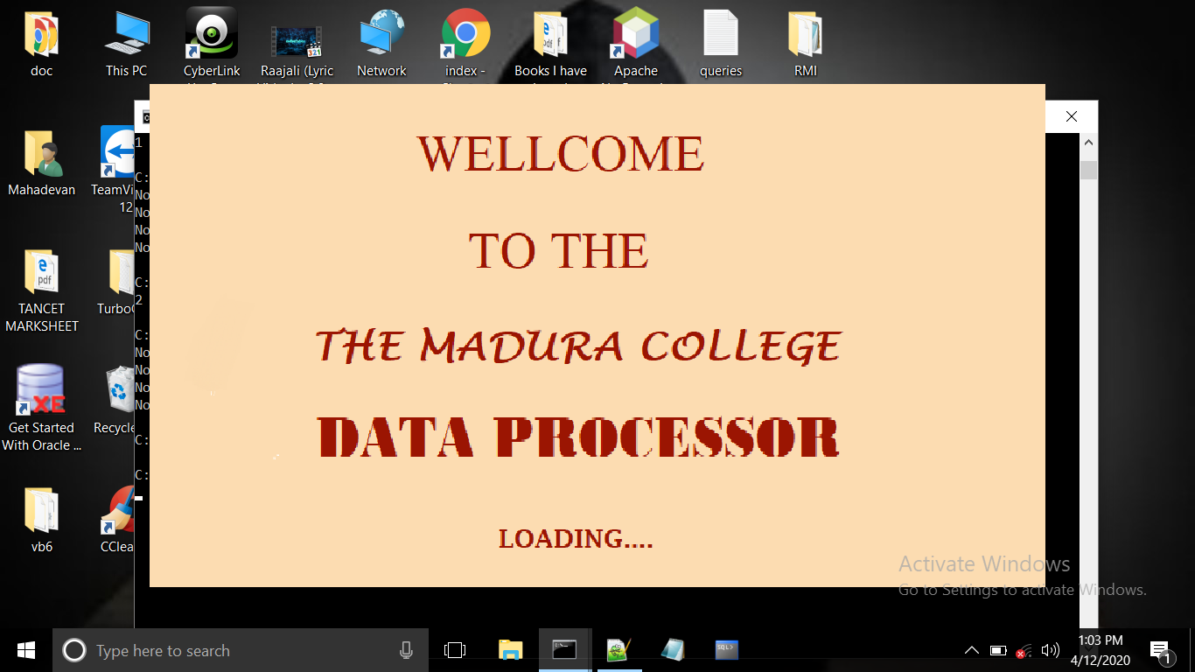

**LOGIN**

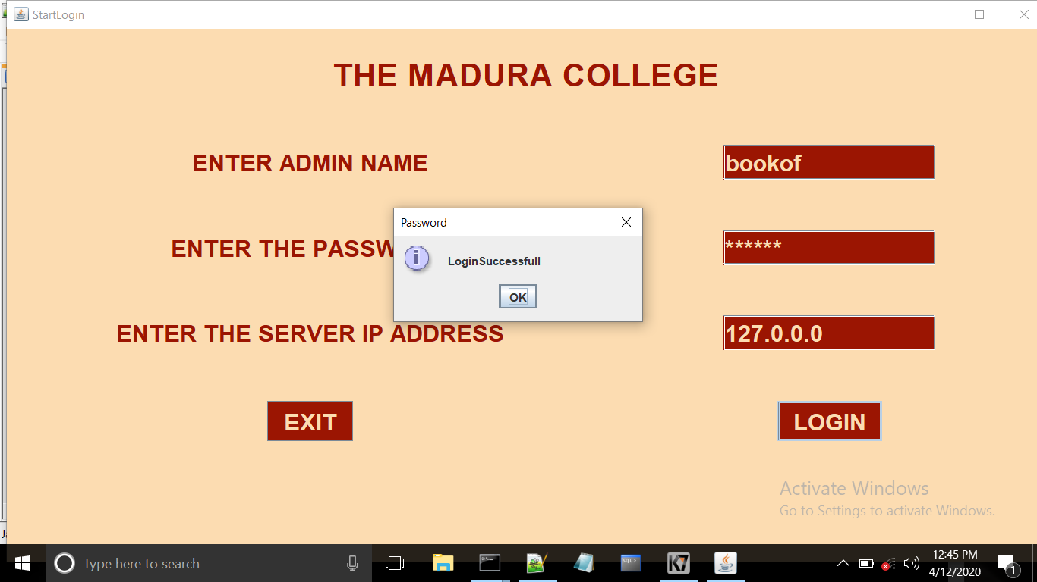

**HOME**

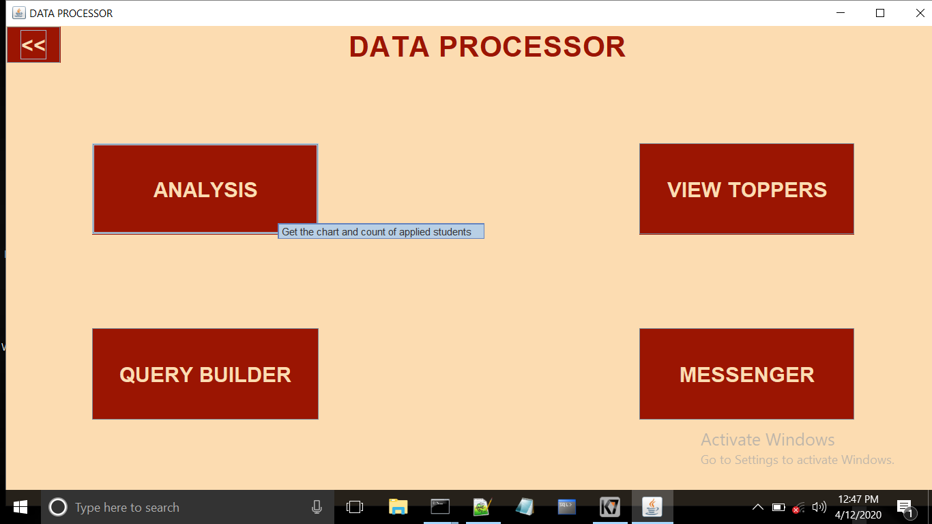

**ANALYSIS**

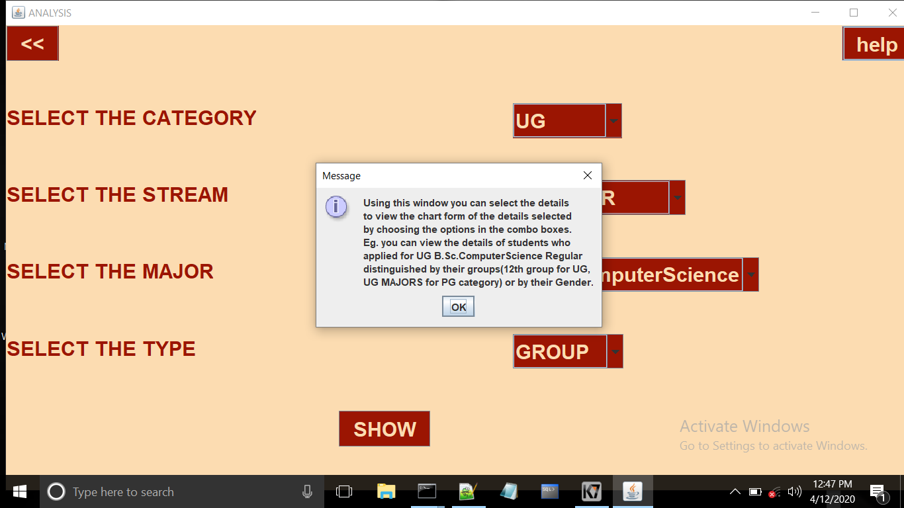

**PIECHART**

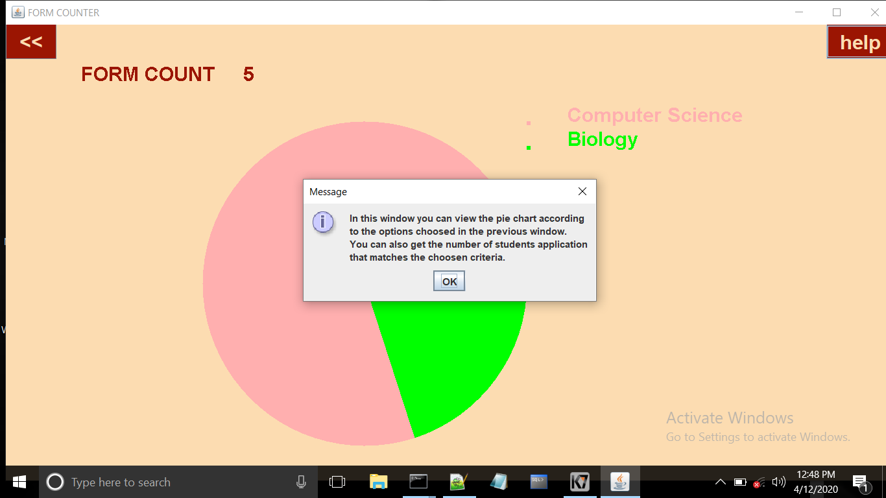

**VIEW TOPPERS**

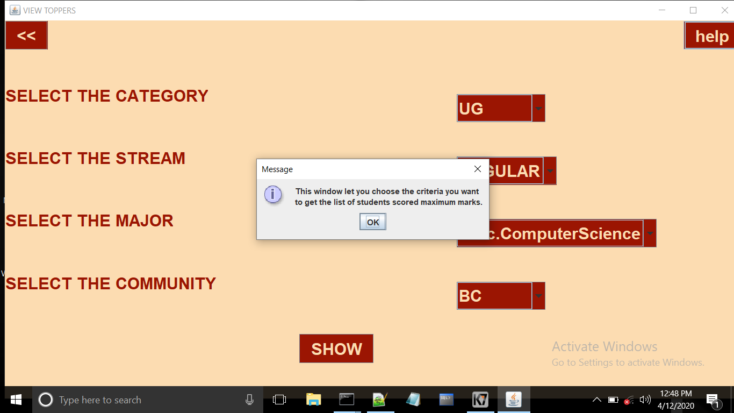

**TOP 2 TOPPER ACCORDING TO SELECTED CATEGORY**

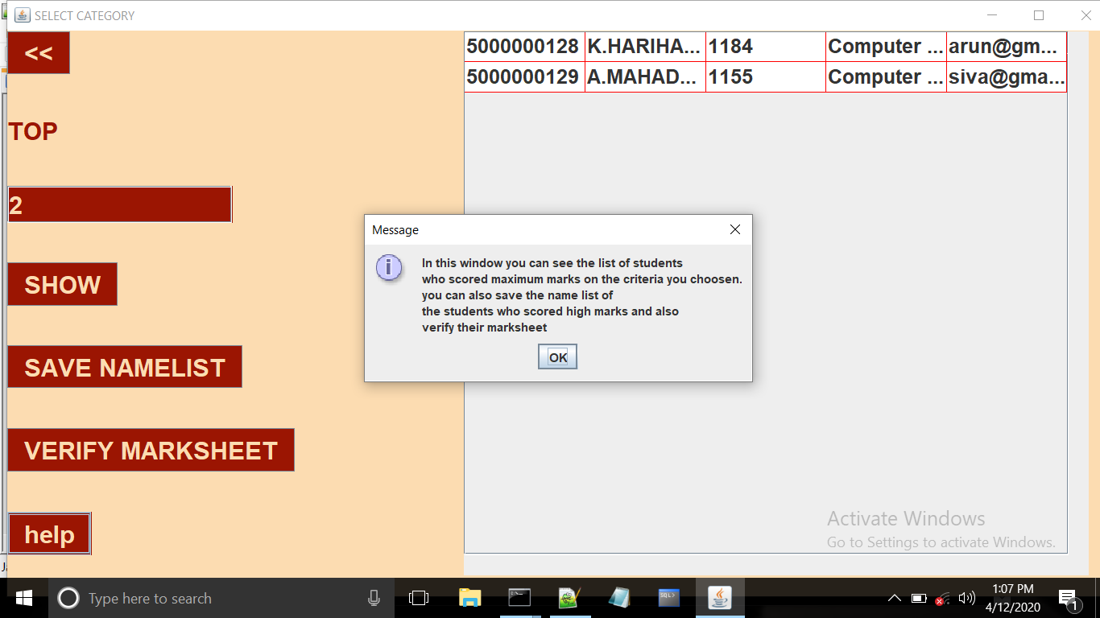

**SELECTING THE TOPPERS BY CREATING THE FILE**

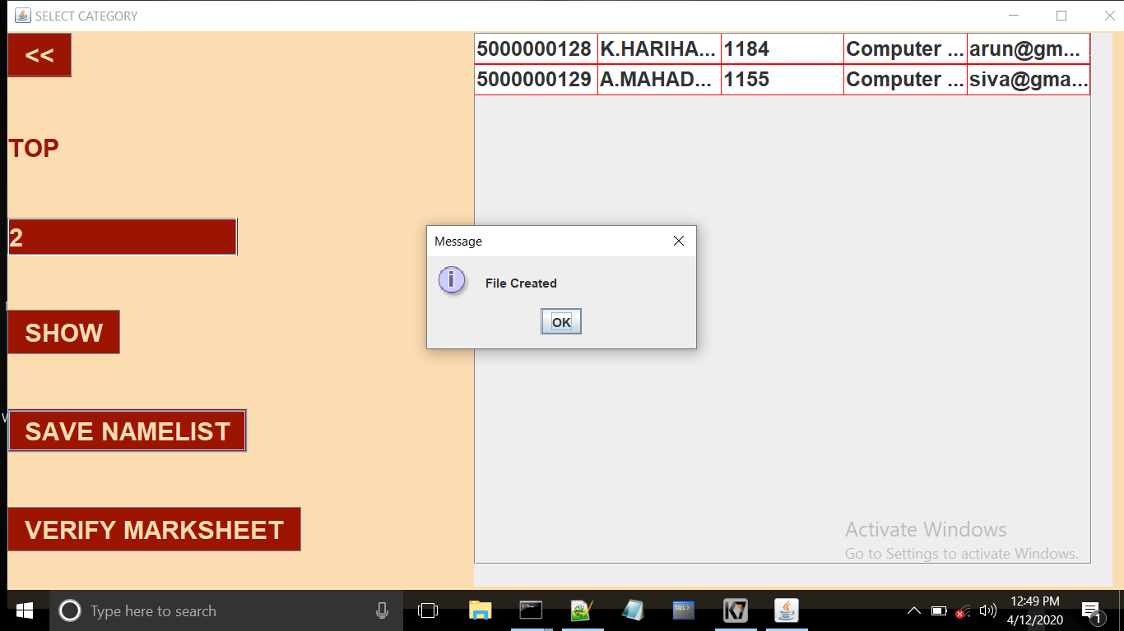

**VERIFY MARKSHEET**

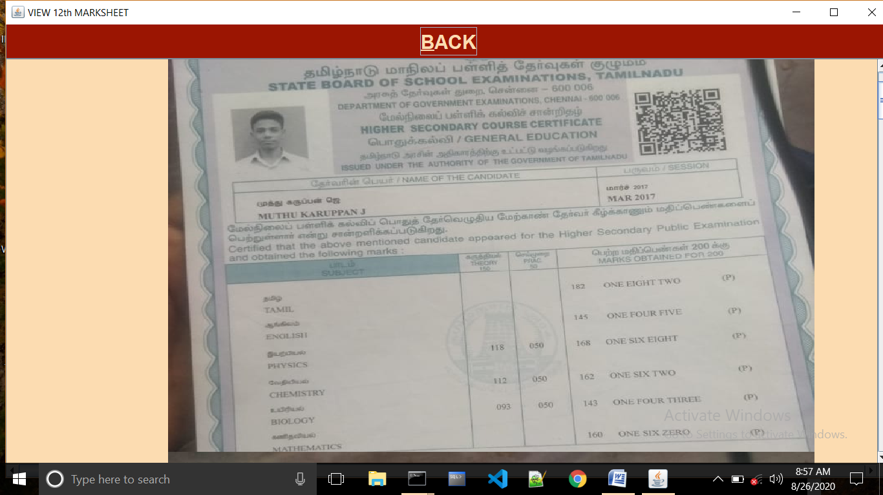

**QUERY BUILDER**

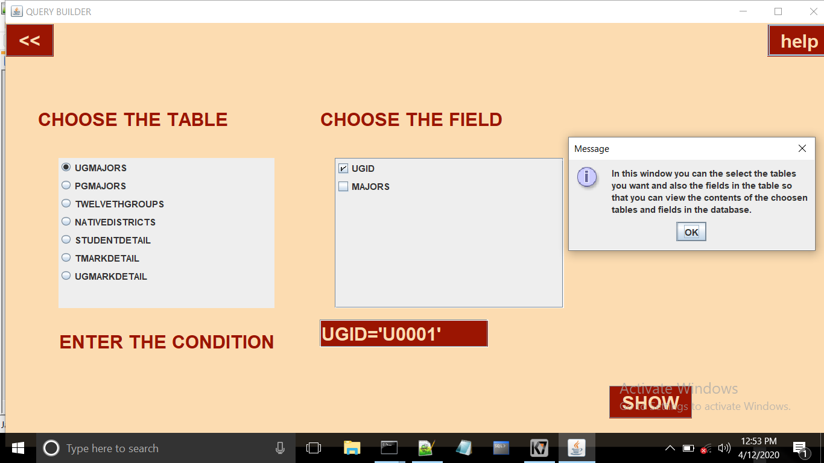

**RESULT OF THE QUERY**

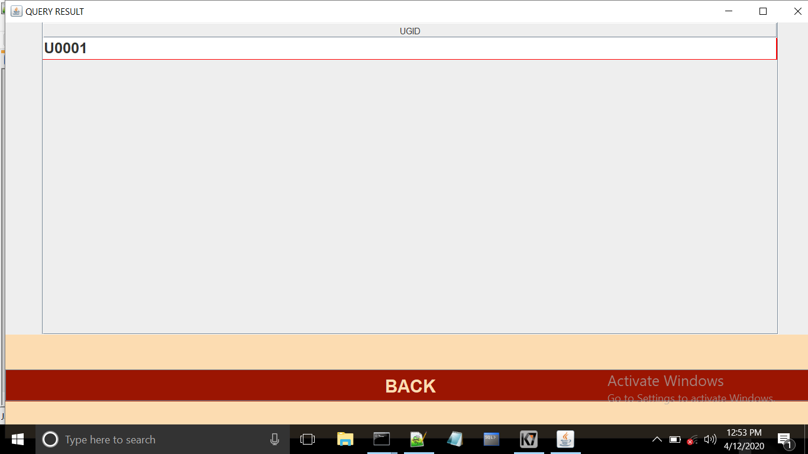

**MESSENGER**

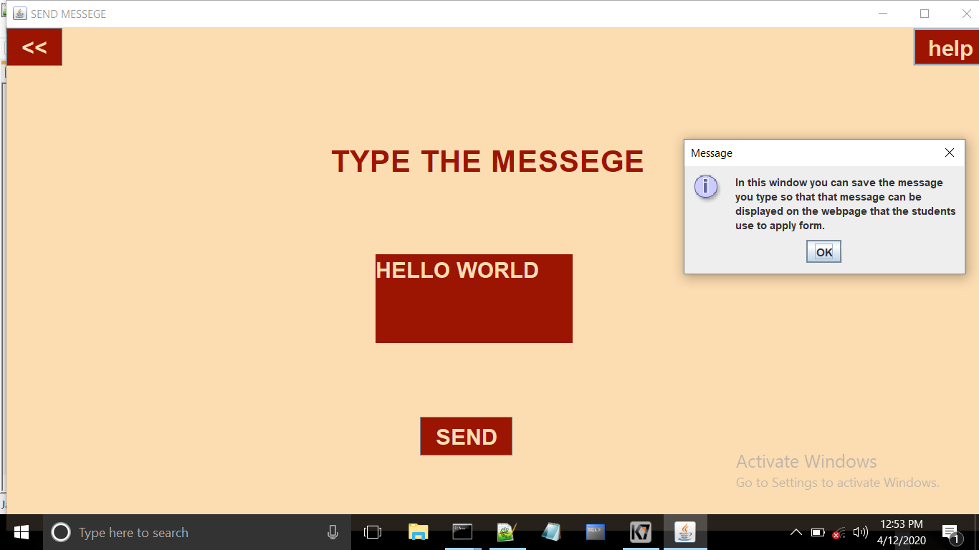

**WEB APPLICATION**

**HOMEPAGE**

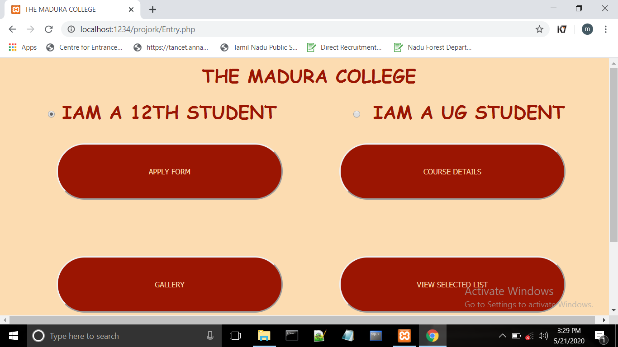

**APPLY FORM**

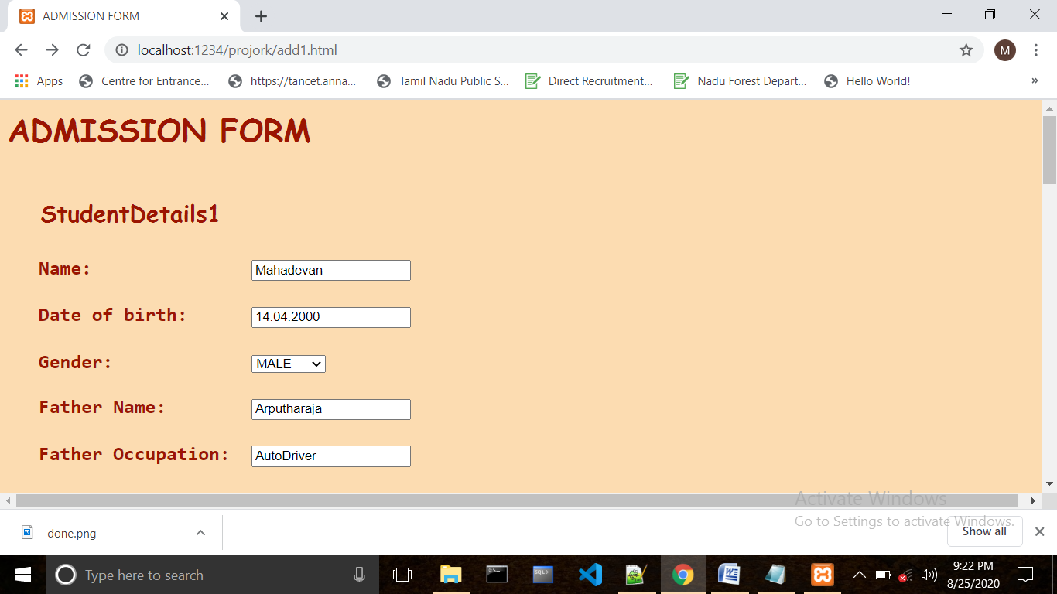

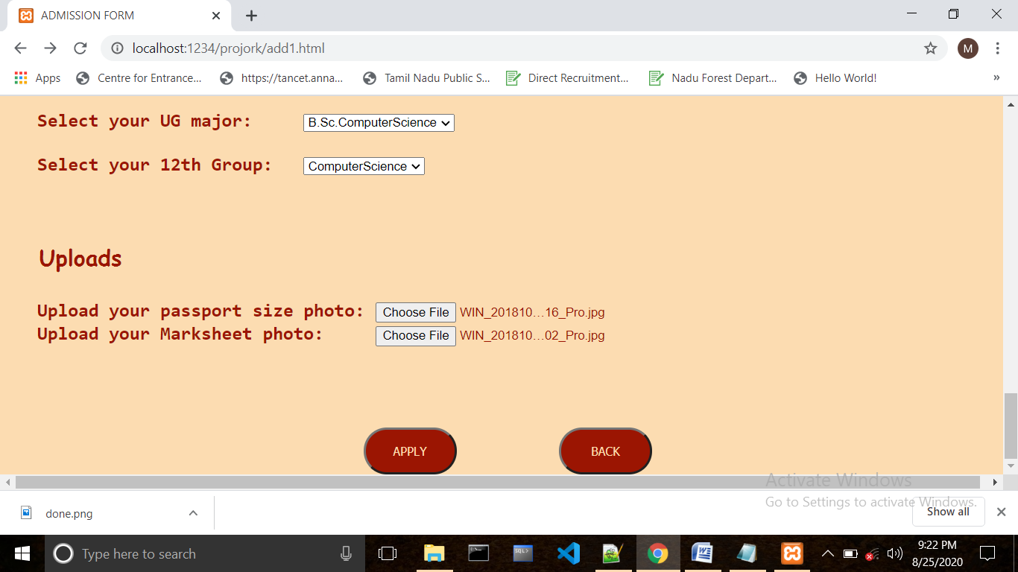

**UPLOADED RESULT**

**UPLOADING THE FORM**

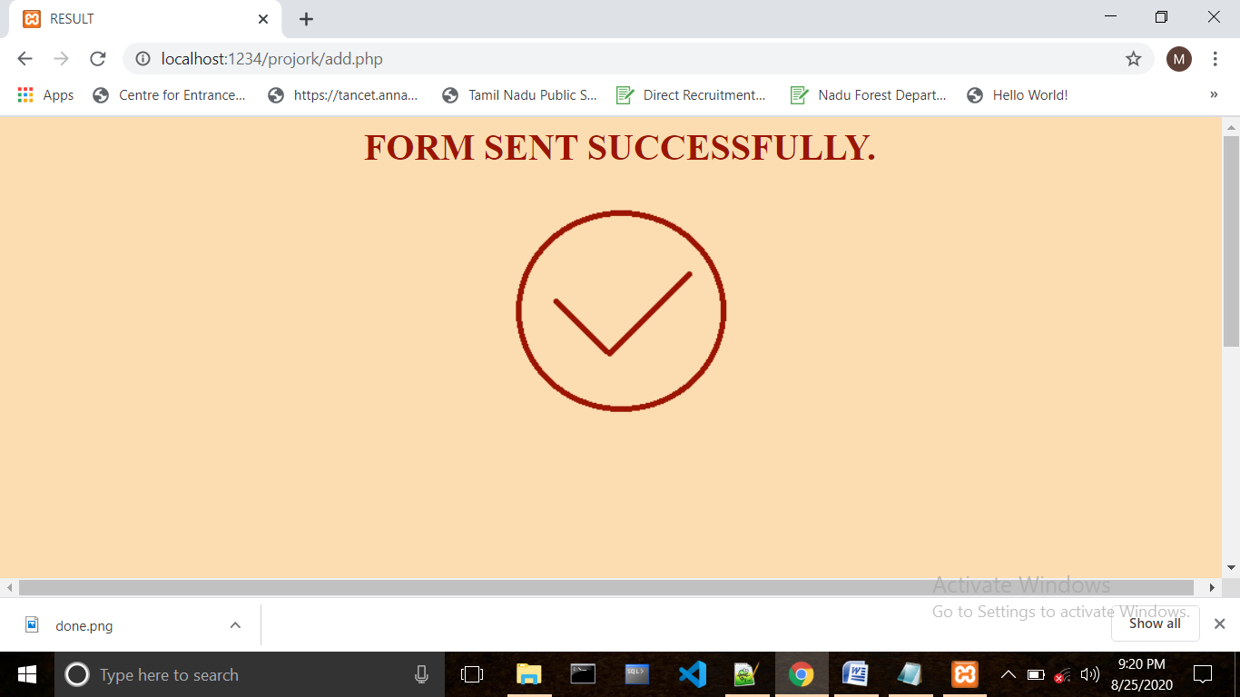

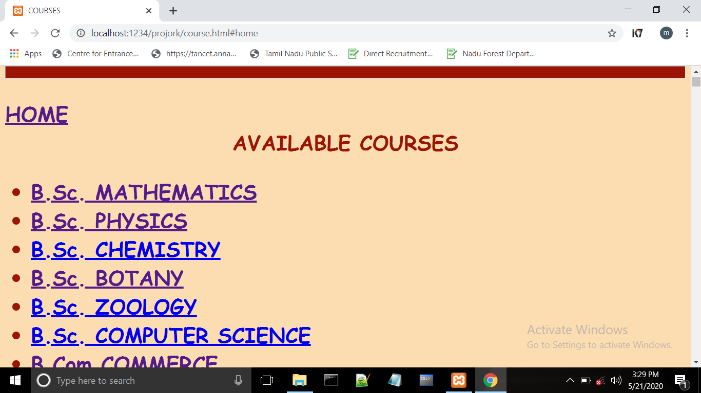

**B.Sc. PHYSICS COURSE DETAILS**

**COURSE DETAILS**

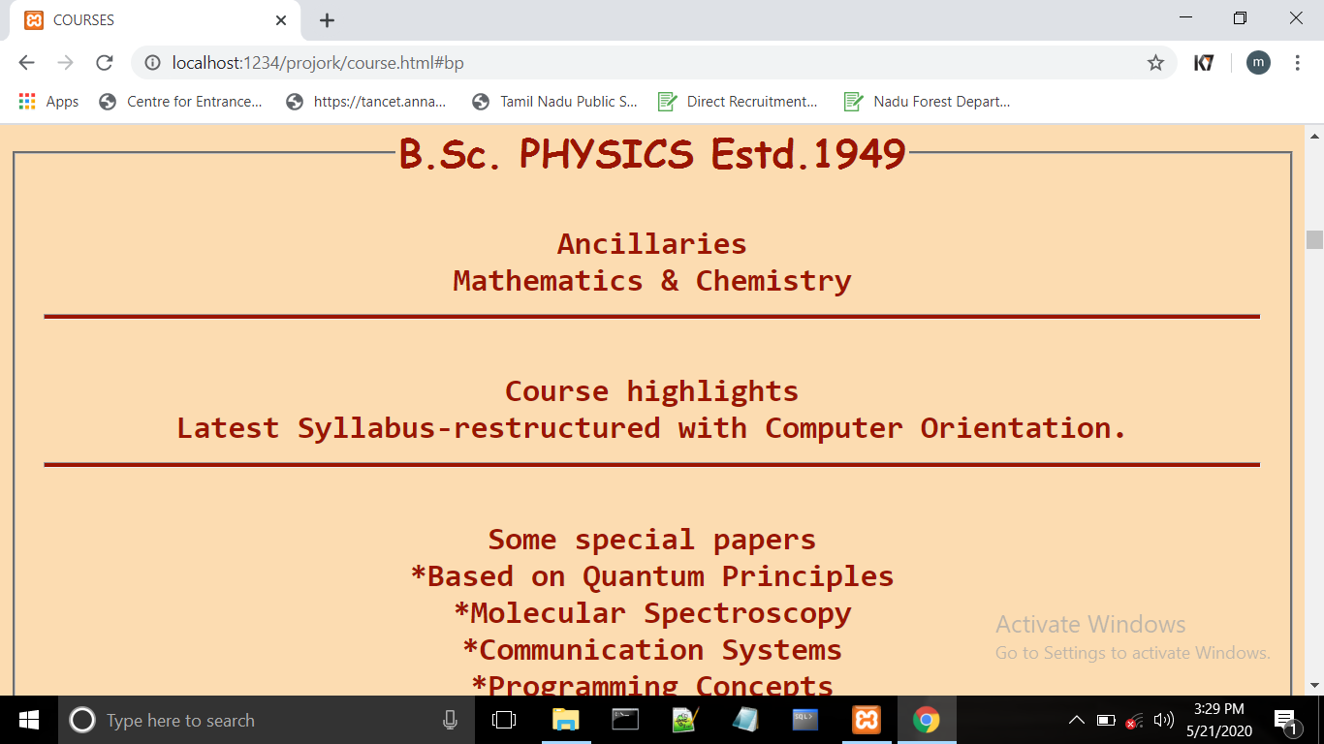

**SELECTED LIST**

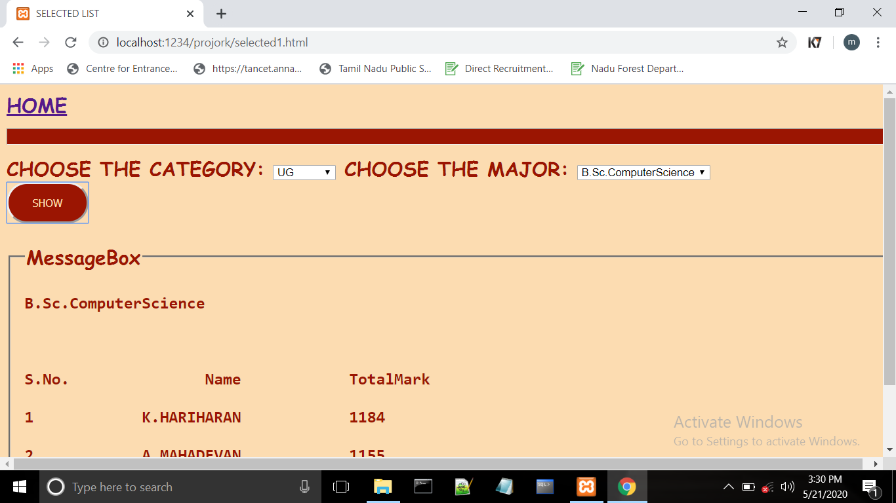

**CONCLUSION**

**ONLINE FORM PROCESSING SYSTEM** is designed to meet all the requirements of a college student admission. The project thus performs well and it is error free and also performs required operations in seconds.

This project was aimed at this and it successfully achieves all the objectives stated. Reports are generated in most of the modules to verify the data at a timely manner. Thus this project minimizes the workload of employees by handling all the tasks and improves accuracy.

**FUTURE ENHANSEMENTS**

This system has two parts of application, a desktop application and a web application.

**DESKTOP APPLICATION**

* + It is a multiuser application, one part of it runs on each user and another one is a RMI server part. In the future, whole part of this application can be deployed on server and the user can access it using the browser, without having to install java.

**WEB APPLICATION**

* + This application does not have any login option for each students,in the future it can provide login facility to each student.
  + There is no option for the student to convey any messages to the college authority, this facility can be established in the future.

**BIBILIOGRAPHY**

1. CORE JAVA by Dr. R. Nageswararao
2. Head First Java by Bert Bates and Kathy Sierra
3. We would like to mention a website which helped us a lot during the project

[www.stackoverflow.com](http://www.stackoverflow.com/)